APPENDIX -IX

MANDATORY PUBLIC DISCLOSURE
A : GENERAL INFORMATION :

SL NO. | INFORMATION | DETAILS
1 | NAME OF THE SCHOOL | GREEN VALLEY HIGH SCHOOL
2 | AFFILIATION NO.(IF APPLICABLE) | 430112
3 | SCHOOL CODE (IF APPLICABLE) | 10098
4 | COMPLETE ADDRESS WITH PIN CODE | Via Sevasi Gotri, Off Effluent Channel road,  Ampad, Vadodara, Gujarat, VADODARA (BARODA) , GUJARAT - 391101
5 | PRINCIPAL NAME | IRFAN KASAM MULTANI
6 | PRINCIPAL QUALIFICATION | M.A, B.ED.
7 | SCHOOL EMAIL ID | greenvalleyhigh@gmail.com
8 | CONTACT DETAILS (LANDLINE/MOBILE) | 09409289929

B : DOCUMENTS AND INFORMATION:

SL NO. | DOCUMENTS/INFORMATION | LINKS OF UPLOADED DOCUMENTS ON YOUR SCHOOL'S WEBSITE
1 | COPIES OF AFFILIATION/UPGRADATION LETTER AND RECENT EXTENSION OF AFFILIATION, IF ANY | PDF Attached
2 | COPIES OF SOCIETIES/TRUST/COMPANY  REGISTRATION/RENEWAL CERTIFICATE, AS APPLICABLE | PDF Attached
3 | COPY OF NO OBJECTION CERTIFICATE (NOC) ISSUED, IF APPLICABLE, BY THE STATE GOVT./UT | PDF Attached
4 | COPIES OF RECOGNITION CERTIFICATE UNDER RTE ACT, 2009, AND IT’S RENEWAL IF APPLICABLE | PDF Attached
5 | COPY OF VALID BUILDING SAFETY  CERTIFICATE AS PER THE NATIONAL BUILDING CODE | PDF Attached
6 | COPY OF VALID FIRE SAFETY CERTIFICATE ISSUED BY THE COMPETENT AUTHORITY | PDF Attached
7 | COPY OF THE SELF CERTIFICATION SUBMITTED BY THE SCHOOL FOR  AFFILIATION/UPGRADATION/EXTENSION OF AFFILIATION | PDF Attached
8 | COPIES OF VALID WATER, HEALTH AND SANITATION CERTIFICATES | PDF Attached --
NOTE:

THE SCHOOLS NEEDS TO UPLOAD THE SELF ATTESTED COPIES OF ABOVE LISTED DOCUMETNS BY CHAIRMAN/MANAGER/SECRETARY AND PRINCIPAL. IN CASE, IT IS NOTICED AT LATER STAGE THAT UPLOADED DOCUMENTS ARE NOT GENUINE THEN SCHOOL SHALL BE LIABLE FOR ACTION AS PER NORMS.

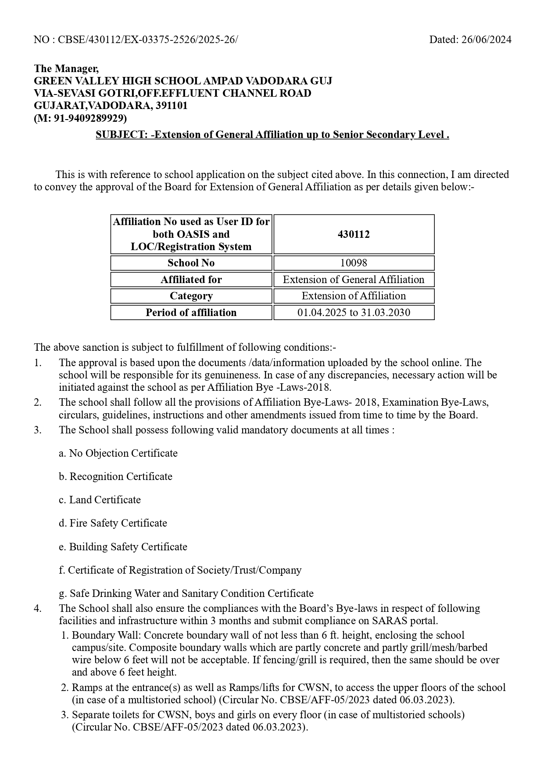
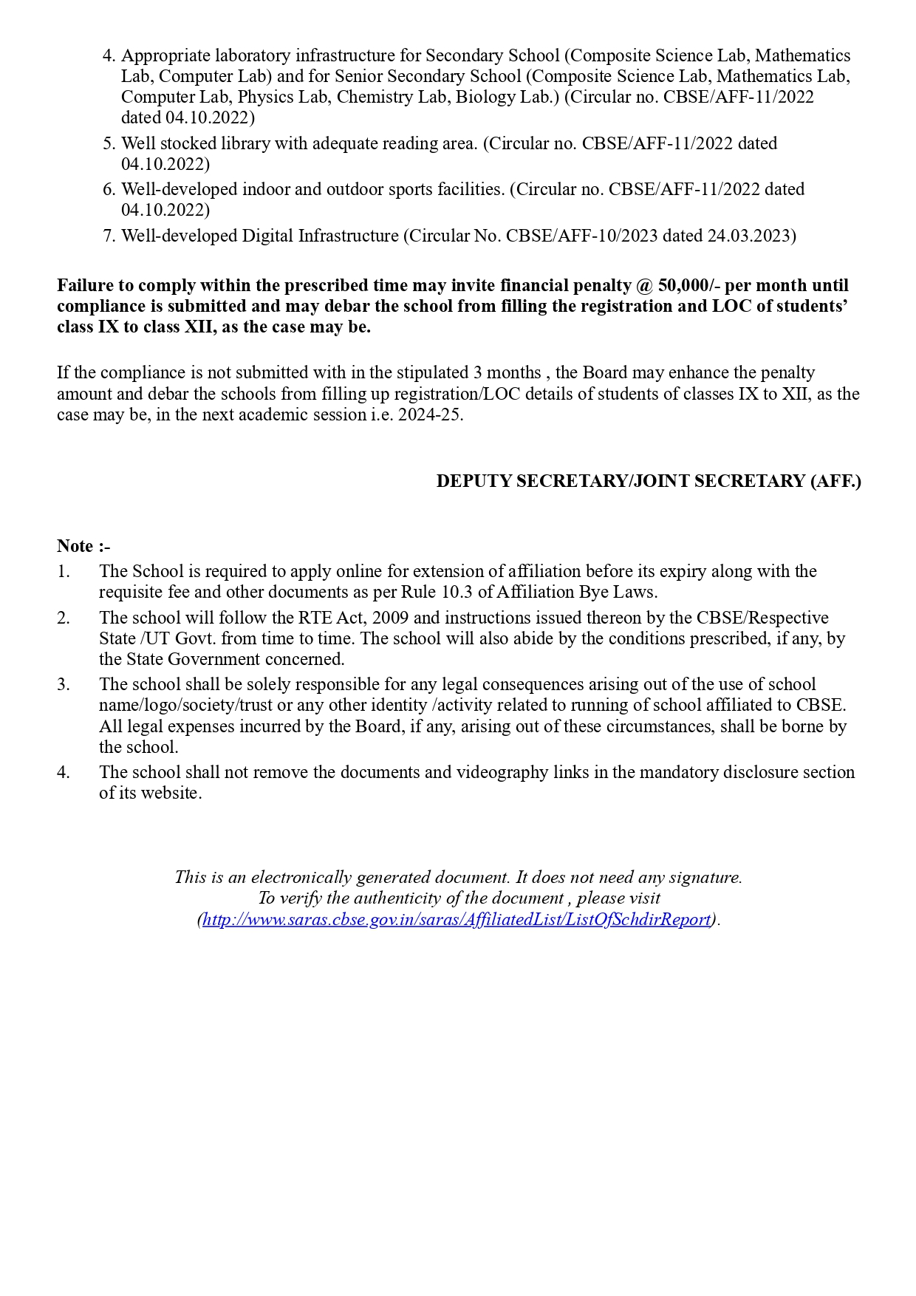
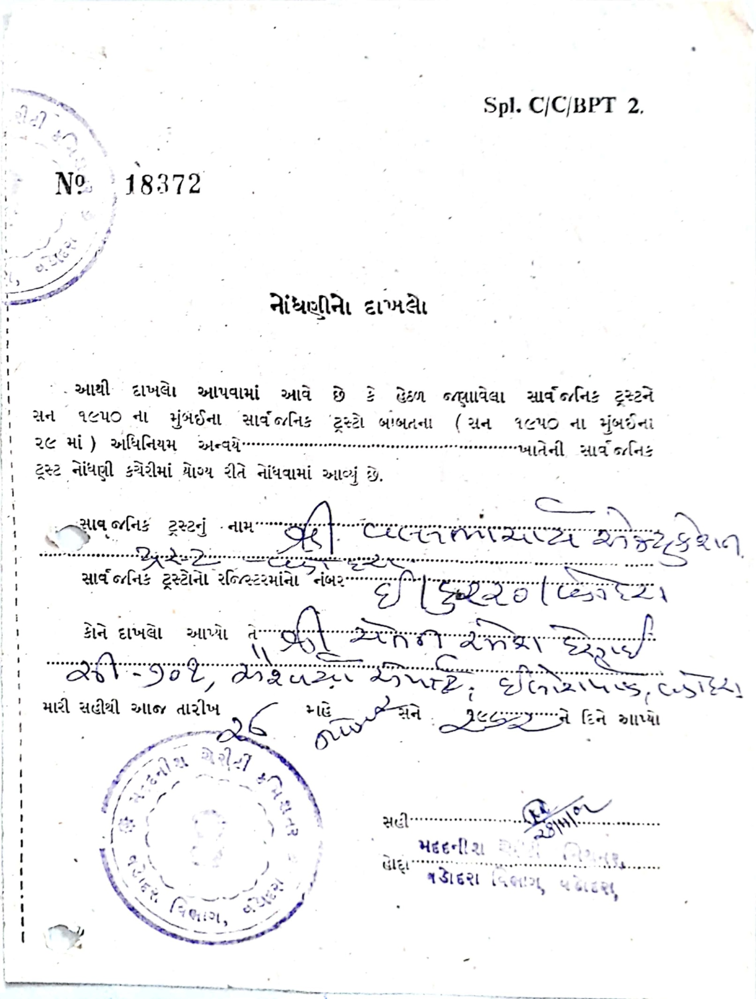

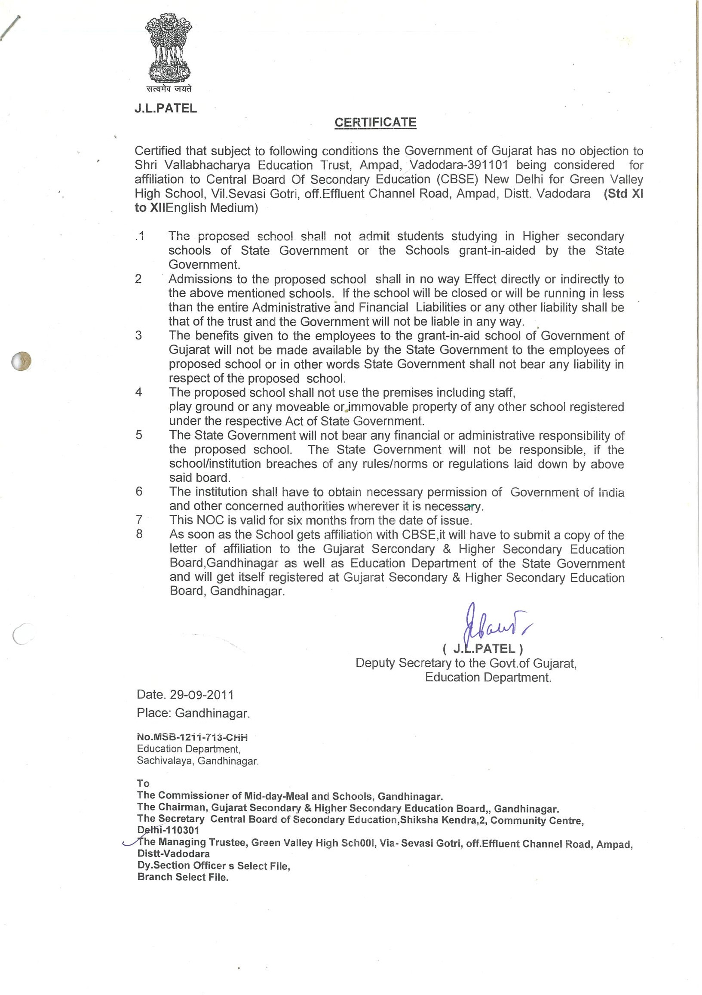

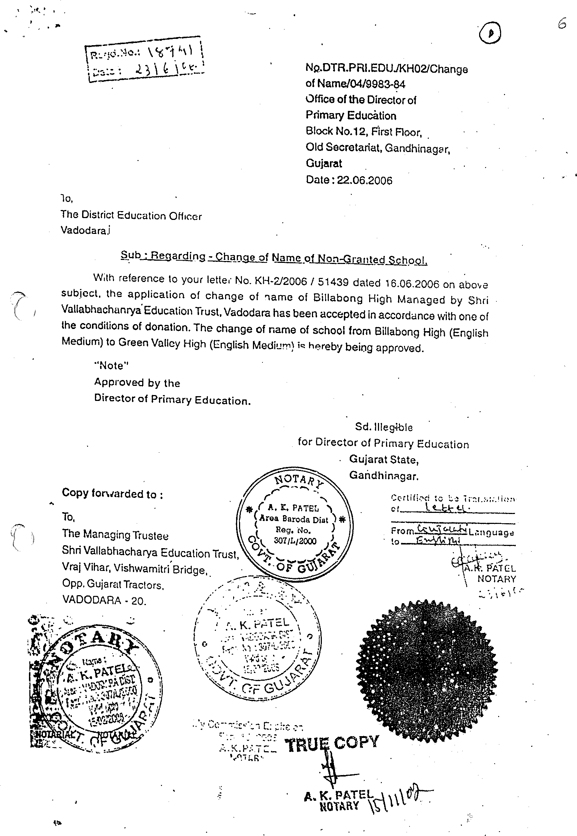

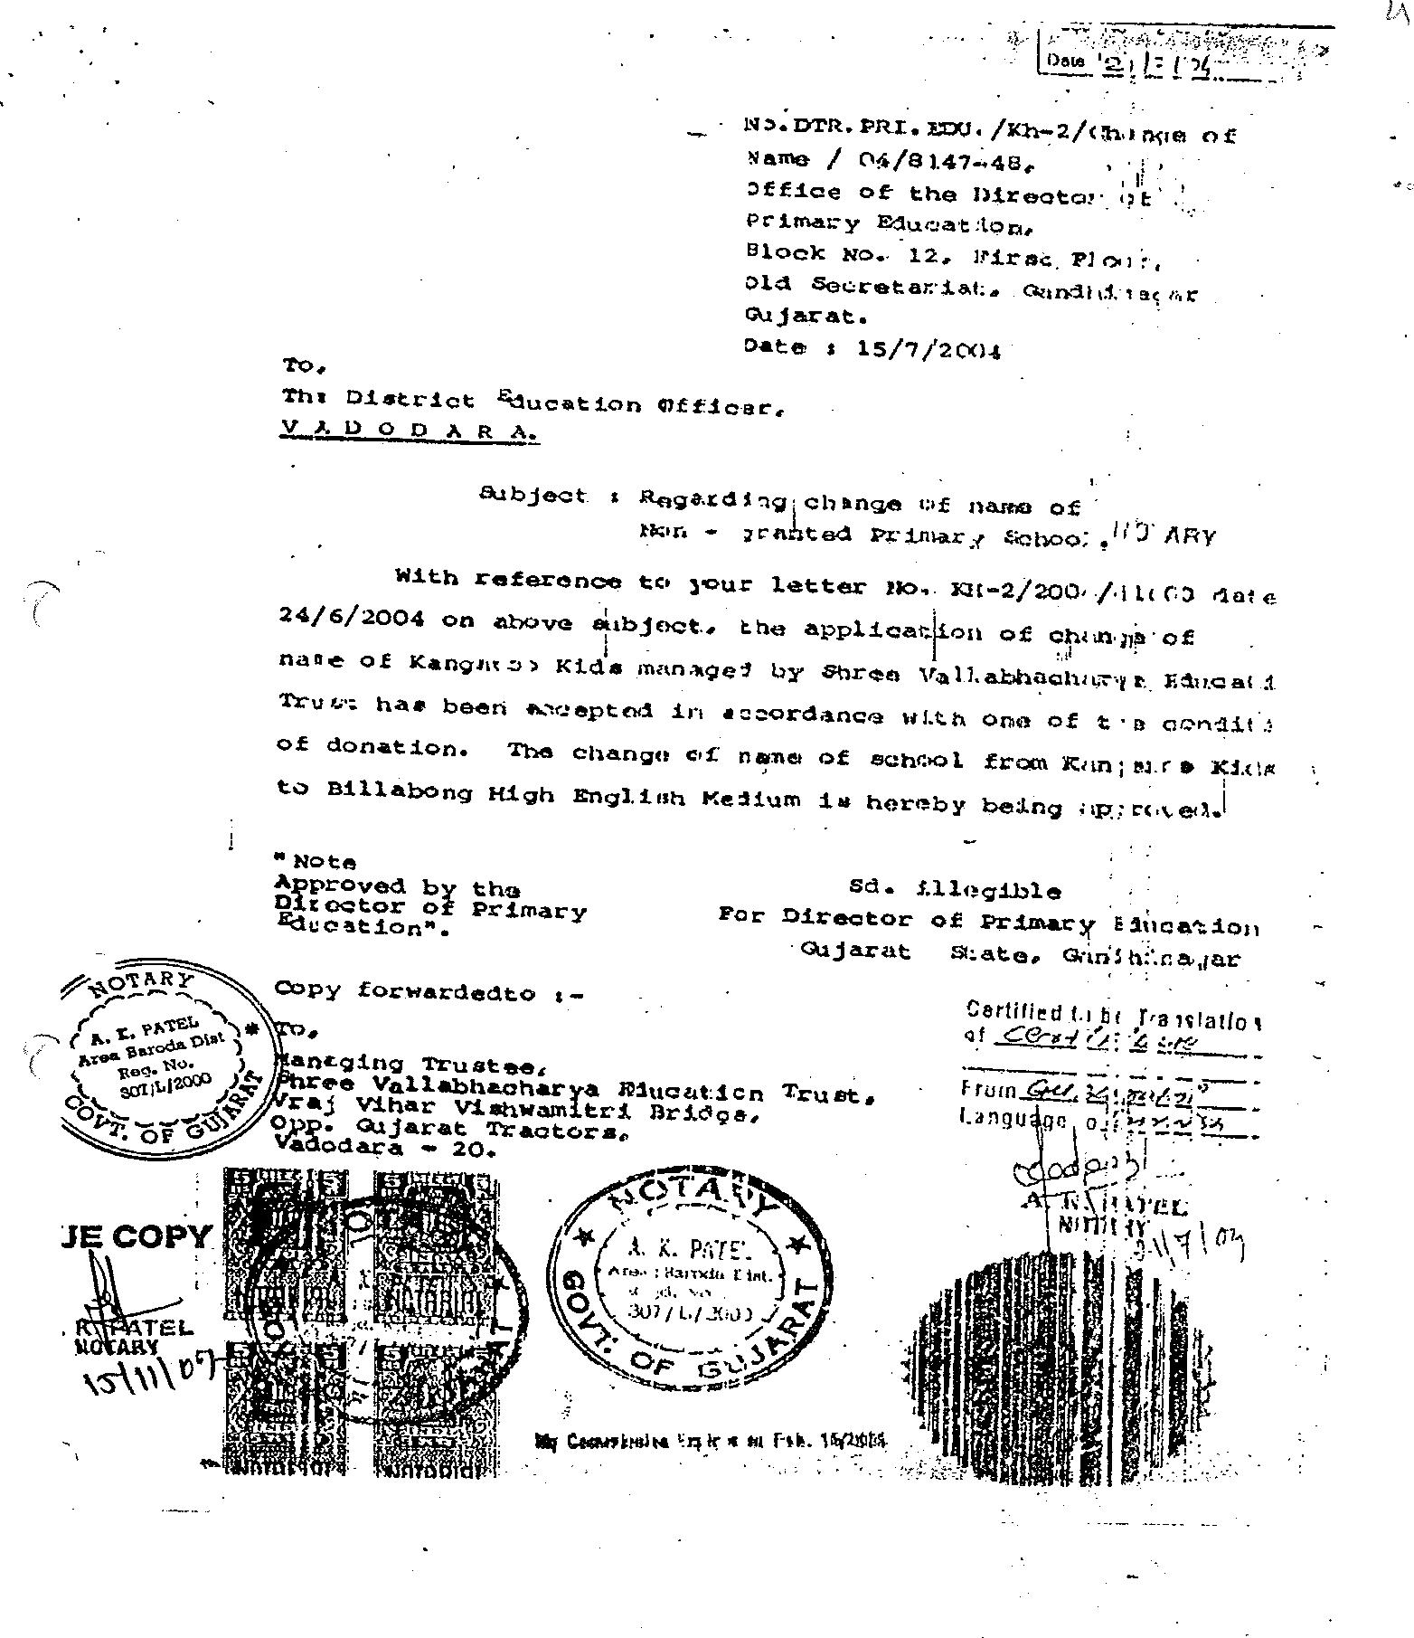

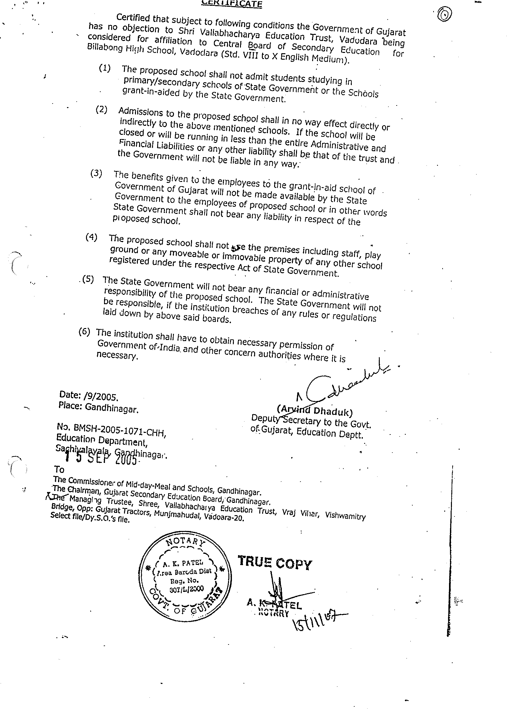

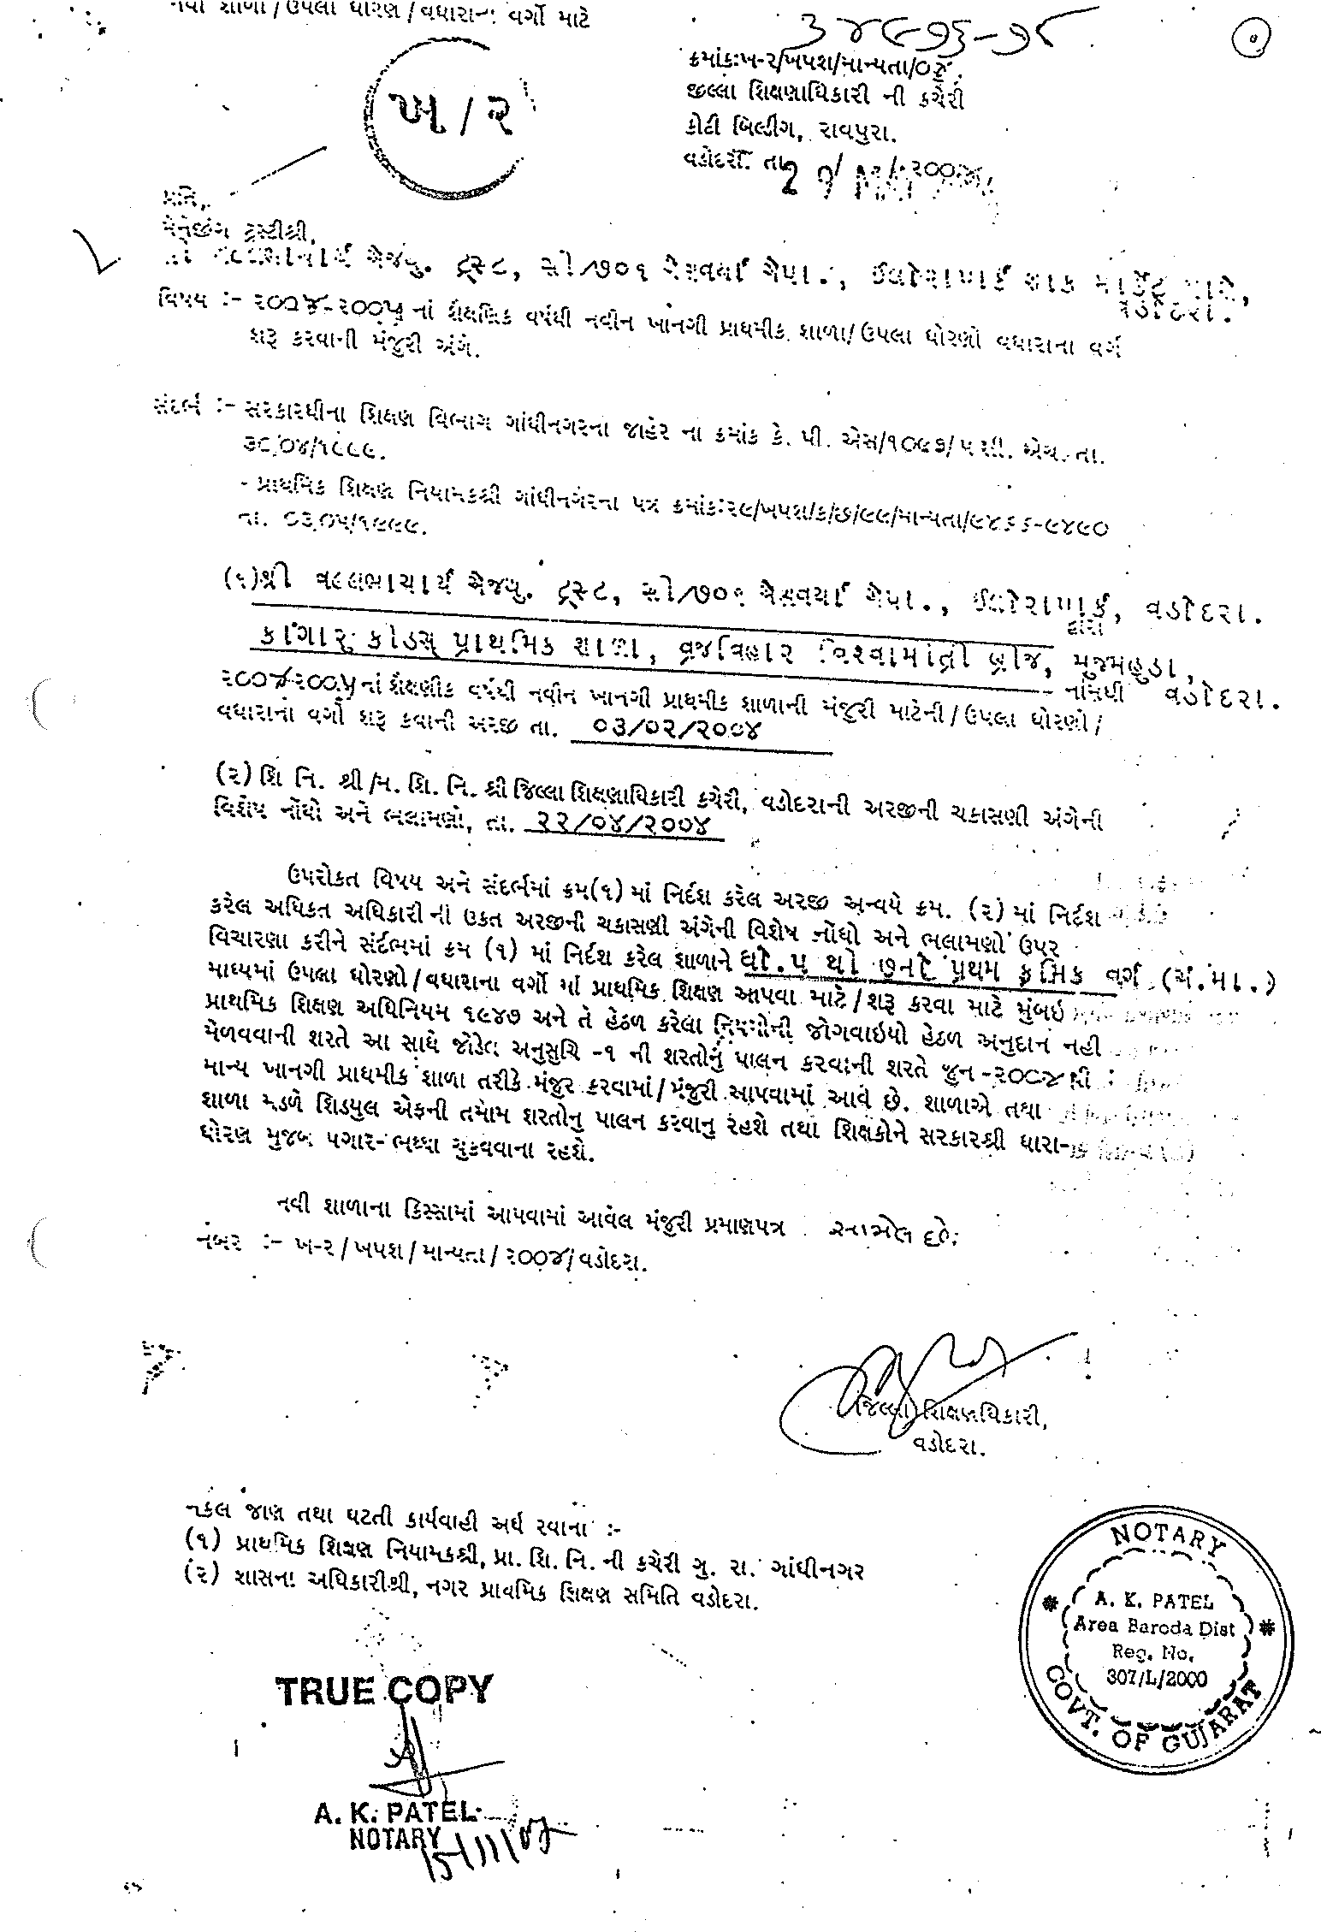
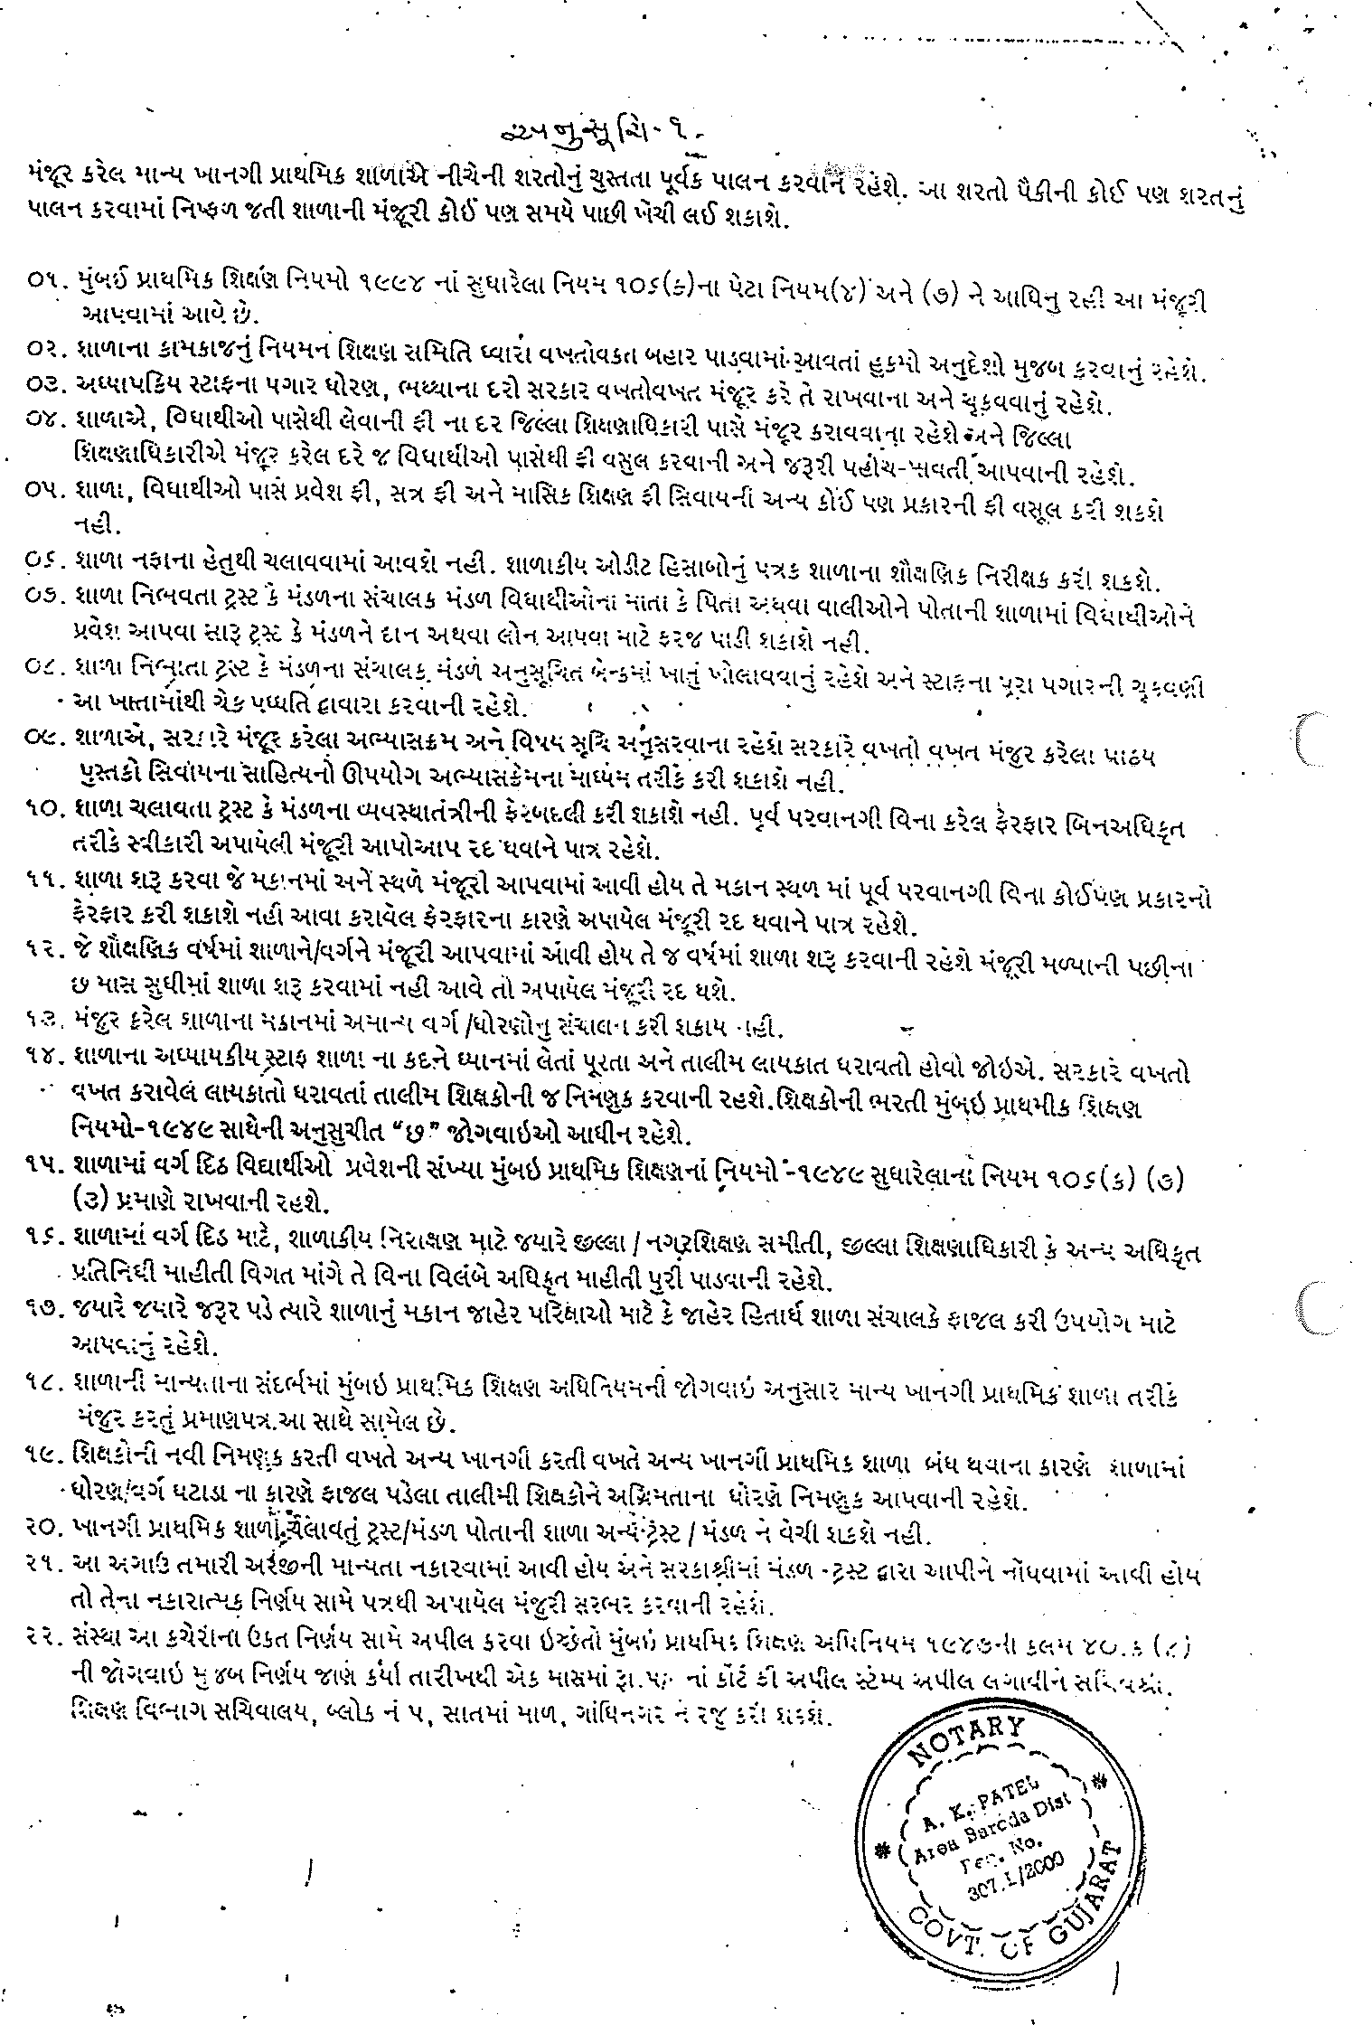

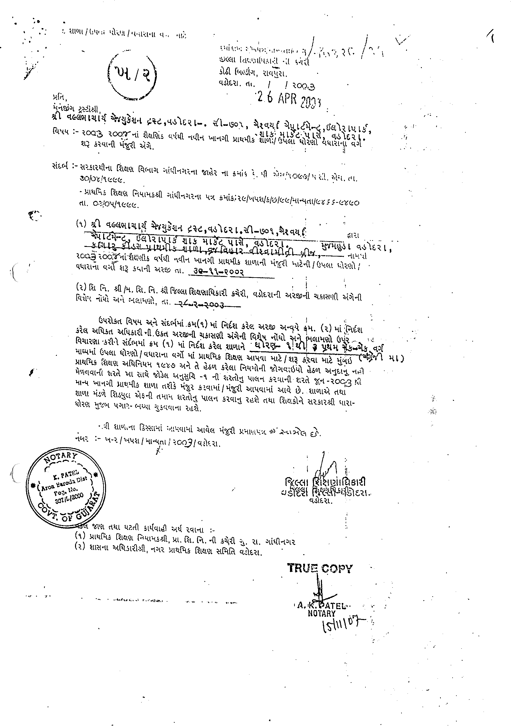

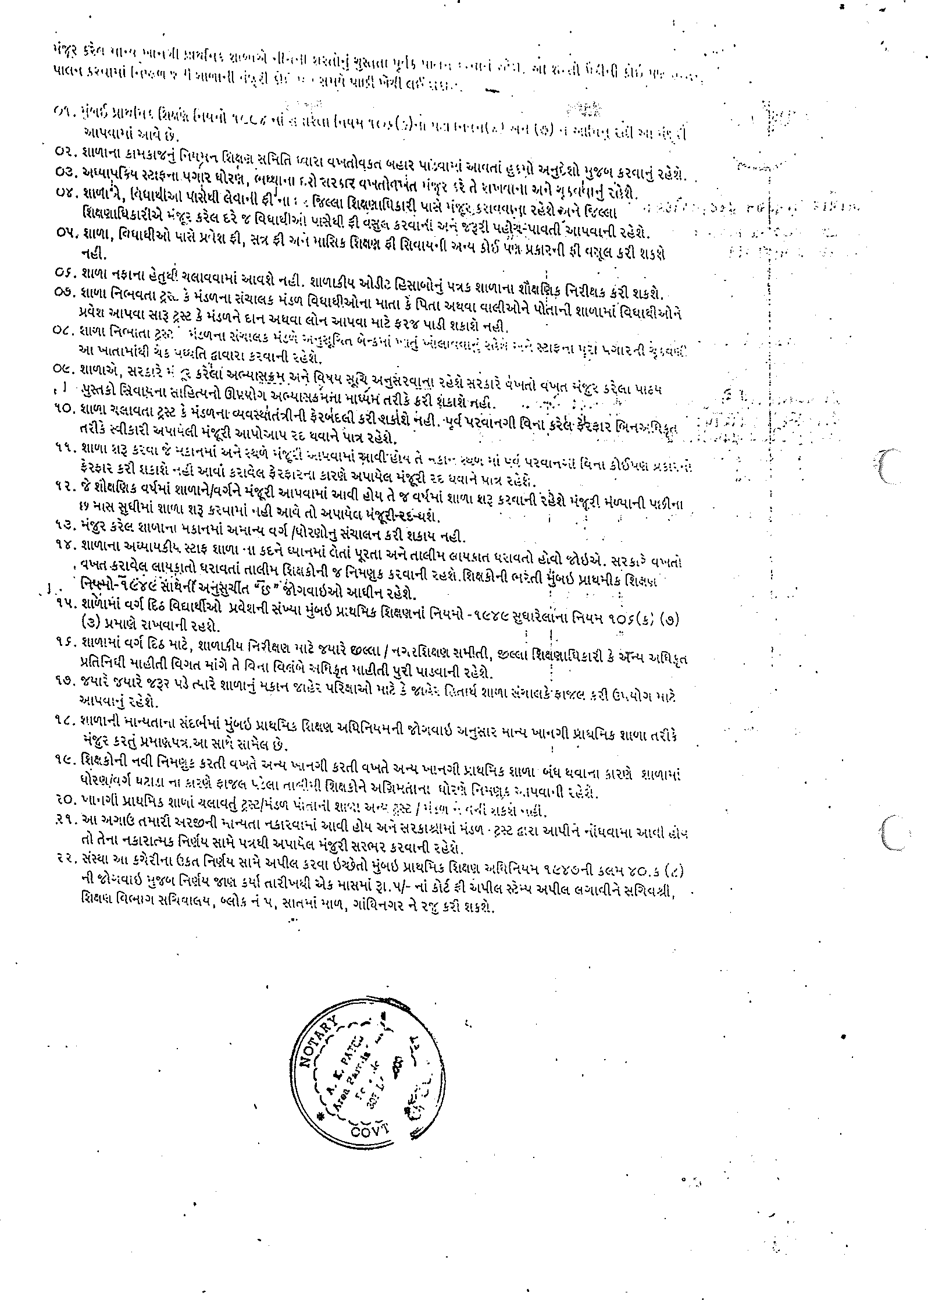

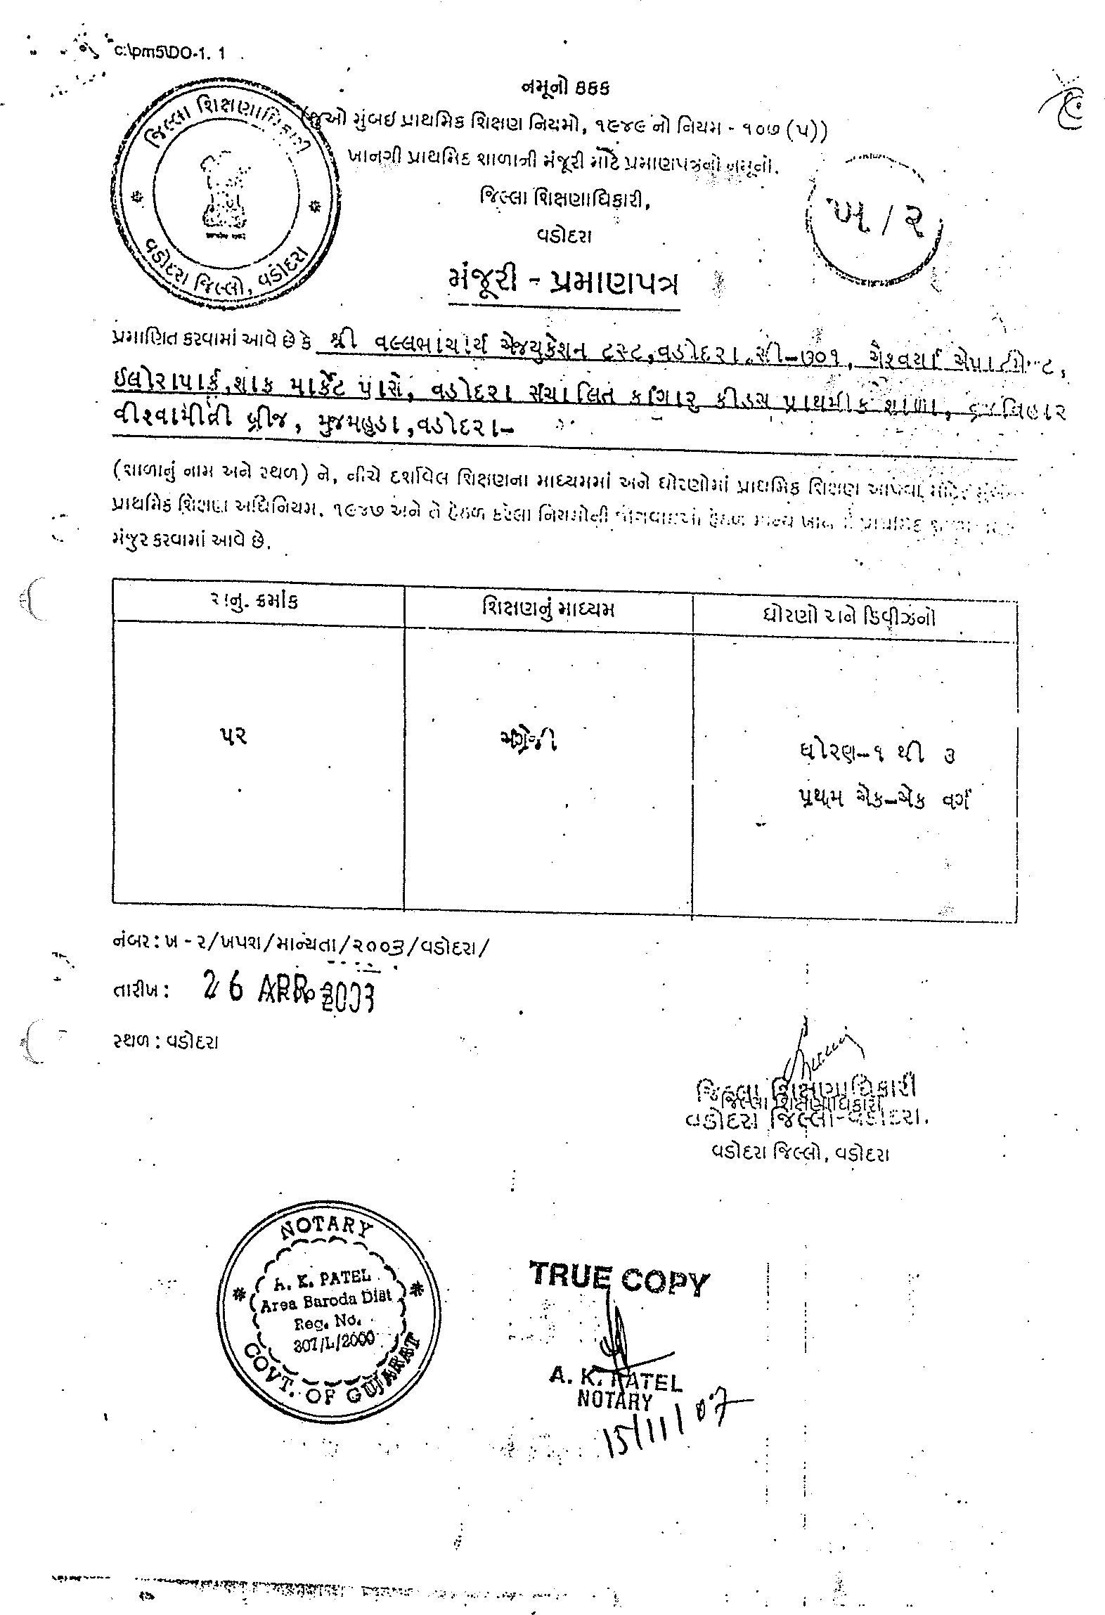

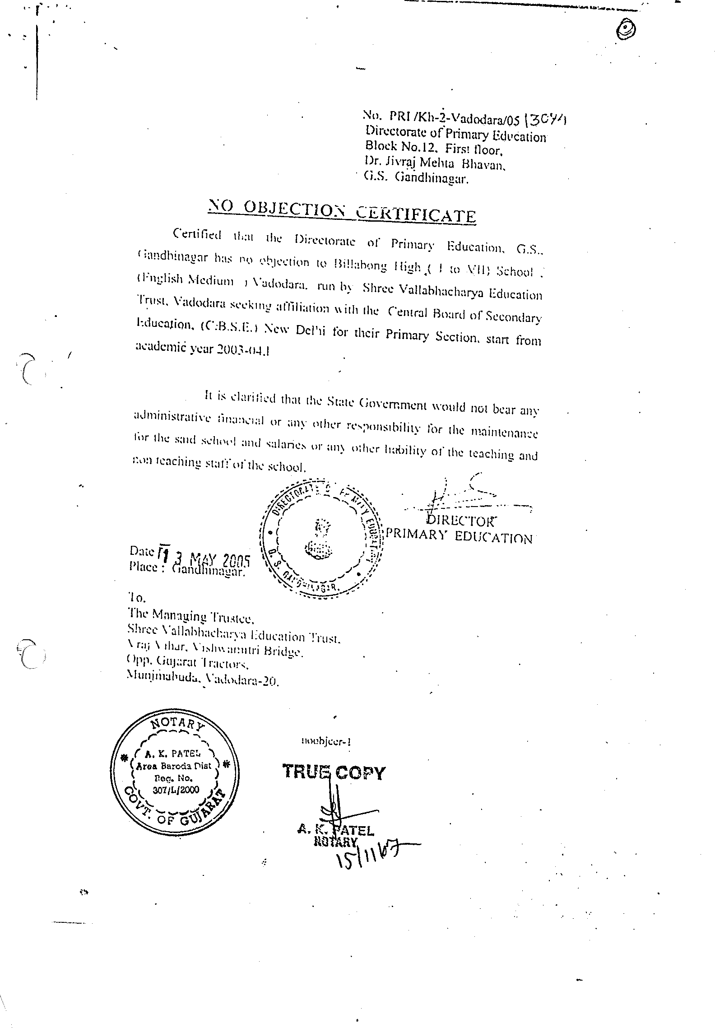

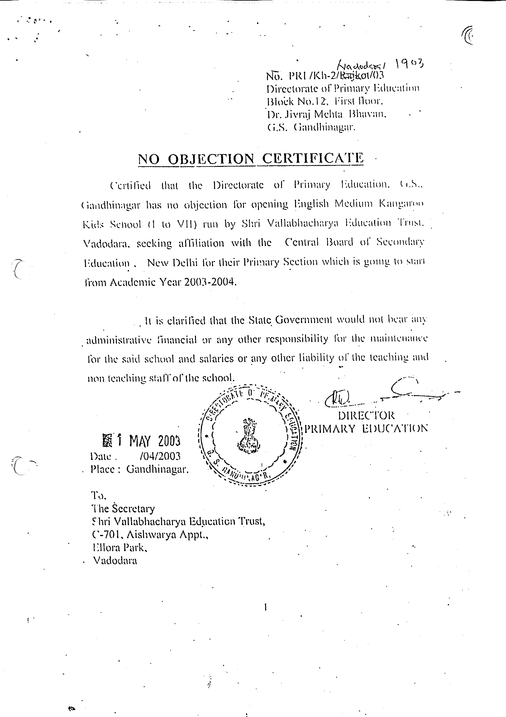

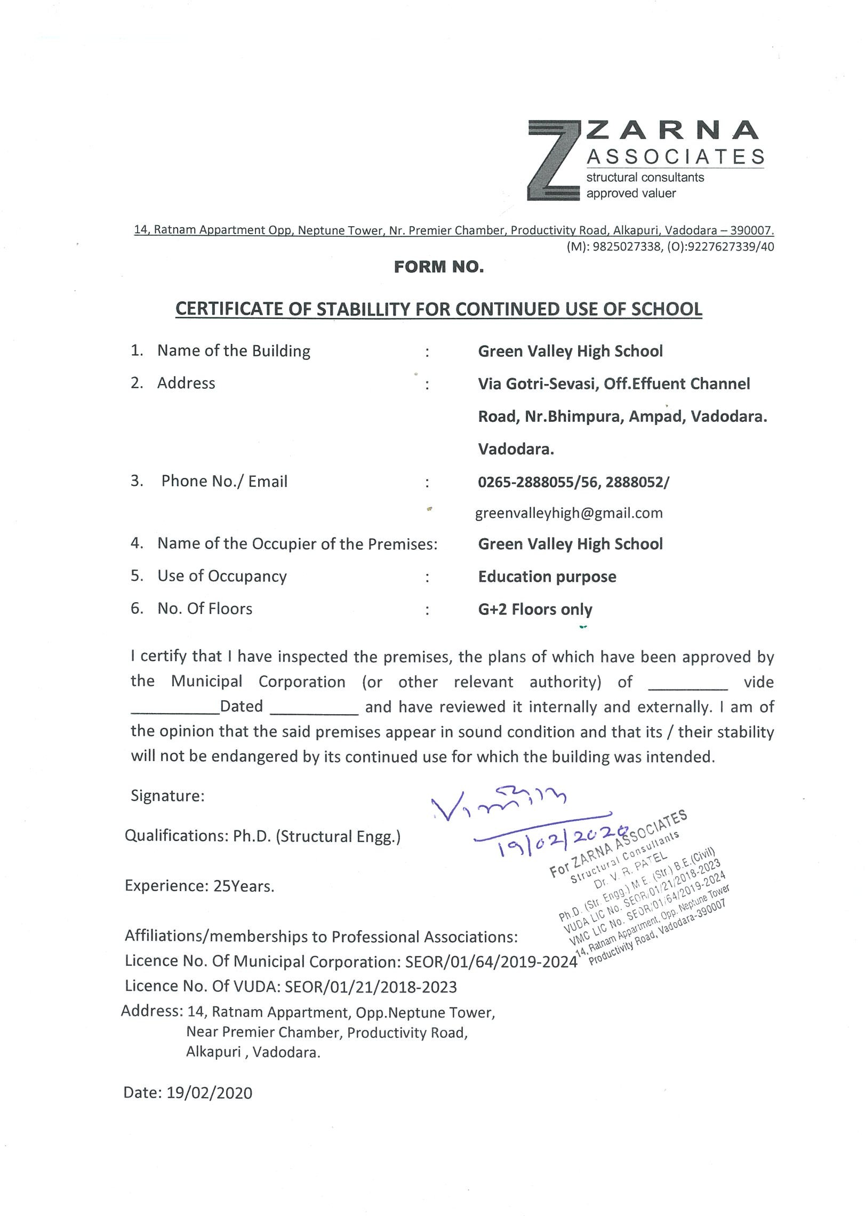

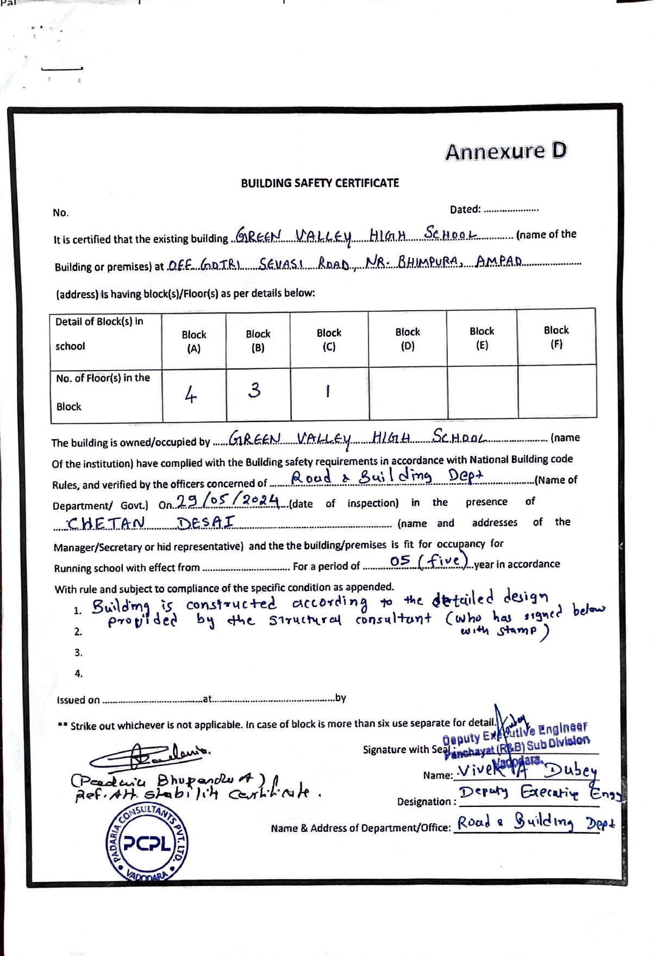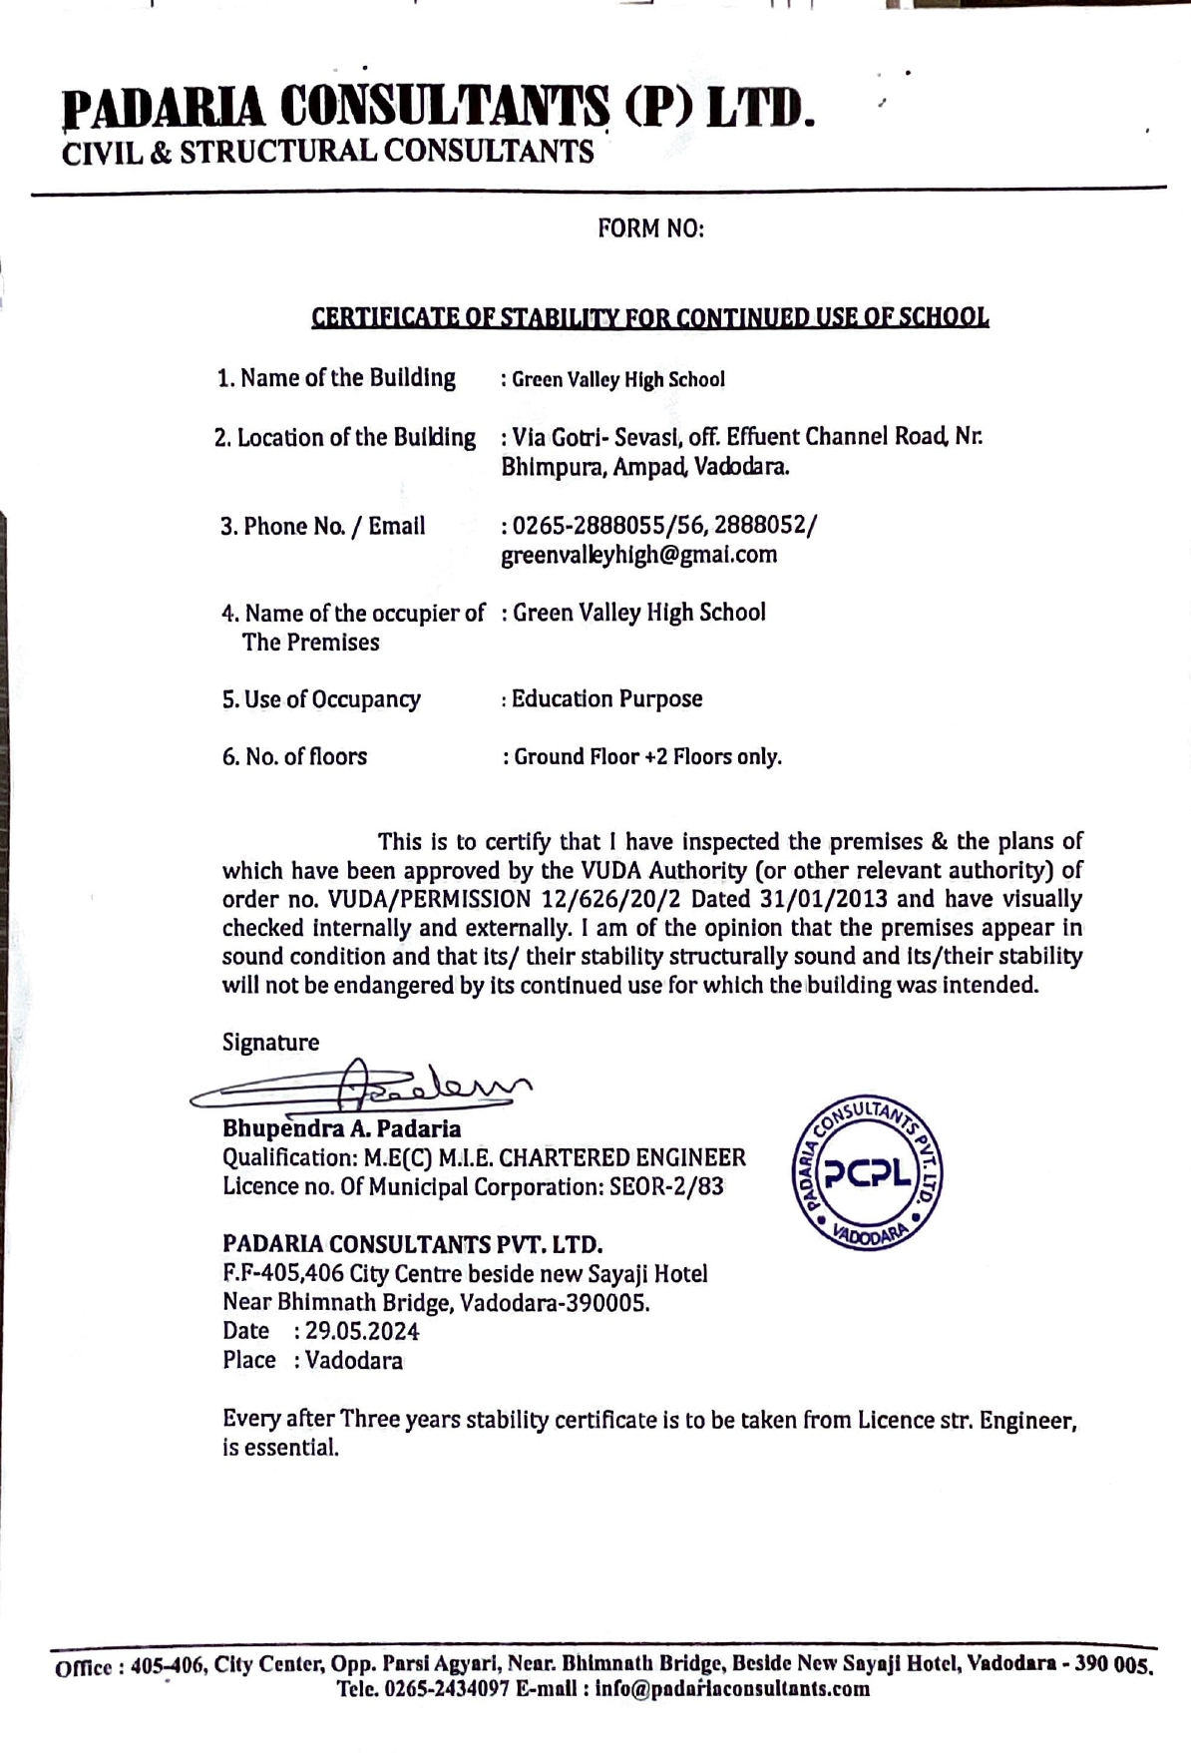
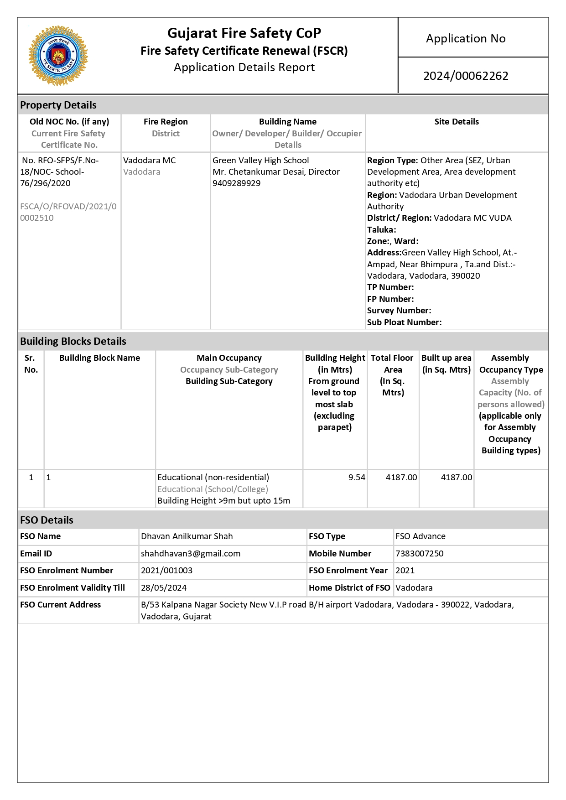
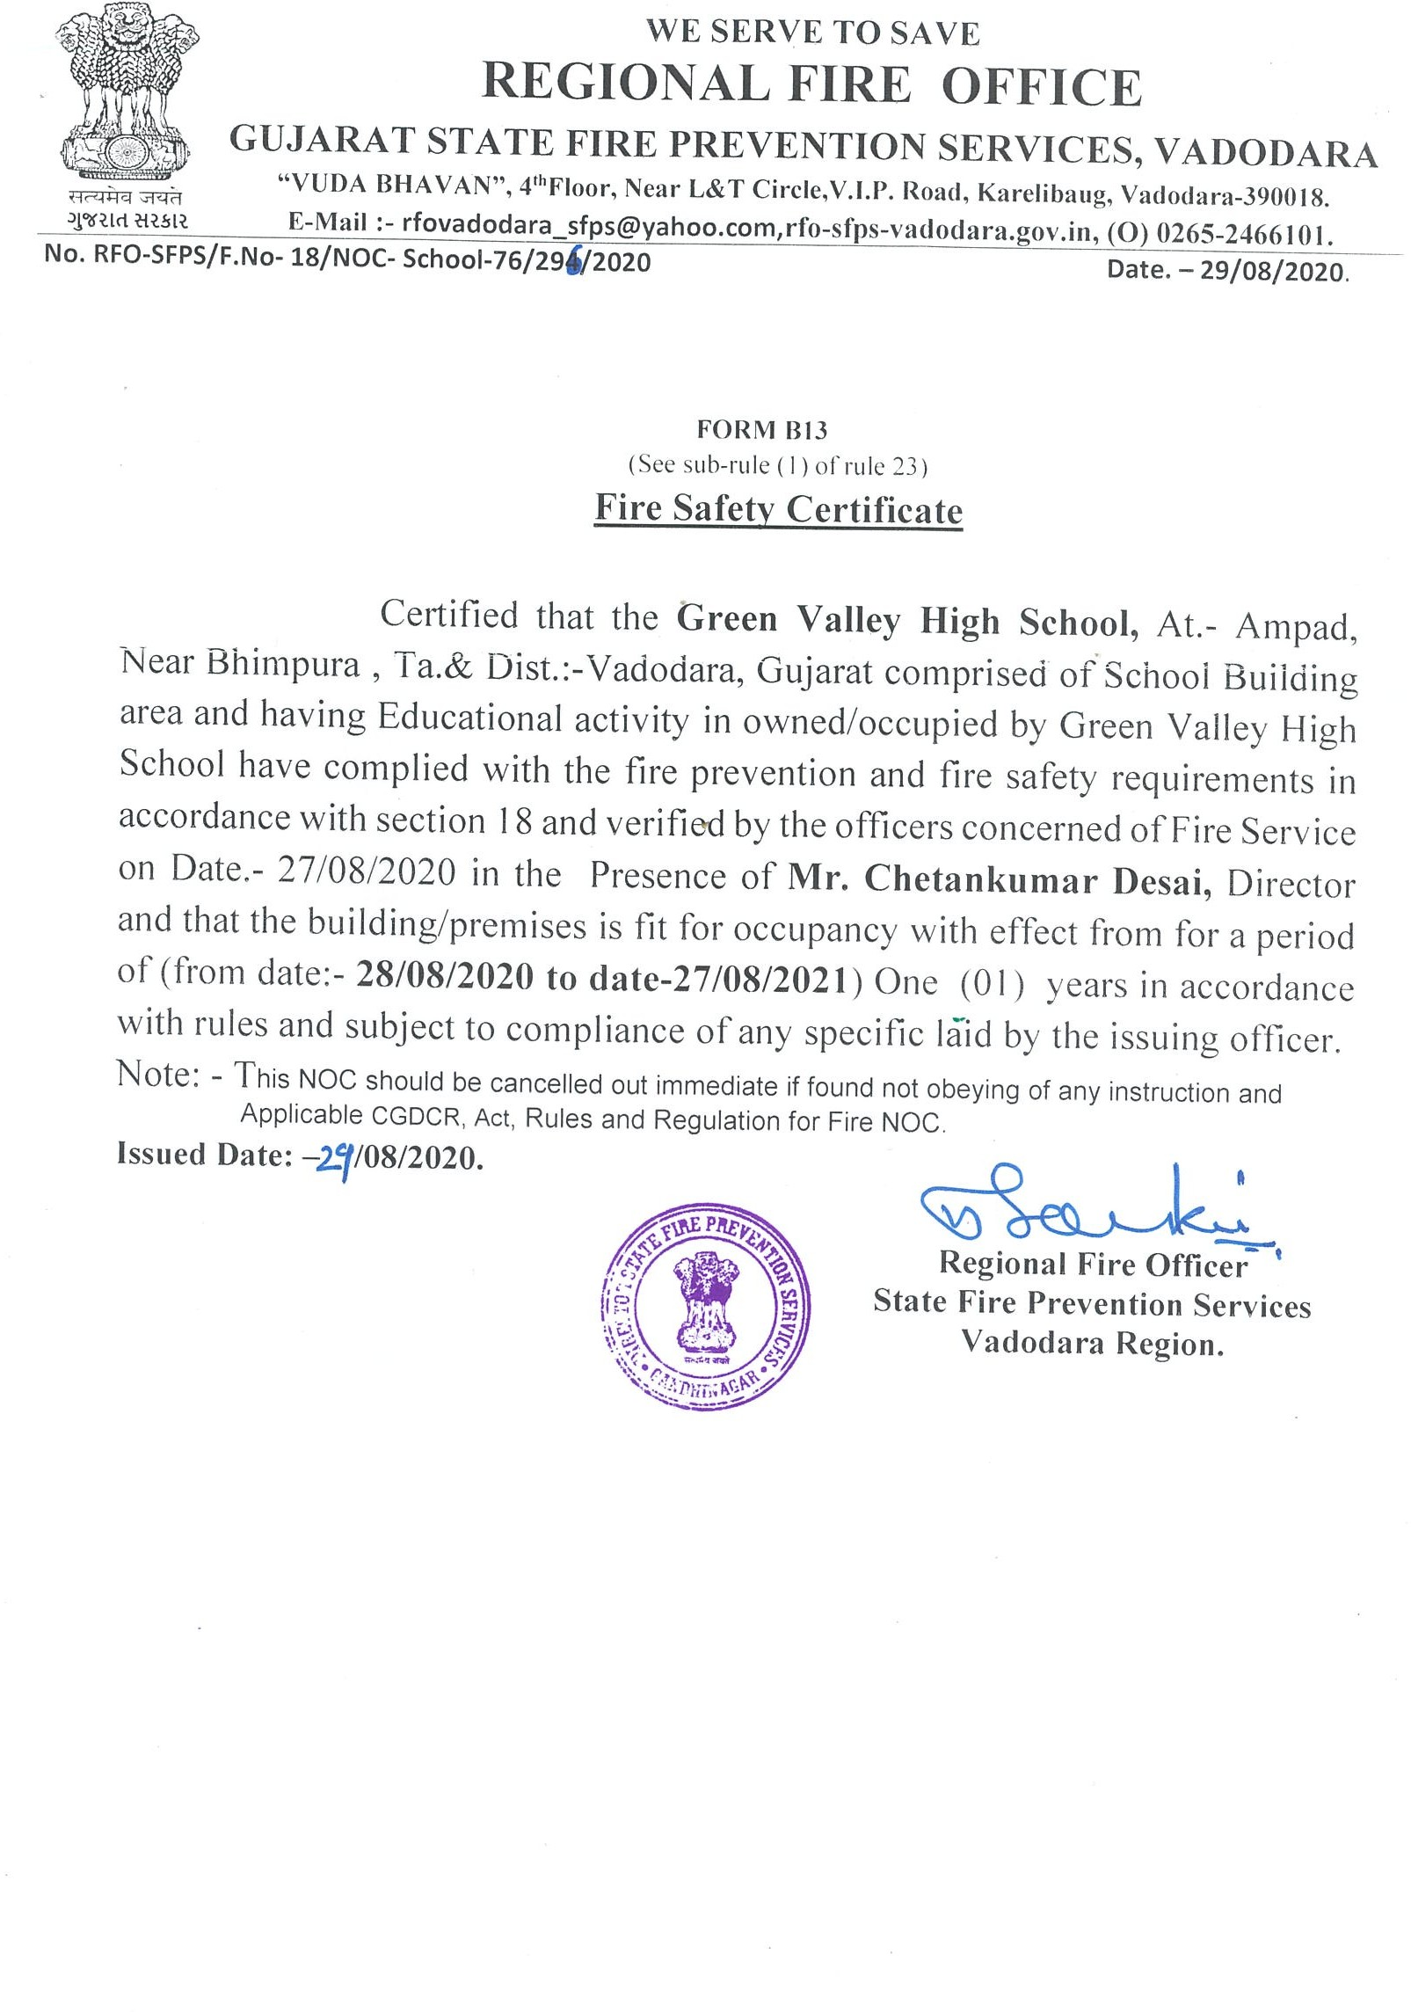

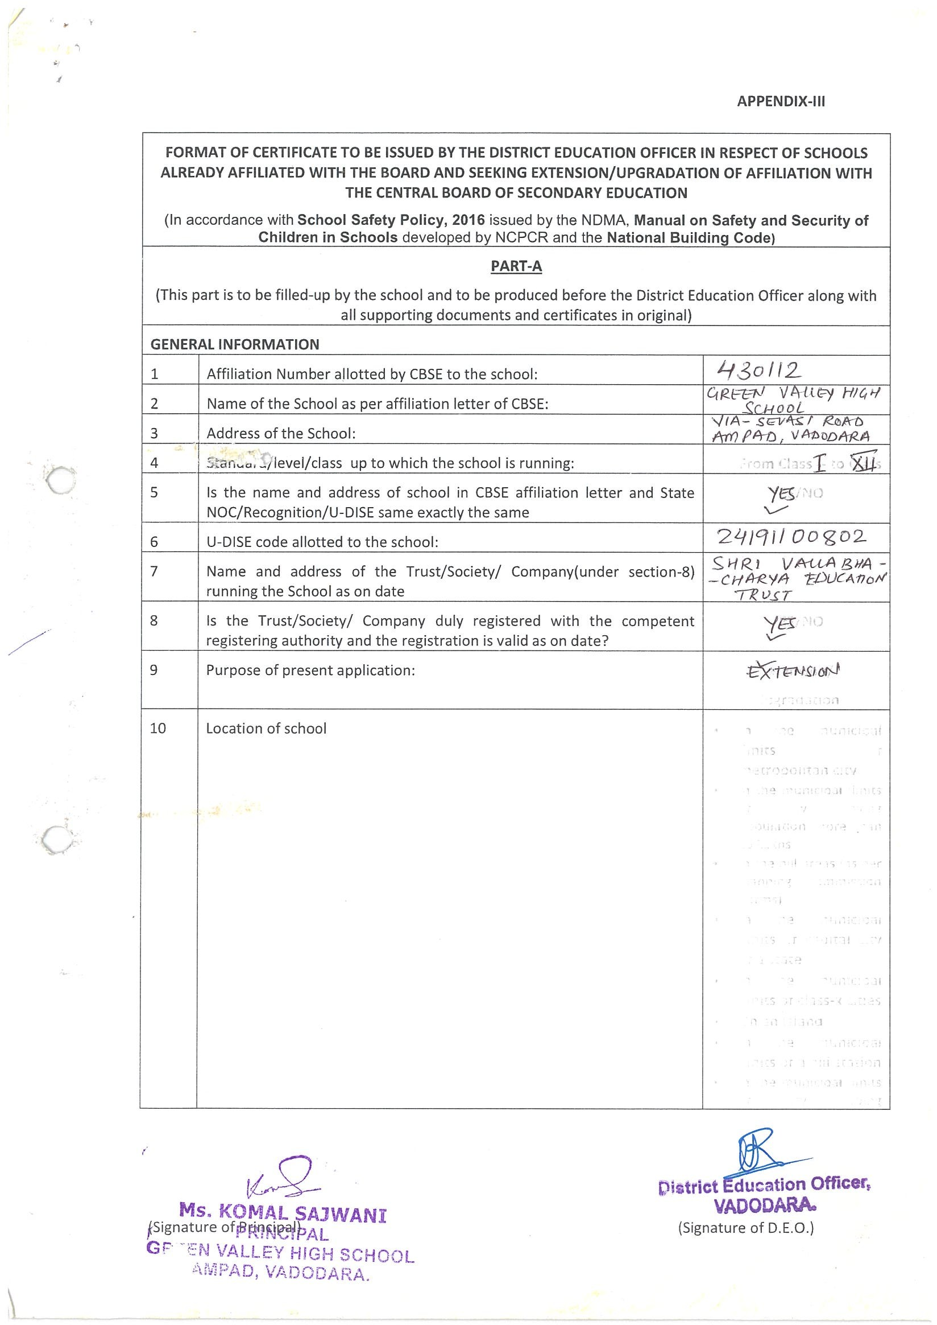

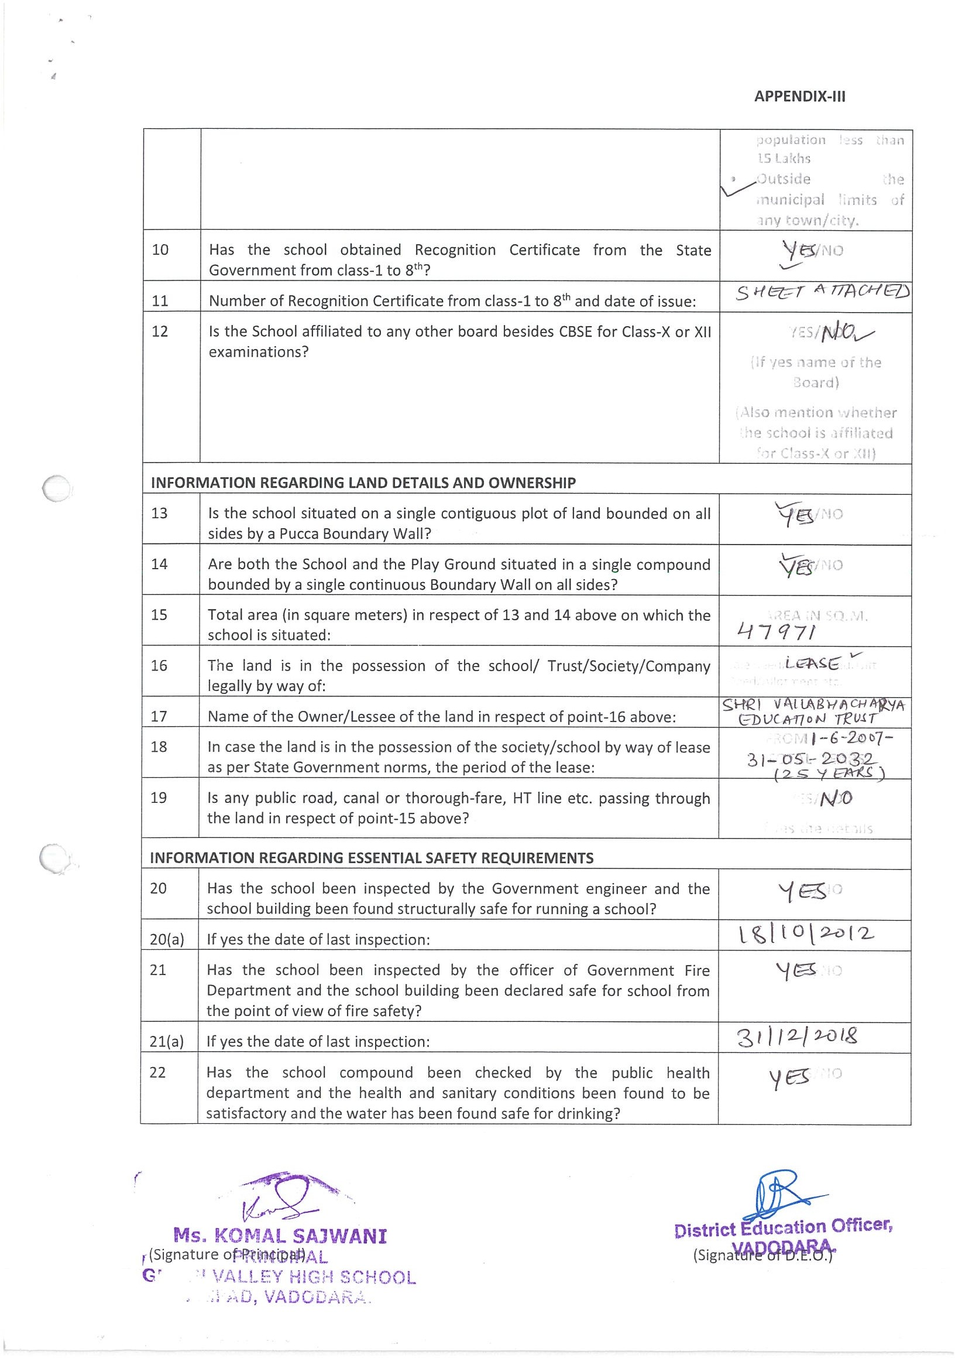

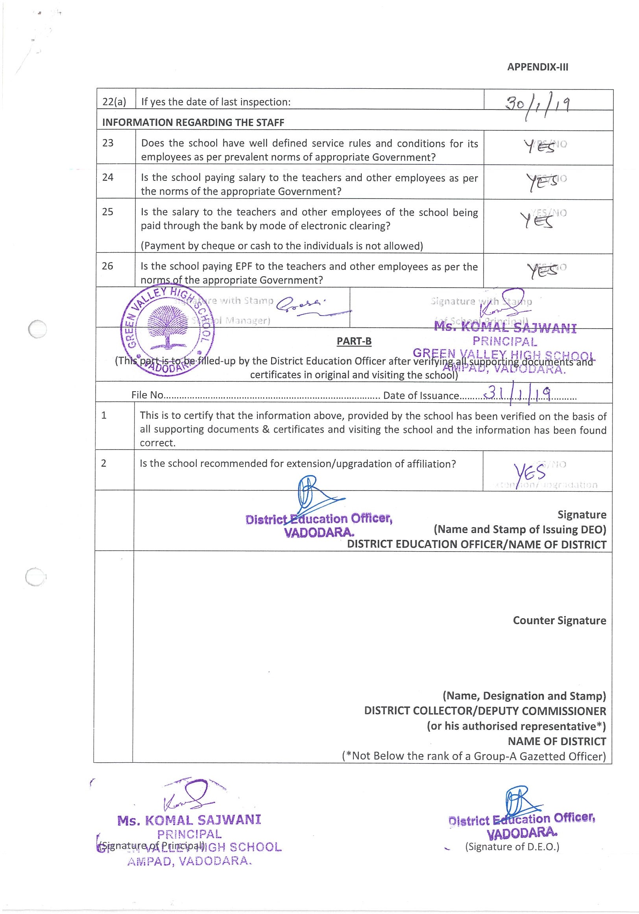

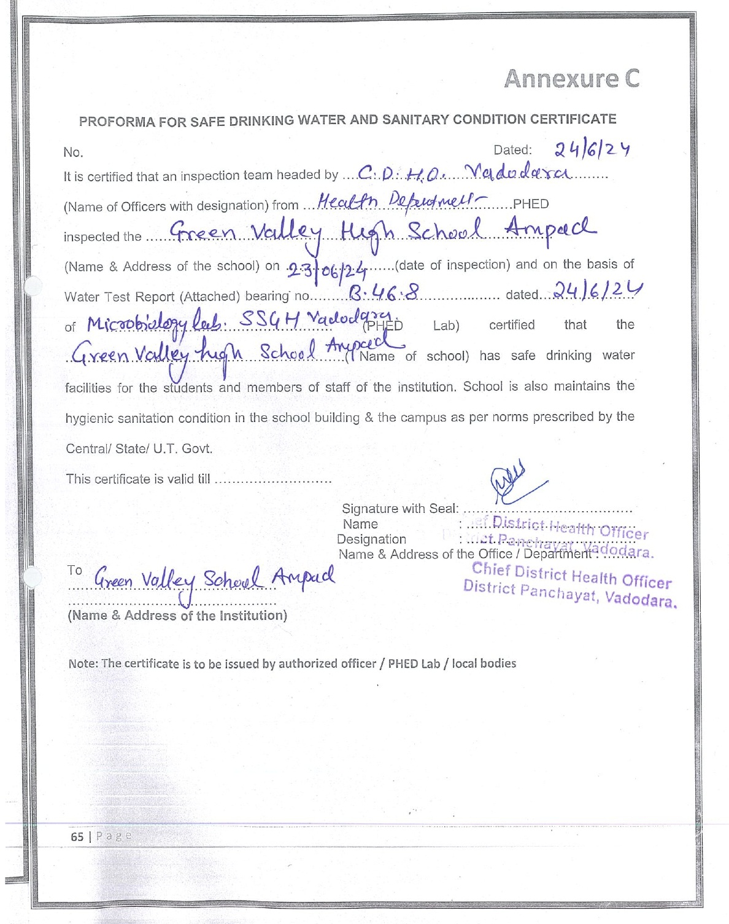

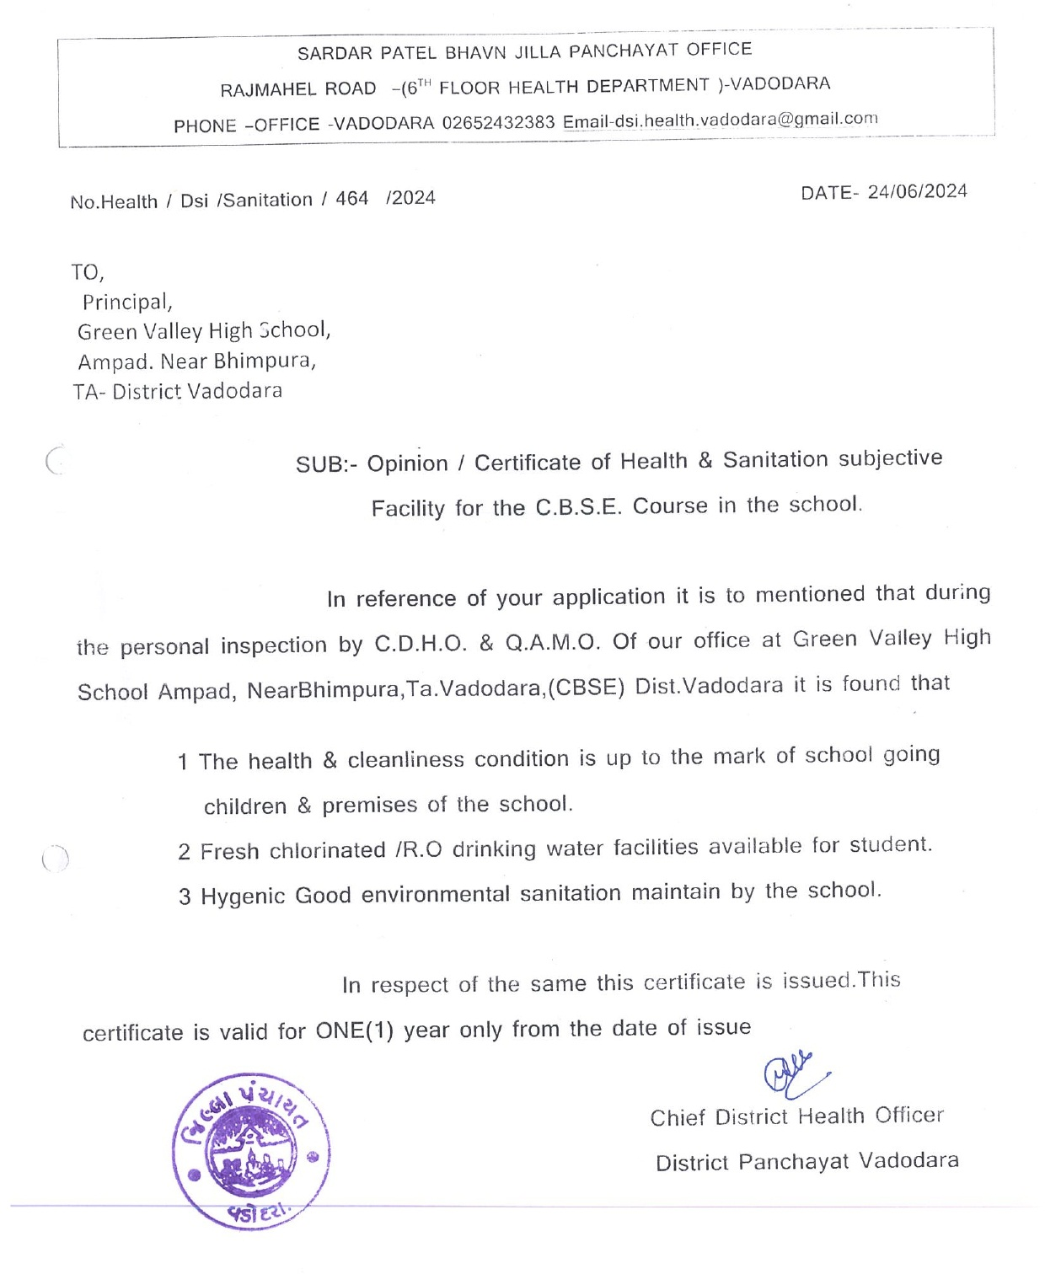
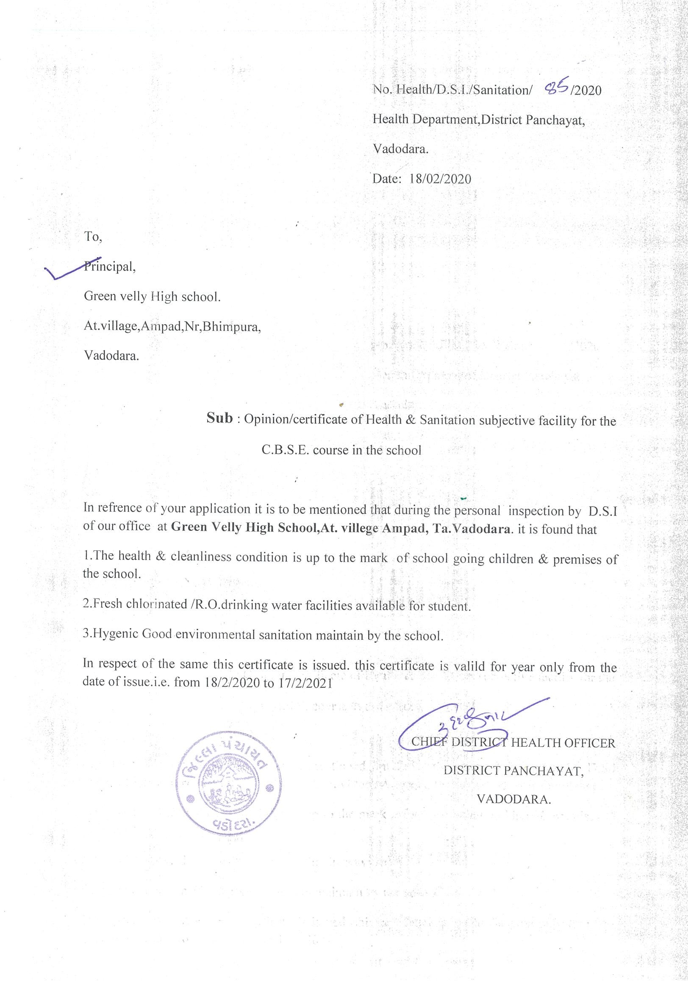

C : RESULT AND ACADEMICS :

SL NO | DOCUMENTS/INFORMATION | LINKS OF UPLOADED DOCUMENTS ON YOUR SCHOOL'S WEBSITE
1 | FEE STRUCTURE OF THE SCHOOL | PDF Attached --
2 | ANNUAL ACADEMIC CALENDER | PDF Attached
3 | LIST OF SCHOOL MANAGEMENT COMMITTEE (SMC) | PDF Attached --
4 | LIST OF PARENTS TEACHERS ASSOCIATION (PTA) MEMBERS | PDF Attached --
5 | LAST THREE-YEAR RESULT OF THE BOARD EXAMINATION AS PER APPLICABILITY | PDF Attached

C. 1. FEE STRUCTURE OF THE SCHOOL ( 2024- 25 ) - Inserting Later

C. 2. ANNUAL ACADEMIC CALENDER
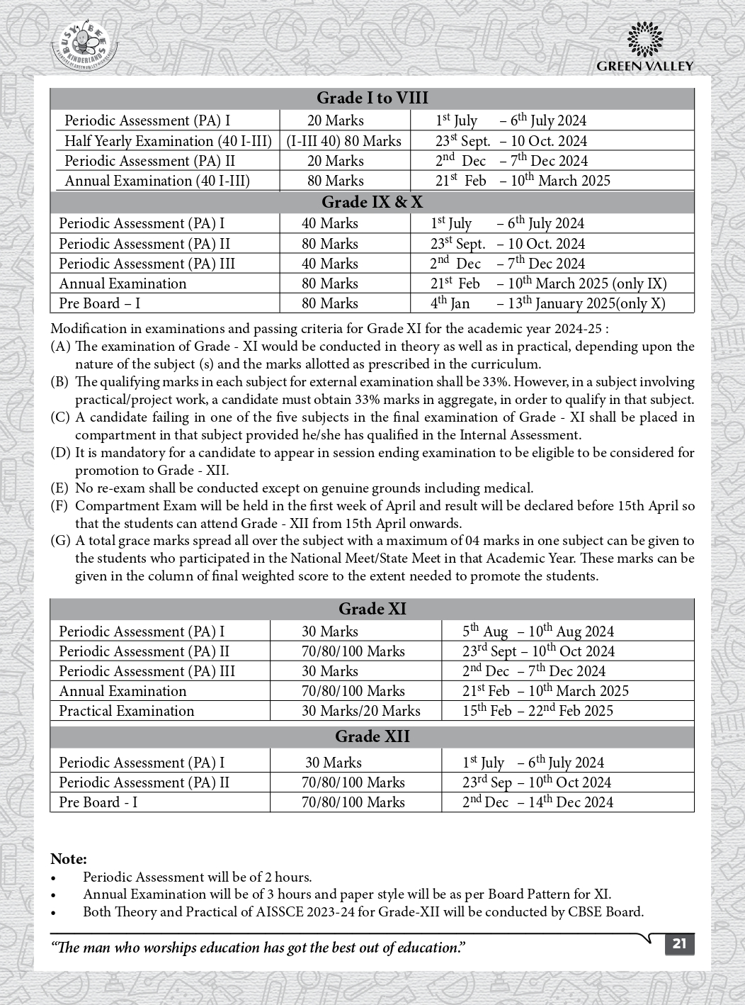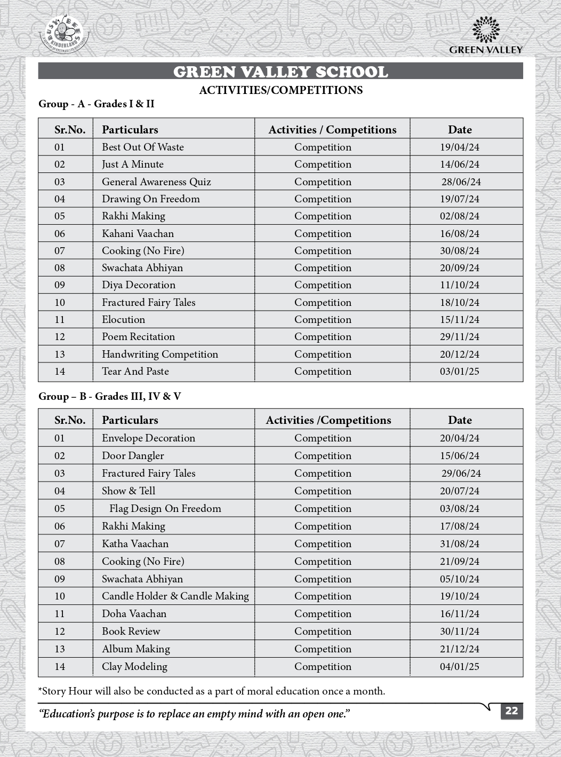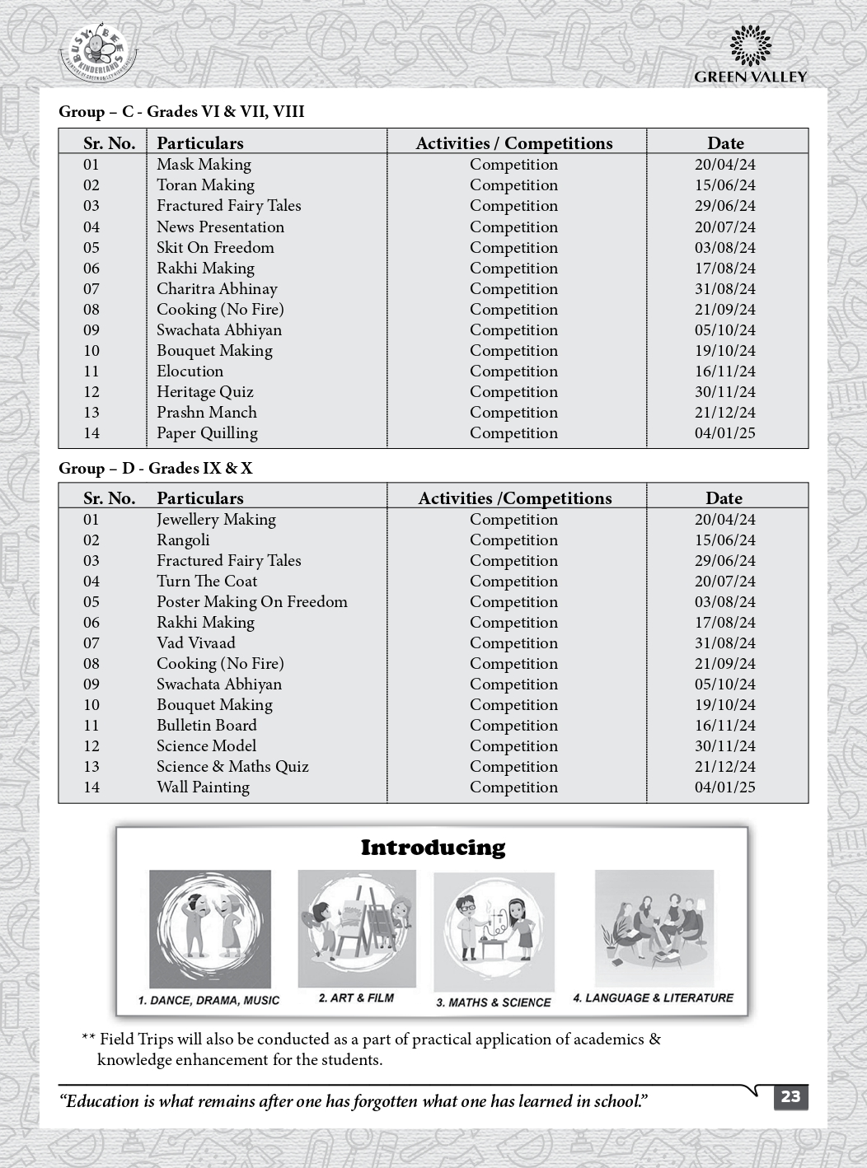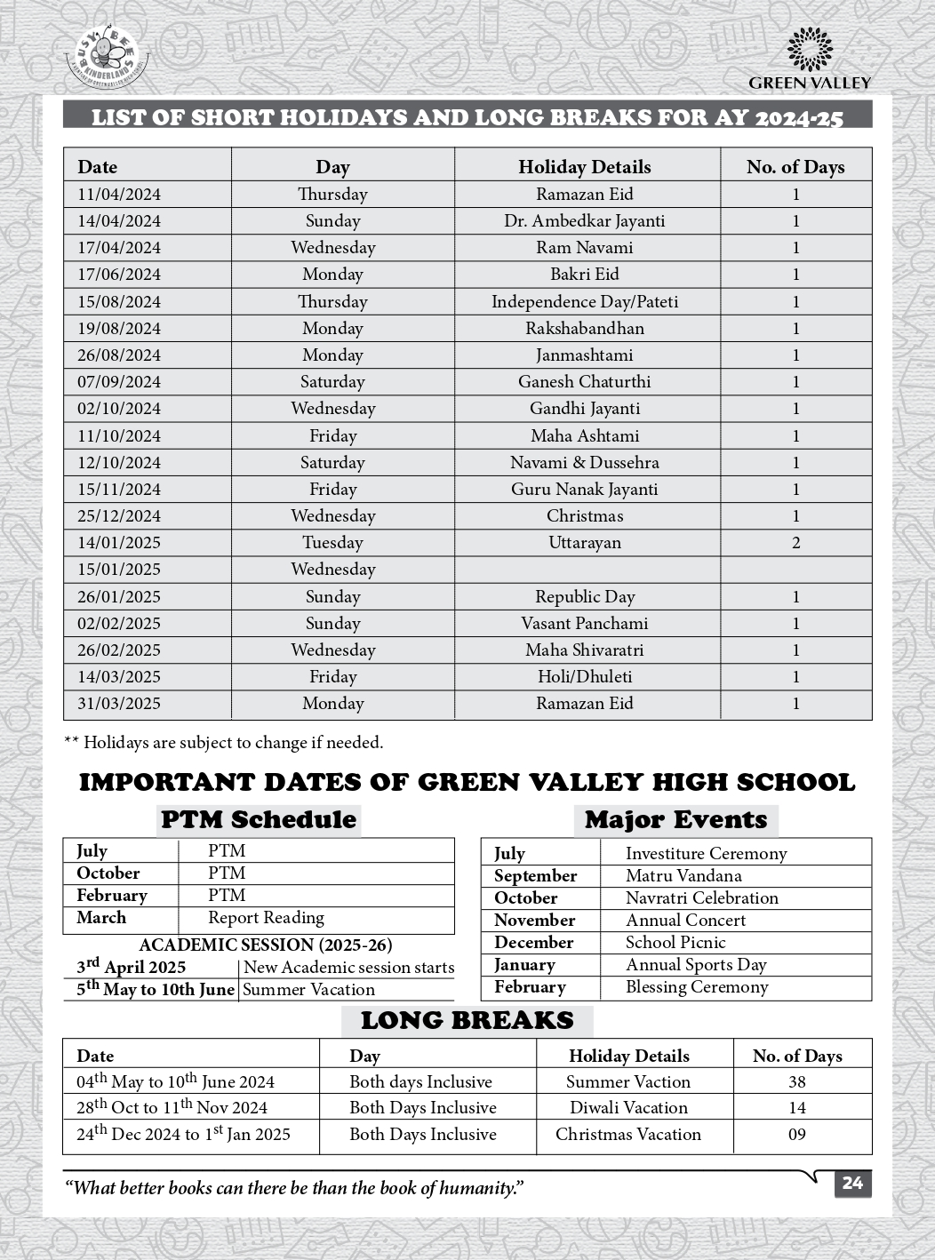

C. 3. LIST OF SCHOOL MANAGEMENT COMMITTEE (SMC)

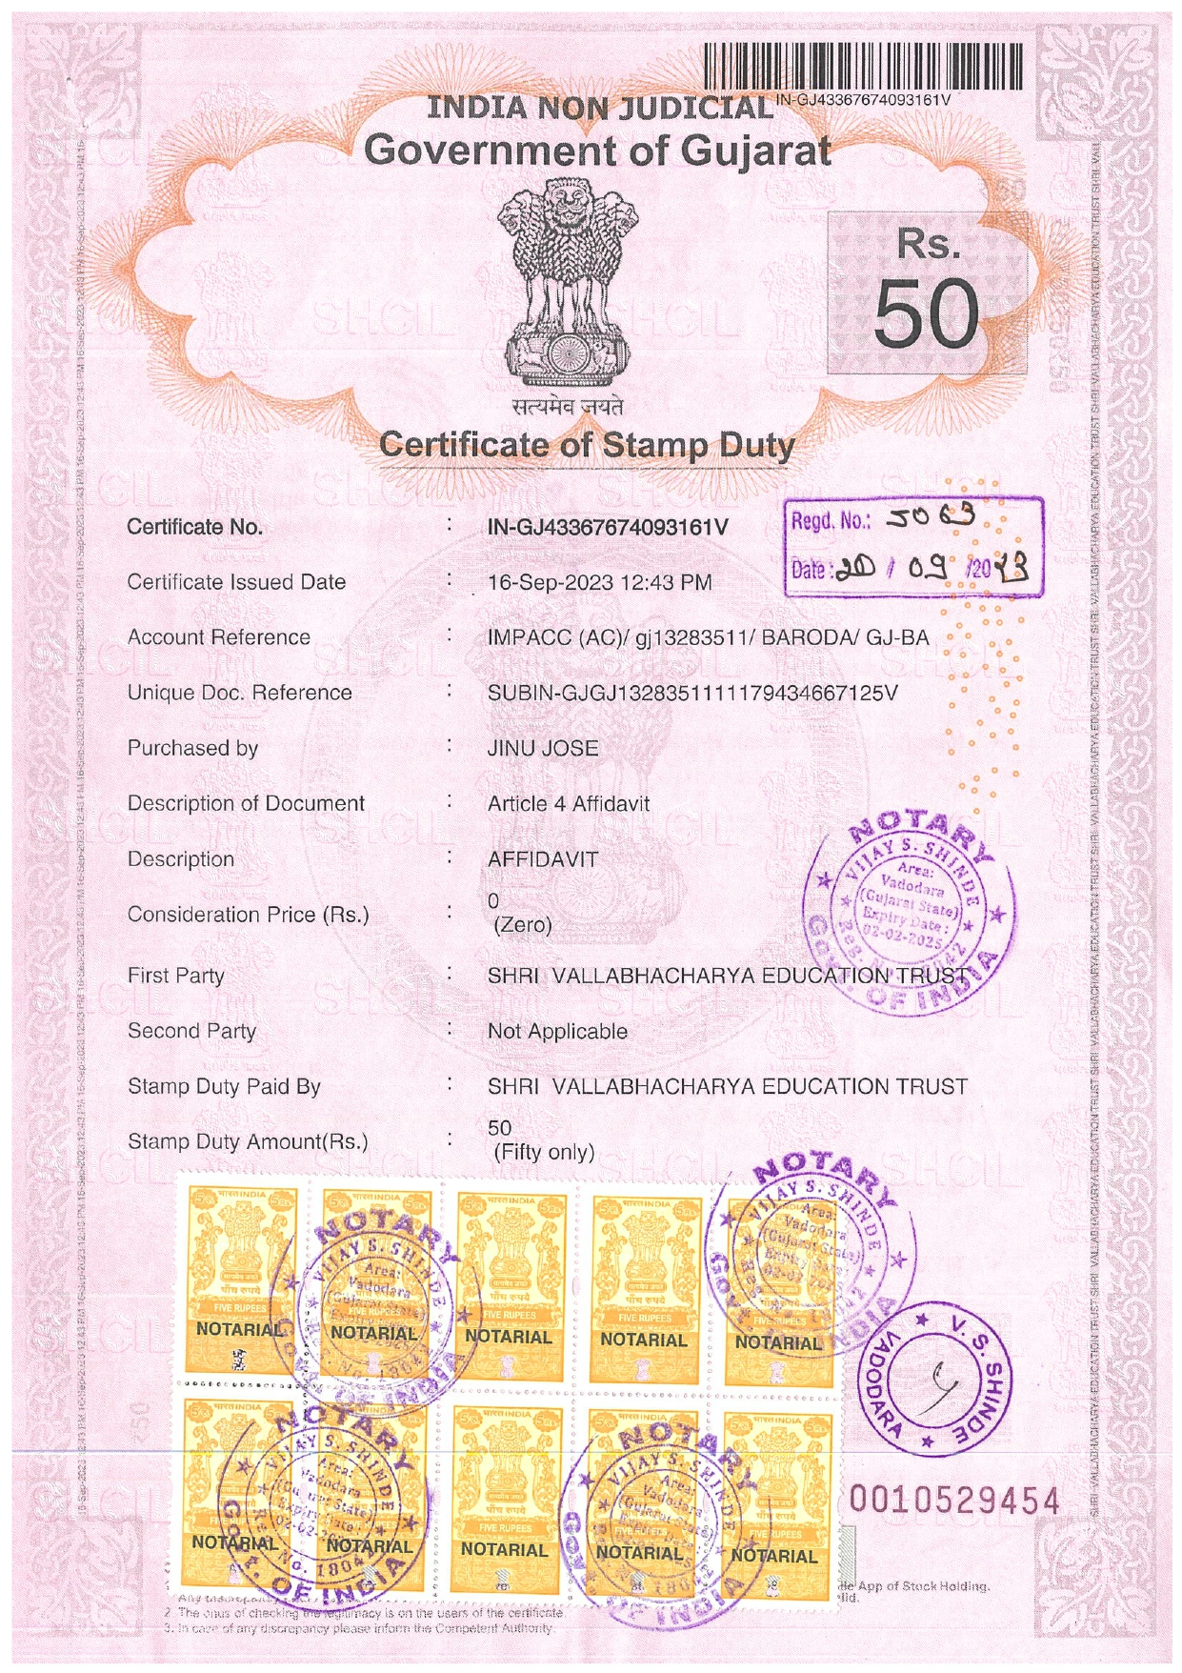

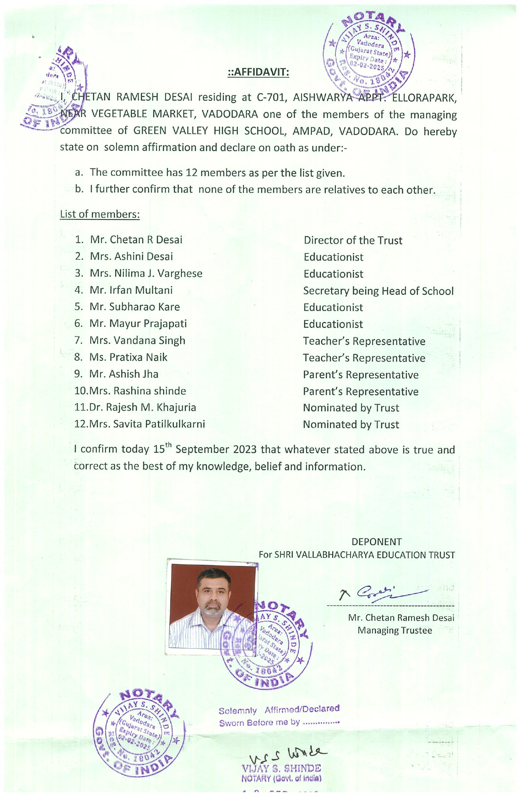

C. 4. LIST OF PARENTS TEACHERS ASSOCIATION (PTA) MEMBERS

C. 5. LAST THREE-YEAR RESULT OF THE BOARD EXAMINATION AS PER
APPLICABILITY

RESULT of CLASS: X

Sl. No. | YEAR | NO. OF REGISTERED STUDENTS | NO. OF PASSED STUDENTS | PASS PERCENTAGE | REMARKS
1. | 2020-21 | 34 | 34 | 100
2. | 2021-22 | 38 | 37 | 97.3
3. | 2022-23 | 37 | 37 | 100
4. | 2023-24 | 51 | 50 | 98.04

RESULT of CLASS XII:

Sl. No. | YEAR | NO. OF REGISTERED STUDENTS | NO. OF PASSED STUDENTS | PASS PERCENTAGE | REMARKS
1. | 2020-21 | 296 | 296 | 100
2. | 2021-22 | 320 | 316 | 98.8
3. | 2022-23 | 266 | 260 | 97.8
4. | 2023-24 | 446 | 398 | 89.24

D : STAFF (TEACHING) :

SL NO | INFORMATION | DETAILS
1 | PRINCIPAL | IRFAN MULTANI
2 | TOTAL NO. OF TEACHERS 49  PGT 27  TGT 14  PRT 8
3 | TEACHERS SECTION RATIO | 1.5:1
4 | DETAILS OF SPECIAL EDUCATOR | UJALA FADIA
5 | DETAILS OF COUNSELLOR AND WELLNESS TEACHER | UJALA FADIA

E : SCHOOL INFRASTRUCTURE:

SL NO | INFORMATION | DETAILS
1 | TOTAL CAMPUS AREA OF THE SCHOOL (IN SQ MTR) | 47971
2 | NO. AND SIZE OF THE CLASS ROOMS (IN SQ MTR) | 37 & 56
3 | NO. AND SIZE OF LABORATORIES INCLUDING COMPUTER LABS (IN SQ MTR) | 9 & 75
4 | INTERNET FACILITY | YES
5 | NO. OF GIRLS TOILETS | 24
6 | NO. OF BOYS TOILETS | 48
7 | LINK OF YOUTUBE VIDEO OF THE  INSPECTION OF SCHOOL COVERING THE INFRASTRUCTURE OF THE SCHOOL | Green Valley High School : CBSE Inspection 2020 - YouTube  Or  In youtube, in search option type  “green valley inspection” .

Teaching staff details in brief :

S.NO | Teacher Name | Gender | Date of Birth | Designation | Qualification
1 | IRFAN KASAM MULTANI | MALE | 07/01/1984 | PRINCIPAL | M.A.,B.ED
2 | JAGRUTI PRAJAPATI | FEMALE | 13/10/1986 | PET | BA,B.PED
3 | KIRAN CHAUHAN | FEMALE | 17/04/1988 | PGT | M.COM, B.ED
4 | BRAHMBHATT BHUMIKA N | FEMALE | 22/02/1998 | PGT | M.SC., B.ED
5 | BAROT DHARMIK NAVINBHAI | MALE | 02/10/1995 | PGT | MASTER OF  PERFORMING ARTS
6 | FESSY JINSON | FEMALE | 14/10/1985 | PGT | M.SC., B.ED
7 | ANISH VASANT | MALE | 08/11/1984 | PGT | MA,MBA,B.ED
8 | HITESH DHANJIBHAI PARMAR | MALE | 13/10/1975 | PGT | MPED
9 | JALPA JAGTAP | FEMALE | 27/03/1995 | PGT | M.SC. B.ED
10 | RAJAN K SANKARAN | MALE | 05/05/1961 | PGT | M.SC. B.ED
11 | ASHISH DANI | MALE | 11/03/1974 | PGT | M.SC. B.ED
12 | RADHIKA SHAH | FEMALE | 18/03/1998 | PGT | M.SC. B.ED
13 | POOJA A KANSARA | FEMALE | 20/10/1985 | PGT | M.SC. B.ED
14 | RAJESHKUMAR SOLANKI | MALE | 07/03/1995 | PGT | M.SC. B.ED
15 | RUPESH S DAVE | MALE | 25/06/1969 | PGT | MCA
16 | ELIZABETH RUPESH GOSAIN | FEMALE | 29/06/1989 | PGT | MA, B.ED
17 | KAUSHAL VALAND | MALE | 07/06/1997 | PGT | M.SC. ,B.ED
18 | KEVIN MATHEWS | MALE | 11/02/1999 | PGT | M.P.ED
19 | JINCY RAJU | FEMALE | 19/11/1986 | PGT | M.E., B.ED
20 | SADHU PARULBEN BALAKDAS | FEMALE | 14/07/1986 | PGT | M.A, B.ED
21 | MINOO OMPRAKASH PAL | FEMALE | 29/10/1972 | PGT | M.A., B.ED
22 | MITESHKUMAR AMBALAL VARIA | MALE | 30/05/1982 | PGT | M.SC, B.ED
23 | SUNIL VANJANI | MALE | 22/03/1974 | PGT | M.SC. ,B.ED
24 | KHUSHI NAVLANI | FEMALE | 07/04/1985 | PGT | M.A., B.ED
25 | SANJIT KUMAR MUKHOPADHYAYA | MALE | 12/02/1983 | PGT | M.SC. ,B.ED
26 | NIRALI KANSAGRA | FEMALE | 29/07/1993 | PGT | M.SC. ,B.ED
27 | PRATIXA PRAKASHCHANDRA NAIK | FEMALE | 03/10/1992 | PGT | M.COM, B.ED
28 | KISHORBHAI TRIBHOVANBHAI  RAVAL | MALE | 26/01/1983 | PGT | M.SC. ,B.ED
29 | ABHISHEK AYARE | MALE | 23/03/1985 | PGT | M.C.A
30 | AASHISH JHA | MALE | 19/09/1989 | PGT | M.A. PHYSICAL  EDUCATION
31 | BRIJESH PATEL | MALE | 18/05/1988 | PGT | M.PED
32 | SOJU GEORGE | MALE | 11/01/1983 | PGT | M.TECH, B.ED
33 | VANDANA SINGH | FEMALE | 14/08/1982 | PGT | M.SC. ,B.ED
34 | CHANDNI LINESH DAVE | FEMALE | 11/02/1978 | TGT | BACHELOR OF FINE  ARTS
35 | NISHI GAUR | FEMALE | 05/05/1984 | TGT | B.SC., B.ED
36 | VARSHA VAZE | FEMALE | 20/03/1972 | TGT | B.COM., B.ED
37 | RIZVANA MULTAINI | FEMALE | 24/11/1988 | TGT | B.A., B.ED
38 | ZAINAB HUSENI CHOTHIYAWALA | FEMALE | 31/01/2001 | TGT | M.A., B.ED
39 | RUKMINI ABHISHEK DUBEY | FEMALE | 17/07/1994 | TGT | M.SC., B.ED
40 | PRAKASH CHAUHAN | MALE | 22/09/1982 | TGT | B.A., B.ED
41 | VASAVA HIRAL F | FEMALE | 12/04/1992 | TGT | M.A. ,B.ED
42 | ALPA PANDYA | FEMALE | 05/08/1977 | TGT | M.A. ,B.ED
43 | PRASHANT DINDORKAR | MALE | 31/05/1974 | TGT | B.SC,B.ED
44 | KRINA RAHUL AGRAWAL | FEMALE | 30/08/1991 | PRT | B.COM., B.ED
45 | RABIBA SARFARAZ MOHIBI | FEMALE | 28/07/1975 | PRT | B.COM.,B.ED
46 | PREXA NIKHIL DAVE | FEMALE | 17/08/1996 | PRT | M.COM.,B.ED
47 | DIVYA RAJKUMAR MAHISURIA | FEMALE | 15/10/1967 | PRT | B.COM,B.ED
48 | JINU JACOB JOSE | MALE | 28/05/1998 | PRT | MBA, B.ED
49 | ARTEE PARMAR | FEMALE | 25/07/1989 | PRT | M.COM, B.ED
50 | ANJANA CHAMOLI | FEMALE | 17/05/1996 | PRT | M.A., B.ED

