APPENDIX -IX MANDATORY PUBLIC DISCLOSURE
A : GENERAL INFORMATION :

SL NO. | INFORMATION | DETAILS
1 | NAME OF THE SCHOOL | GREEN VALLEY HIGH SCHOOL
2 | AFFILIATION NO.(IF APPLICABLE) | 430112
3 | SCHOOL CODE (IF APPLICABLE) | 10098
4 | COMPLETE ADDRESS WITH PIN CODE | Via Sevasi Gotri, Off Effluent Channel road, Ampad, Vadodara, Gujarat, VADODARA  (BARODA) , GUJARAT - 391101
5 | PRINCIPAL NAME | Mrs. KAVERI UNIYAL
6 | PRINCIPAL QUALIFICATION | M.SC, M.A, B.ED
7 | SCHOOL EMAIL ID | greenvalleyhigh@gmail.com
8 | CONTACT DETAILS (LANDLINE/MOBILE) | 09409289929

B : DOCUMENTS AND INFORMATION:

SL NO. | DOCUMENTS/INFORMATION | LINKS OF UPLOADED DOCUMENTS ON YOURSCHOOL'S WEBSITE
1 | COPIES OF AFFILIATION/UPGRADATION LETTER AND RECENT EXTENSION OF AFFILIATION, IF ANY | PDF Attached
2 | COPIES OF SOCIETIES/TRUST/COMPANY REGISTRATION/RENEWAL CERTIFICATE, ASAPPLICABLE | PDF Attached
3 | COPY OF NO OBJECTION CERTIFICATE (NOC)ISSUED, IF APPLICABLE, BY THE STATE GOVT./UT | PDF Attached
4 | COPIES OF RECOGNITION CERTIFICATE UNDER RTE ACT, 2009, AND IT’S RENEWAL IF  APPLICABLE | PDF Attached
5 | COPY OF VALID BUILDING SAFETY CERTIFICATE AS PER THE NATIONALBUILDING CODE | PDF Attached
6 | COPY OF VALID FIRE SAFETY CERTIFICATEISSUED BY THE COMPETENT AUTHORITY | PDF Attached
7 | COPY OF THE SELF CERTIFICATIONSUBMITTED BY THE SCHOOL FOR  AFFILIATION/UPGRADATION/EX TENSION OFAFFILIATION | PDF Attached
8 | COPIES OF VALID WATER, HEALTH AND SANITATION CERTIFICATES | PDF Attached --
NOTE:
THE SCHOOLS NEEDS TO UPLOAD THE SELF ATTESTED COPIES OF ABOVE LISTED DOCUMETNS BY CHAIRMAN/MANAGER/SECRETARY AND PRINCIPAL. IN CASE, IT IS NOTICED AT LATER STAGE THAT UPLOADED DOCUMENTS ARE NOT GENUINE THEN SCHOOL SHALL BE LIABLE FOR ACTION AS PER NORMS.

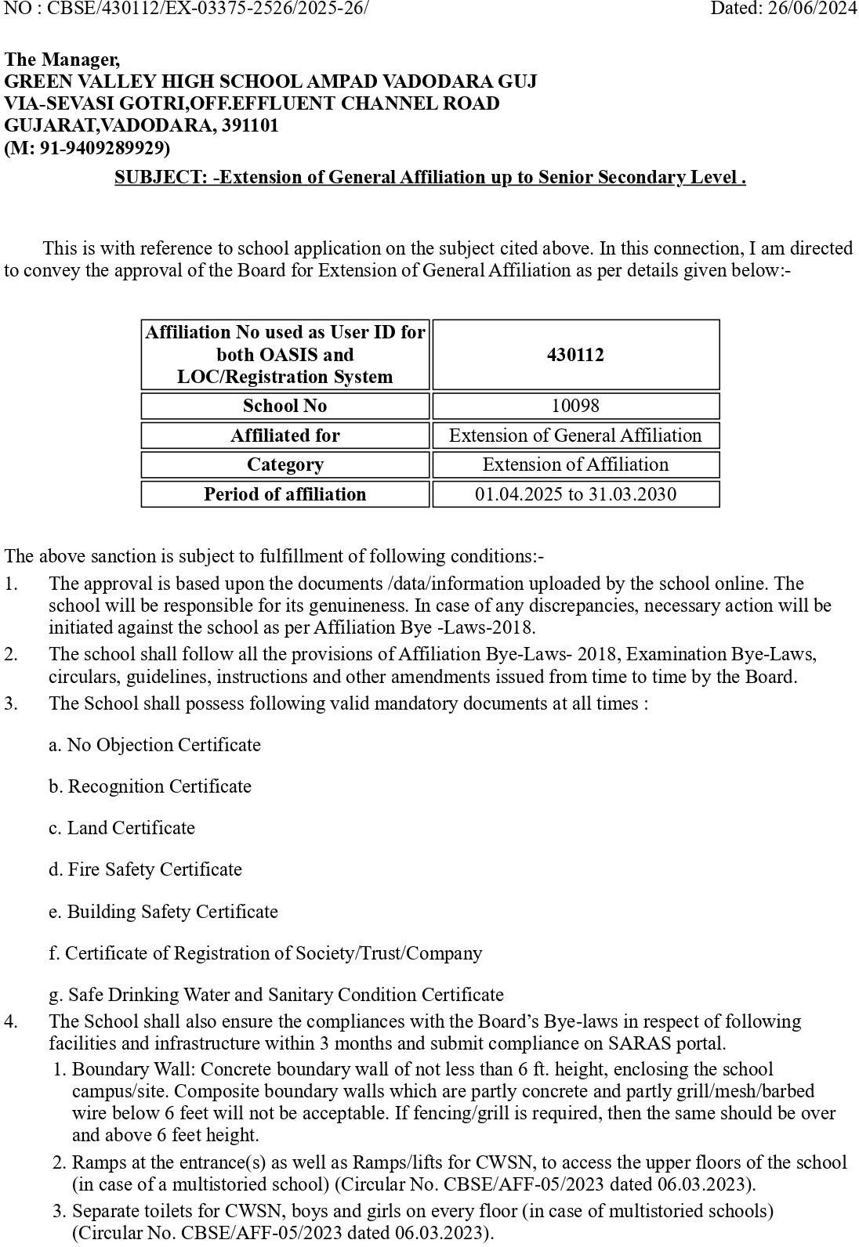

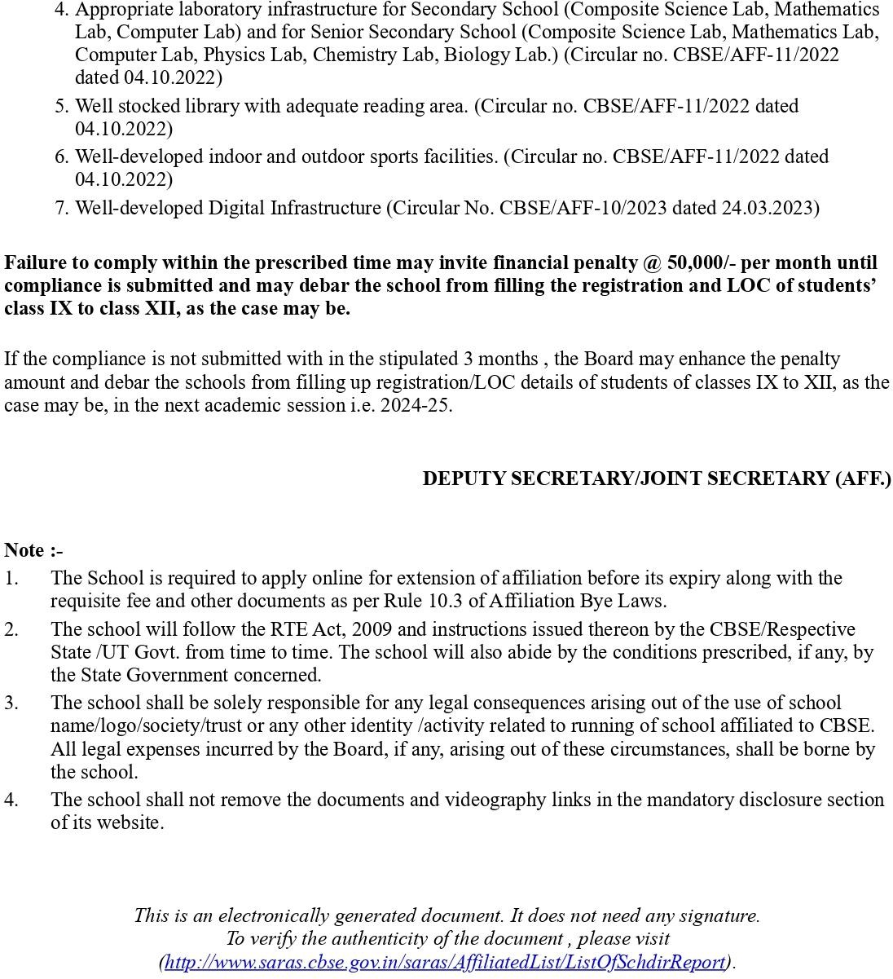

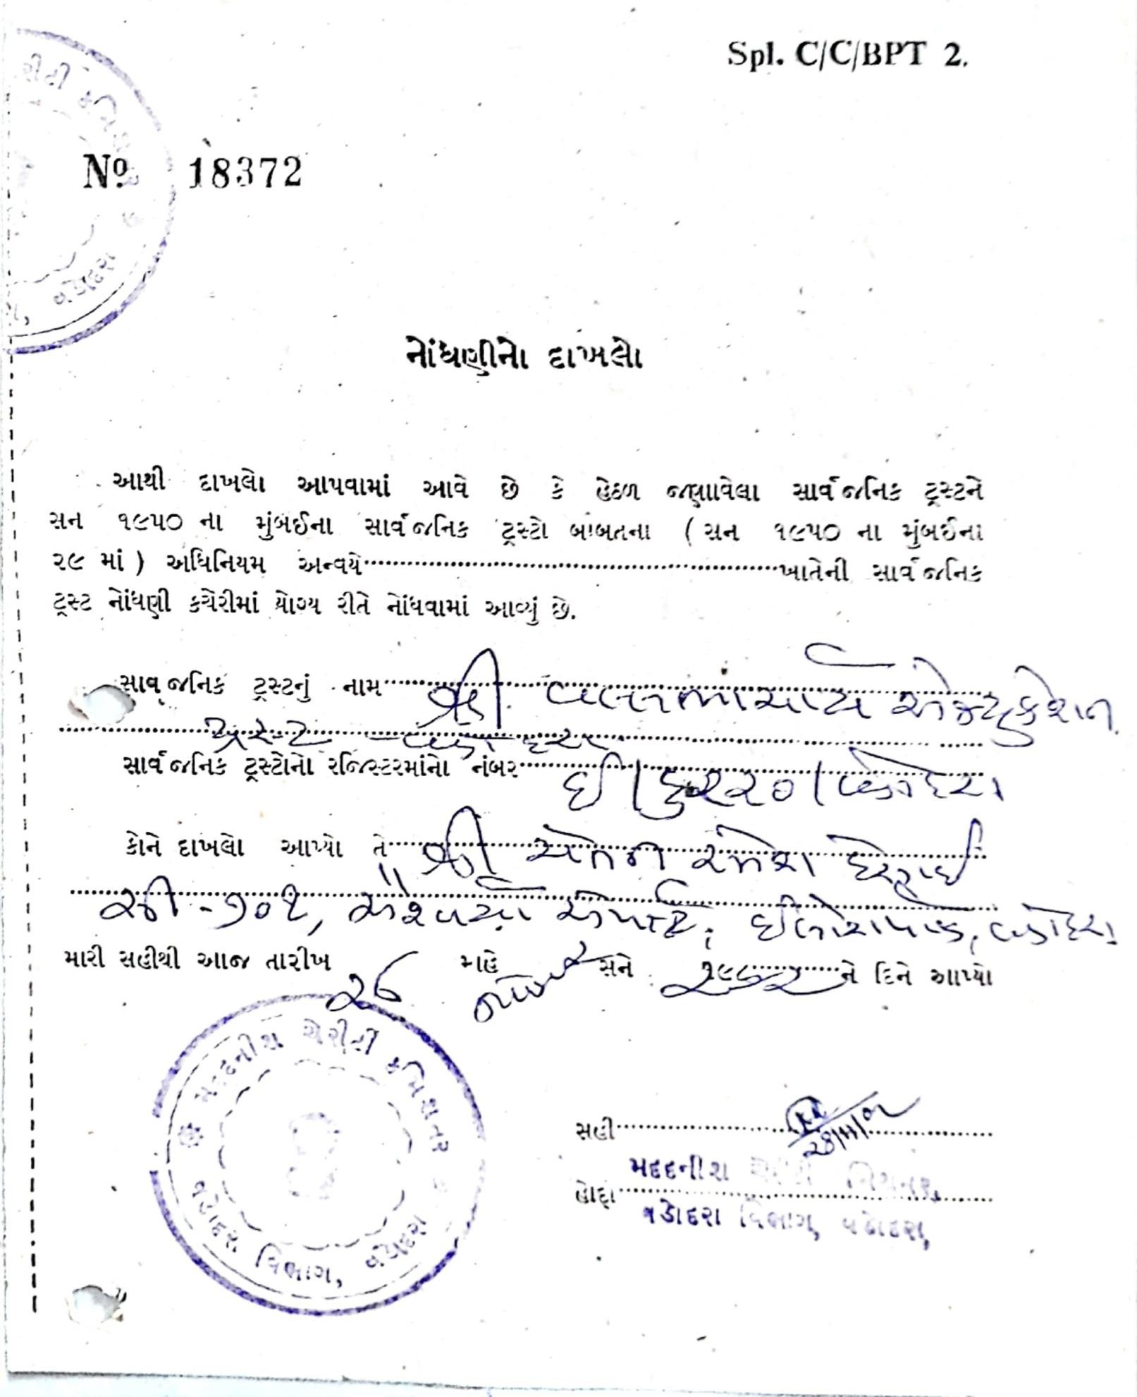

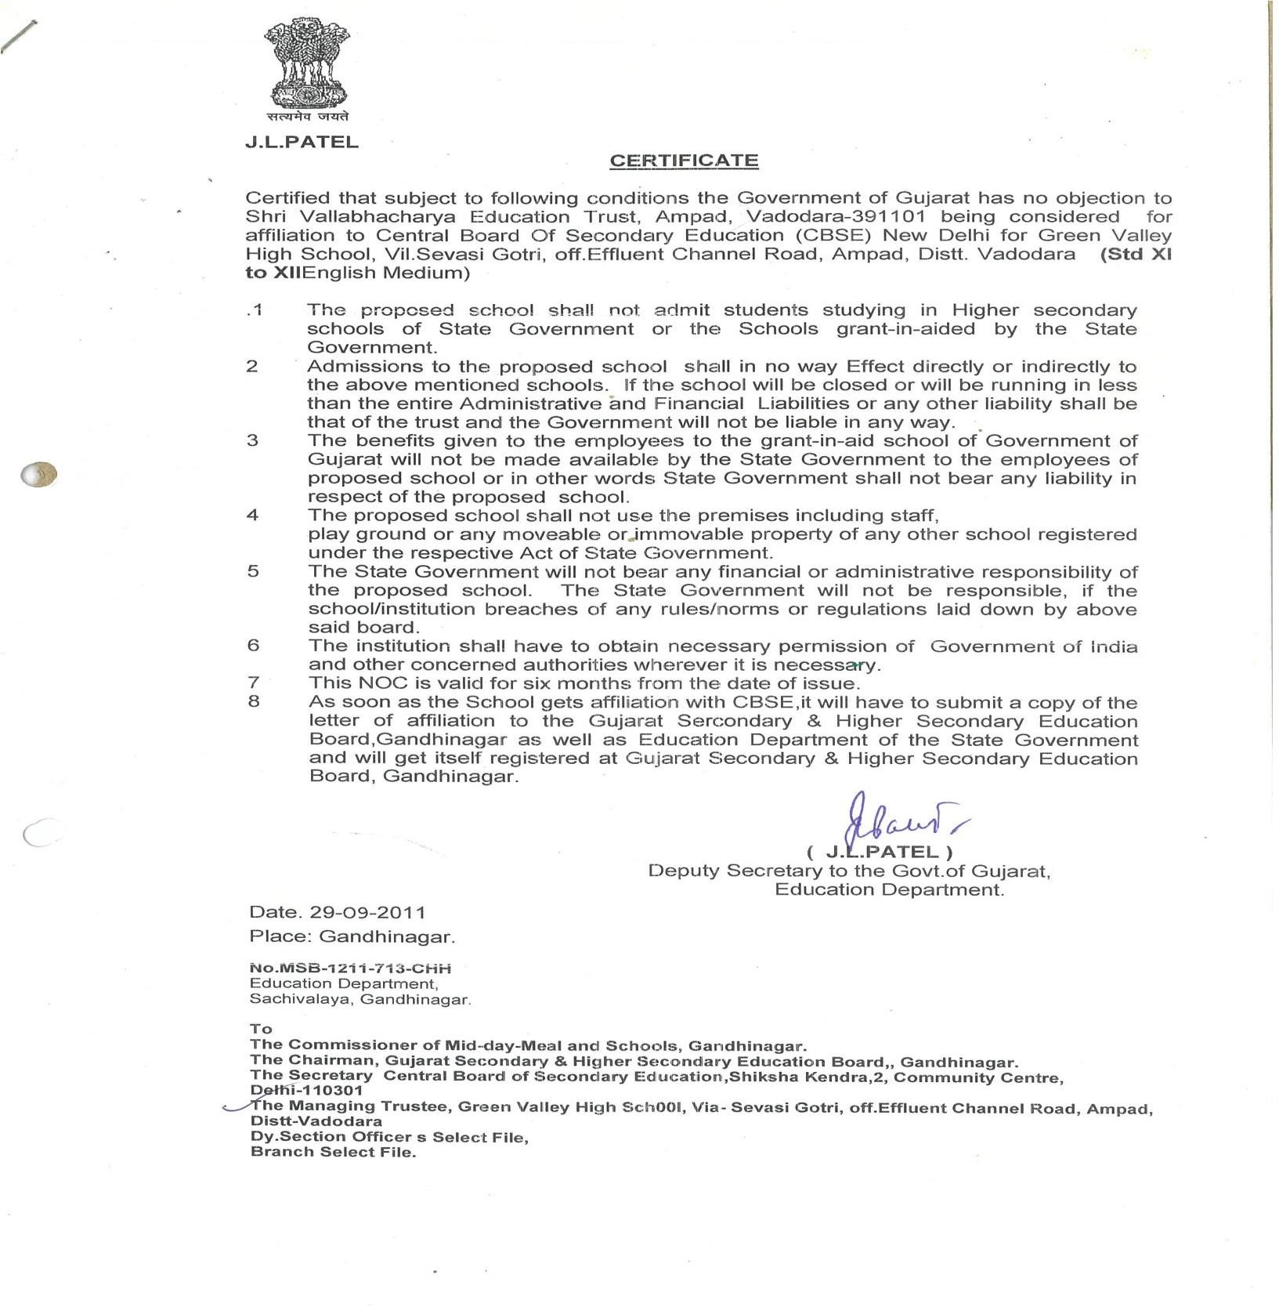

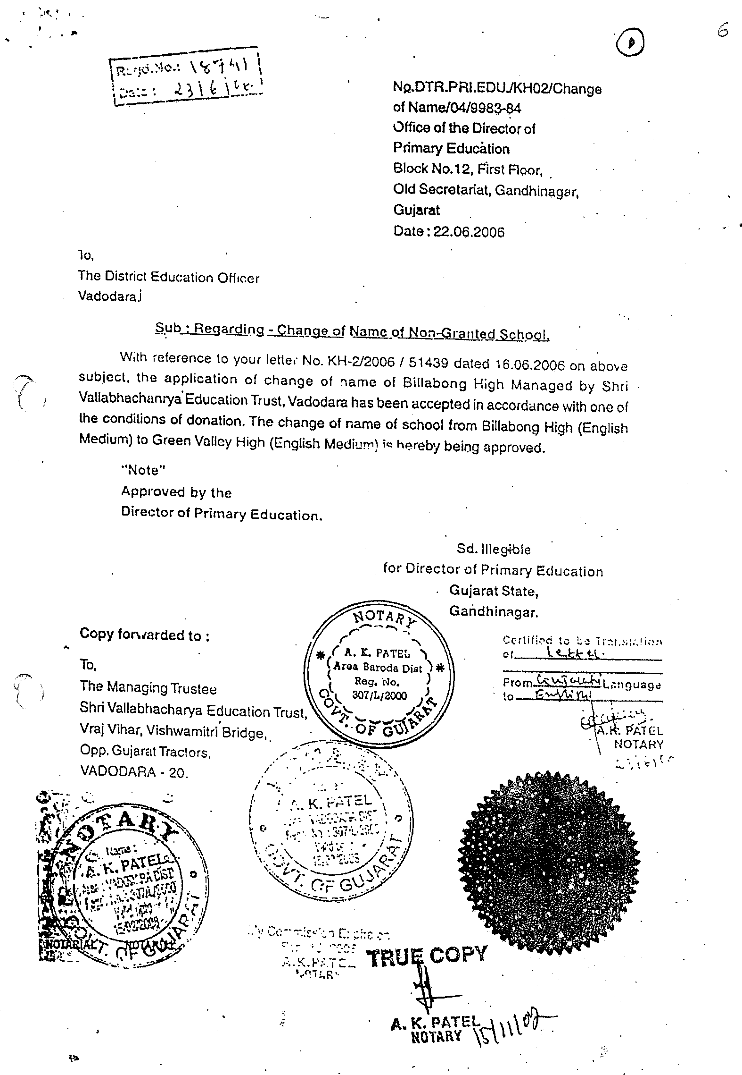

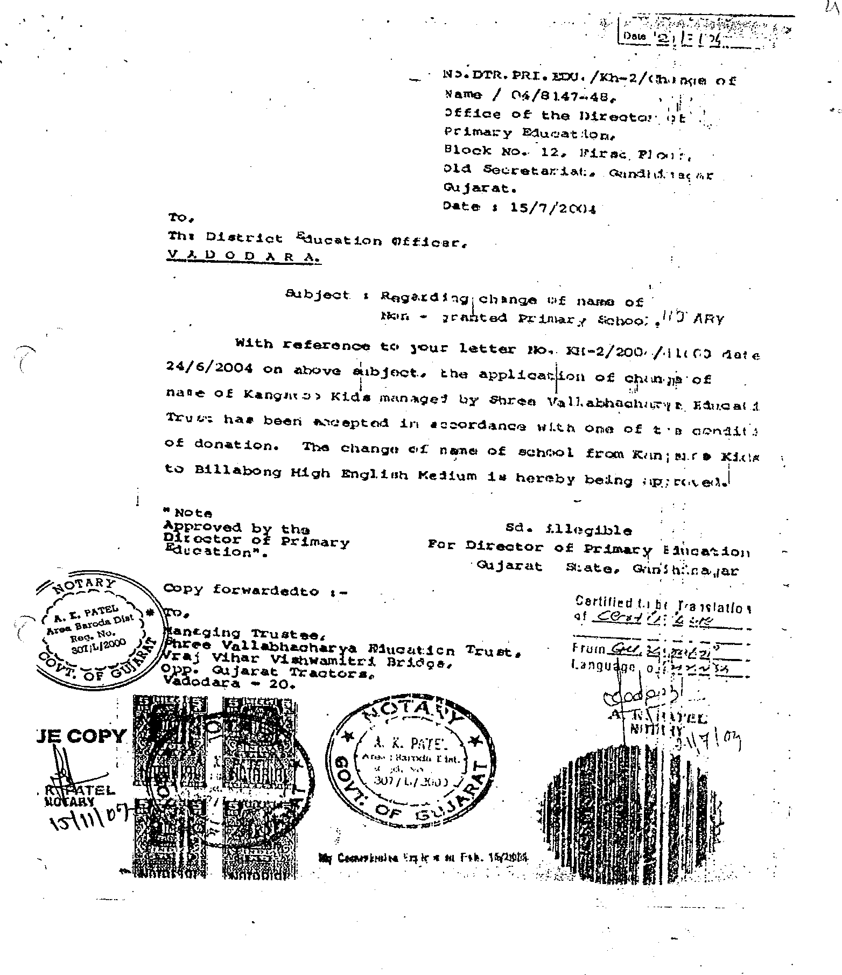

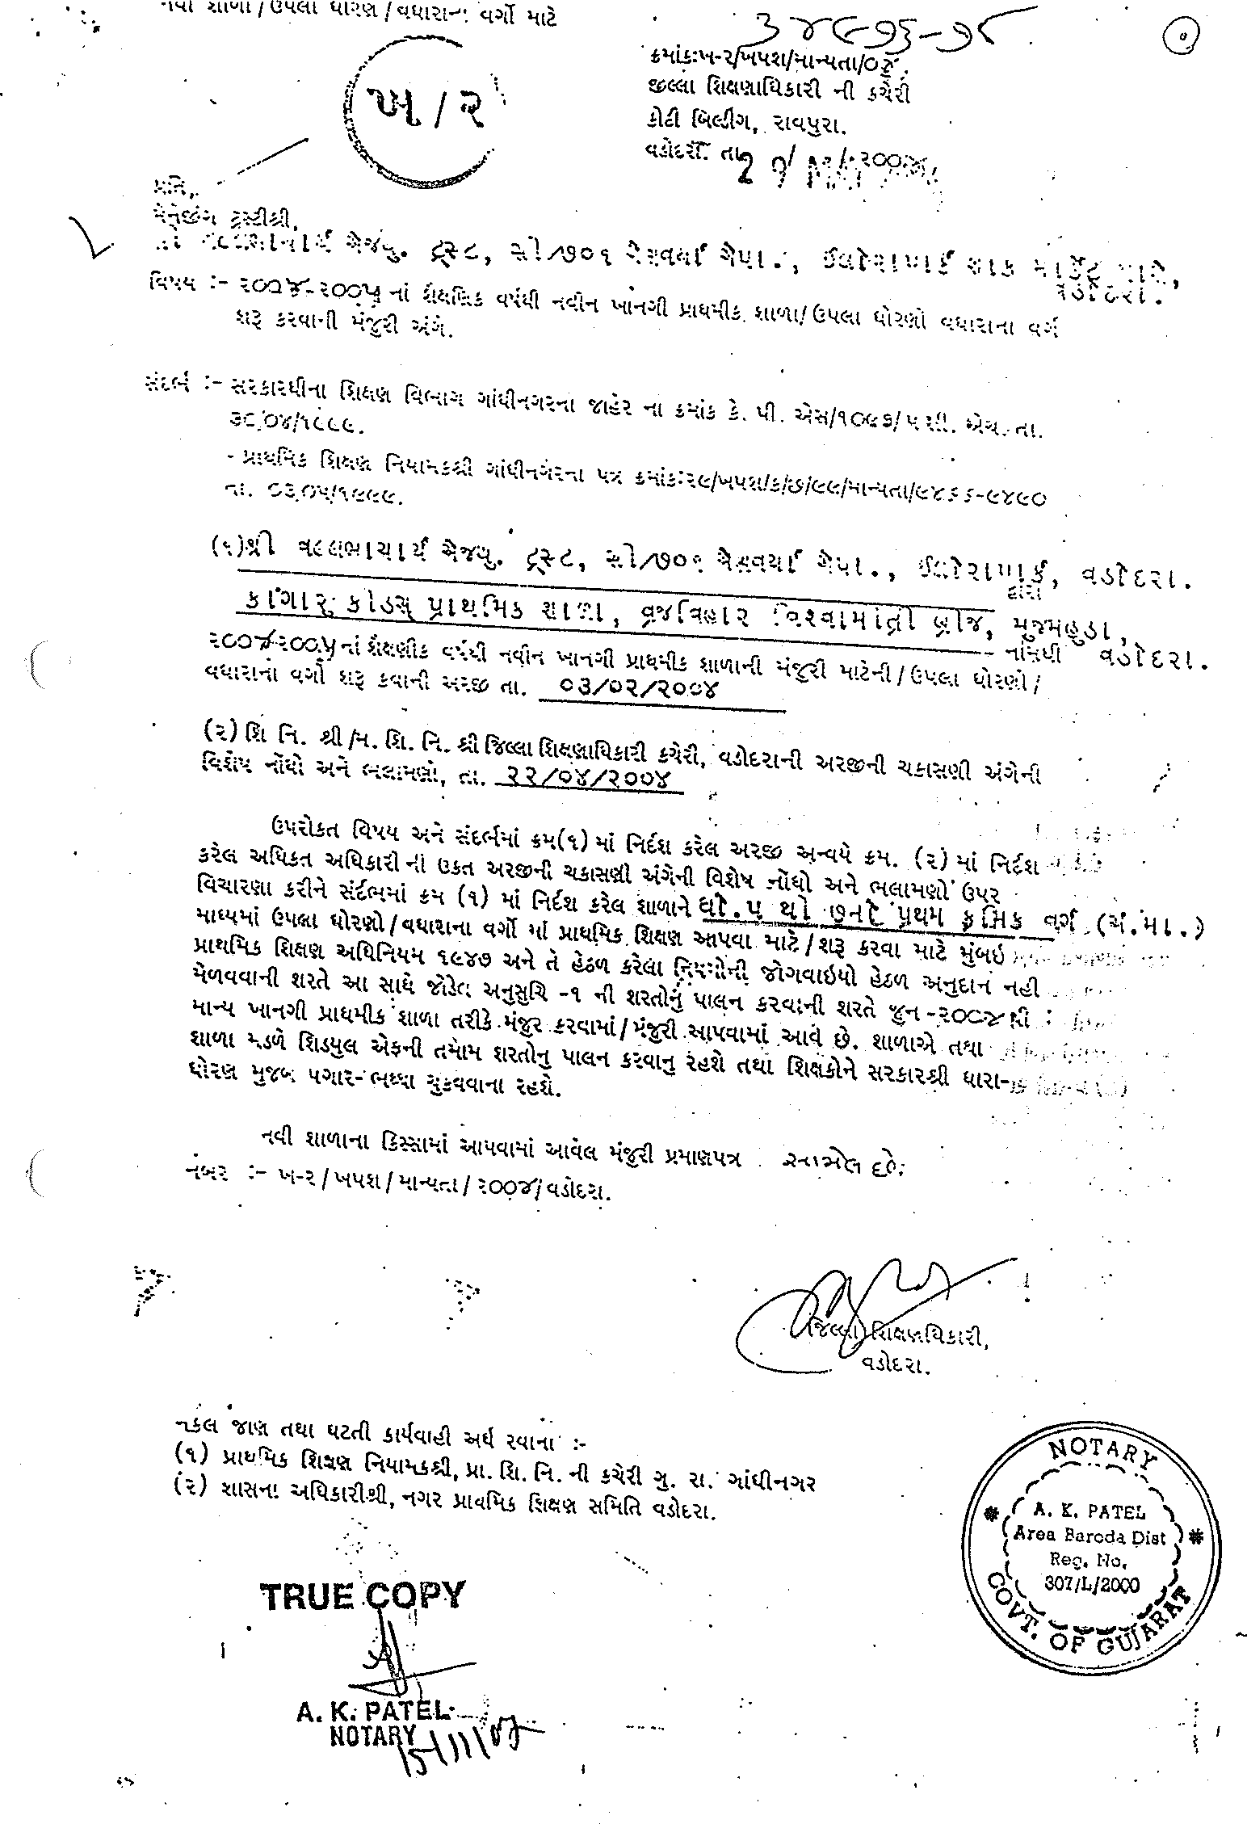

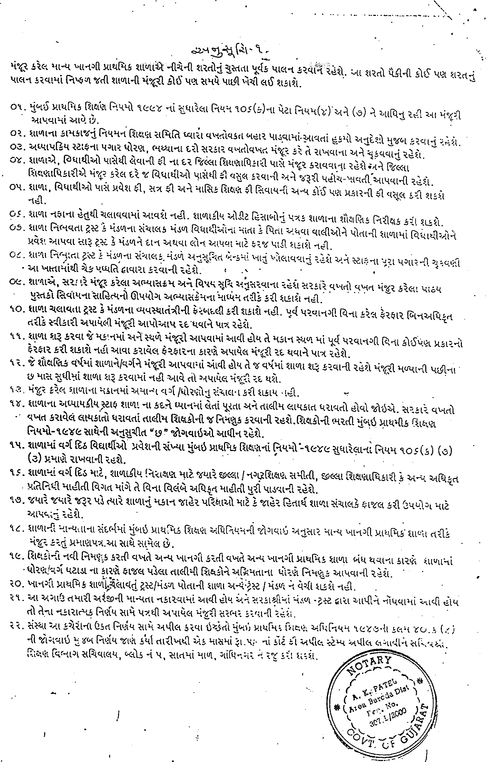

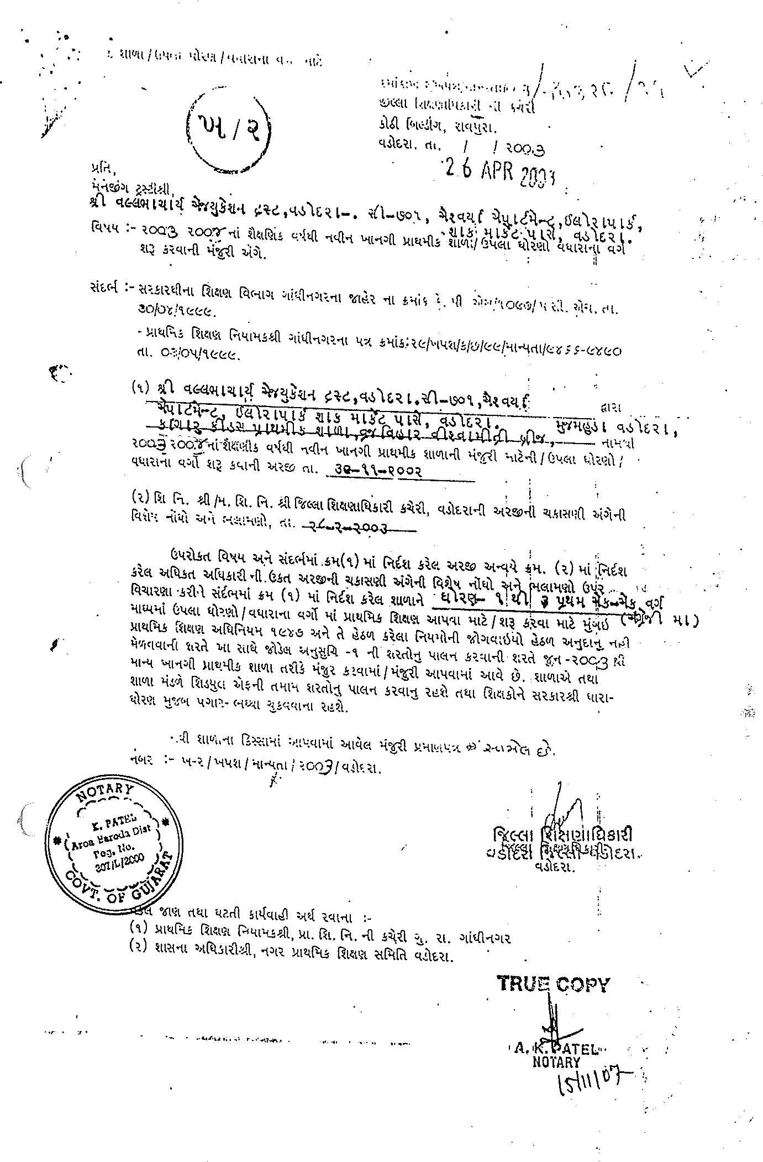

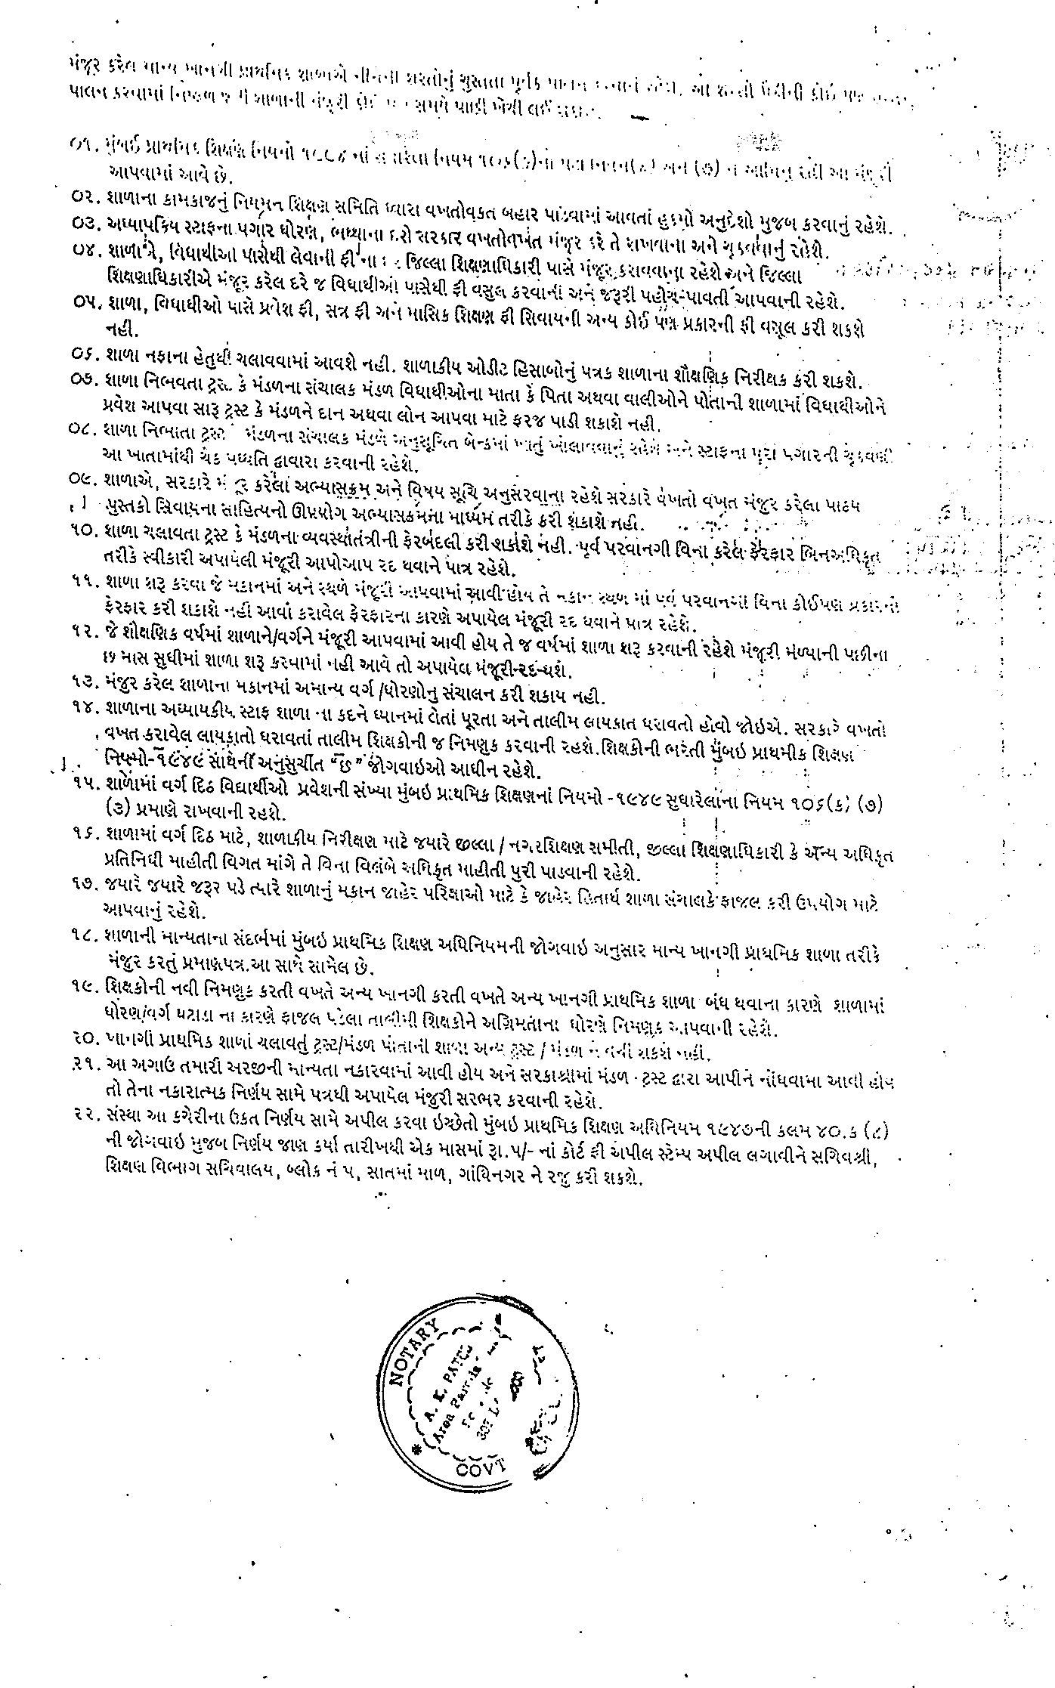

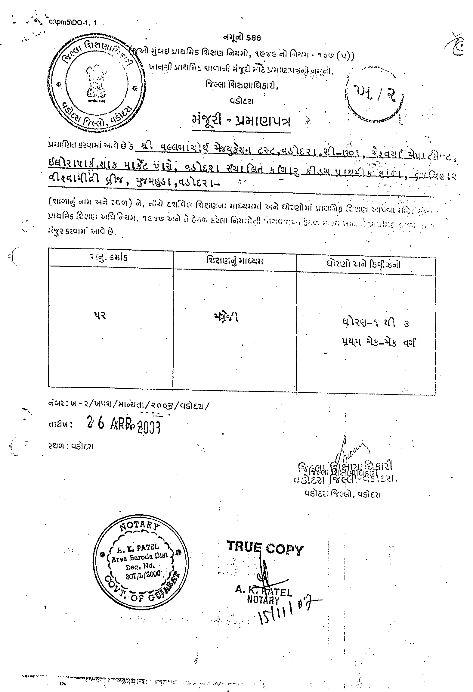

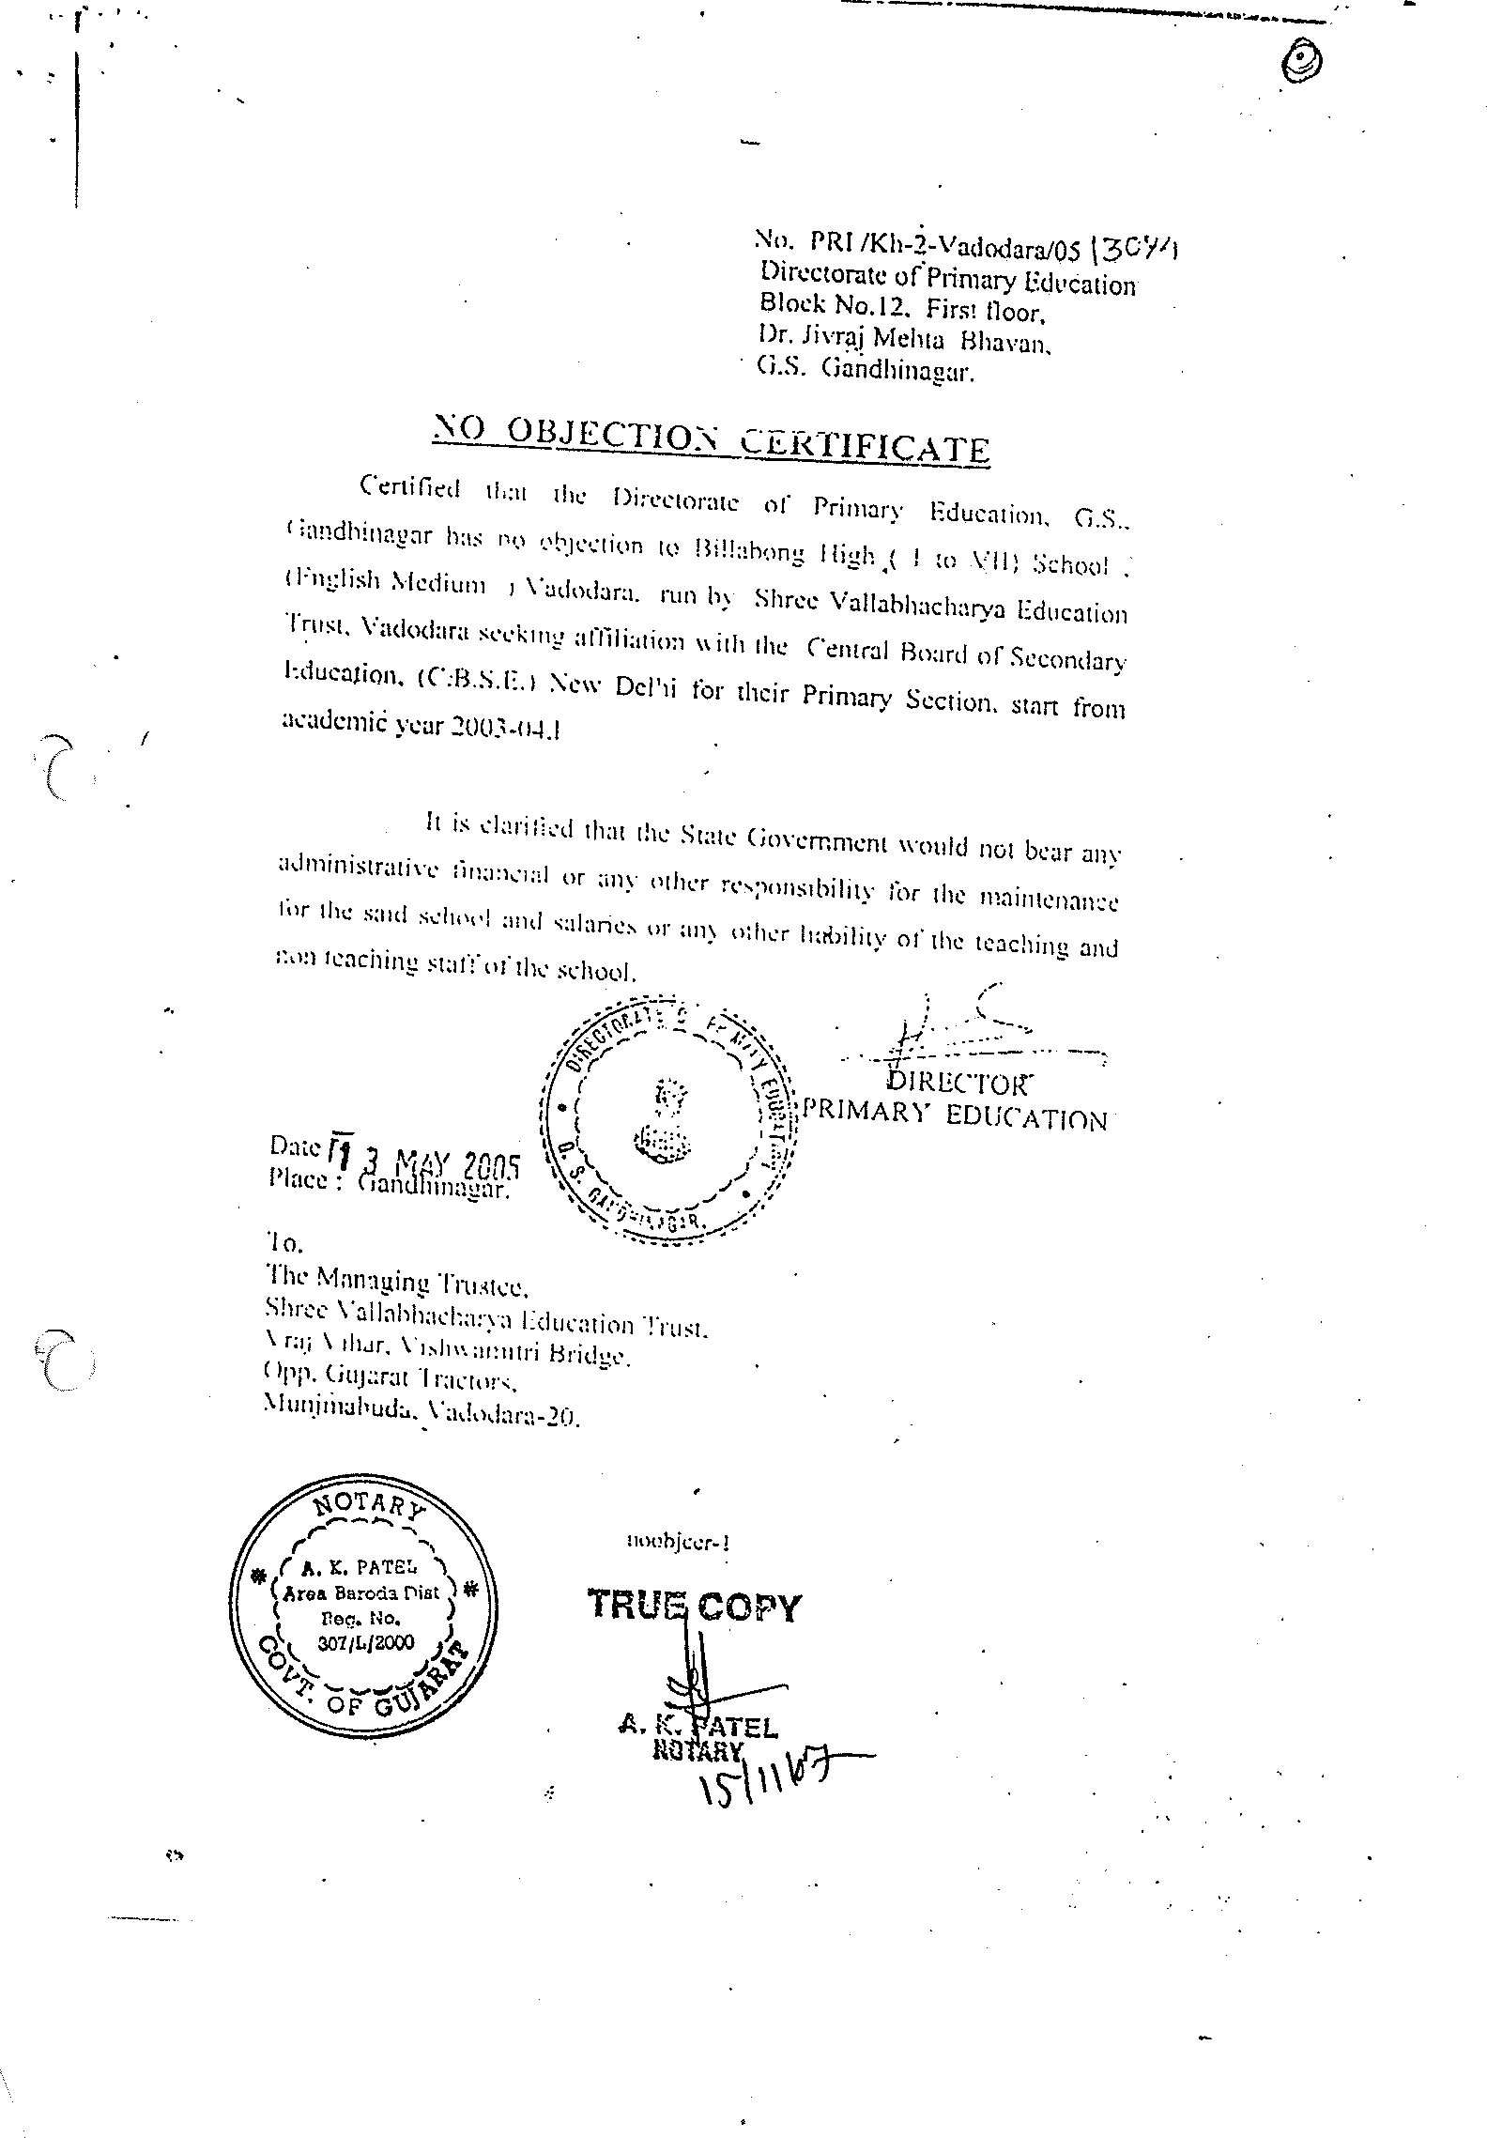

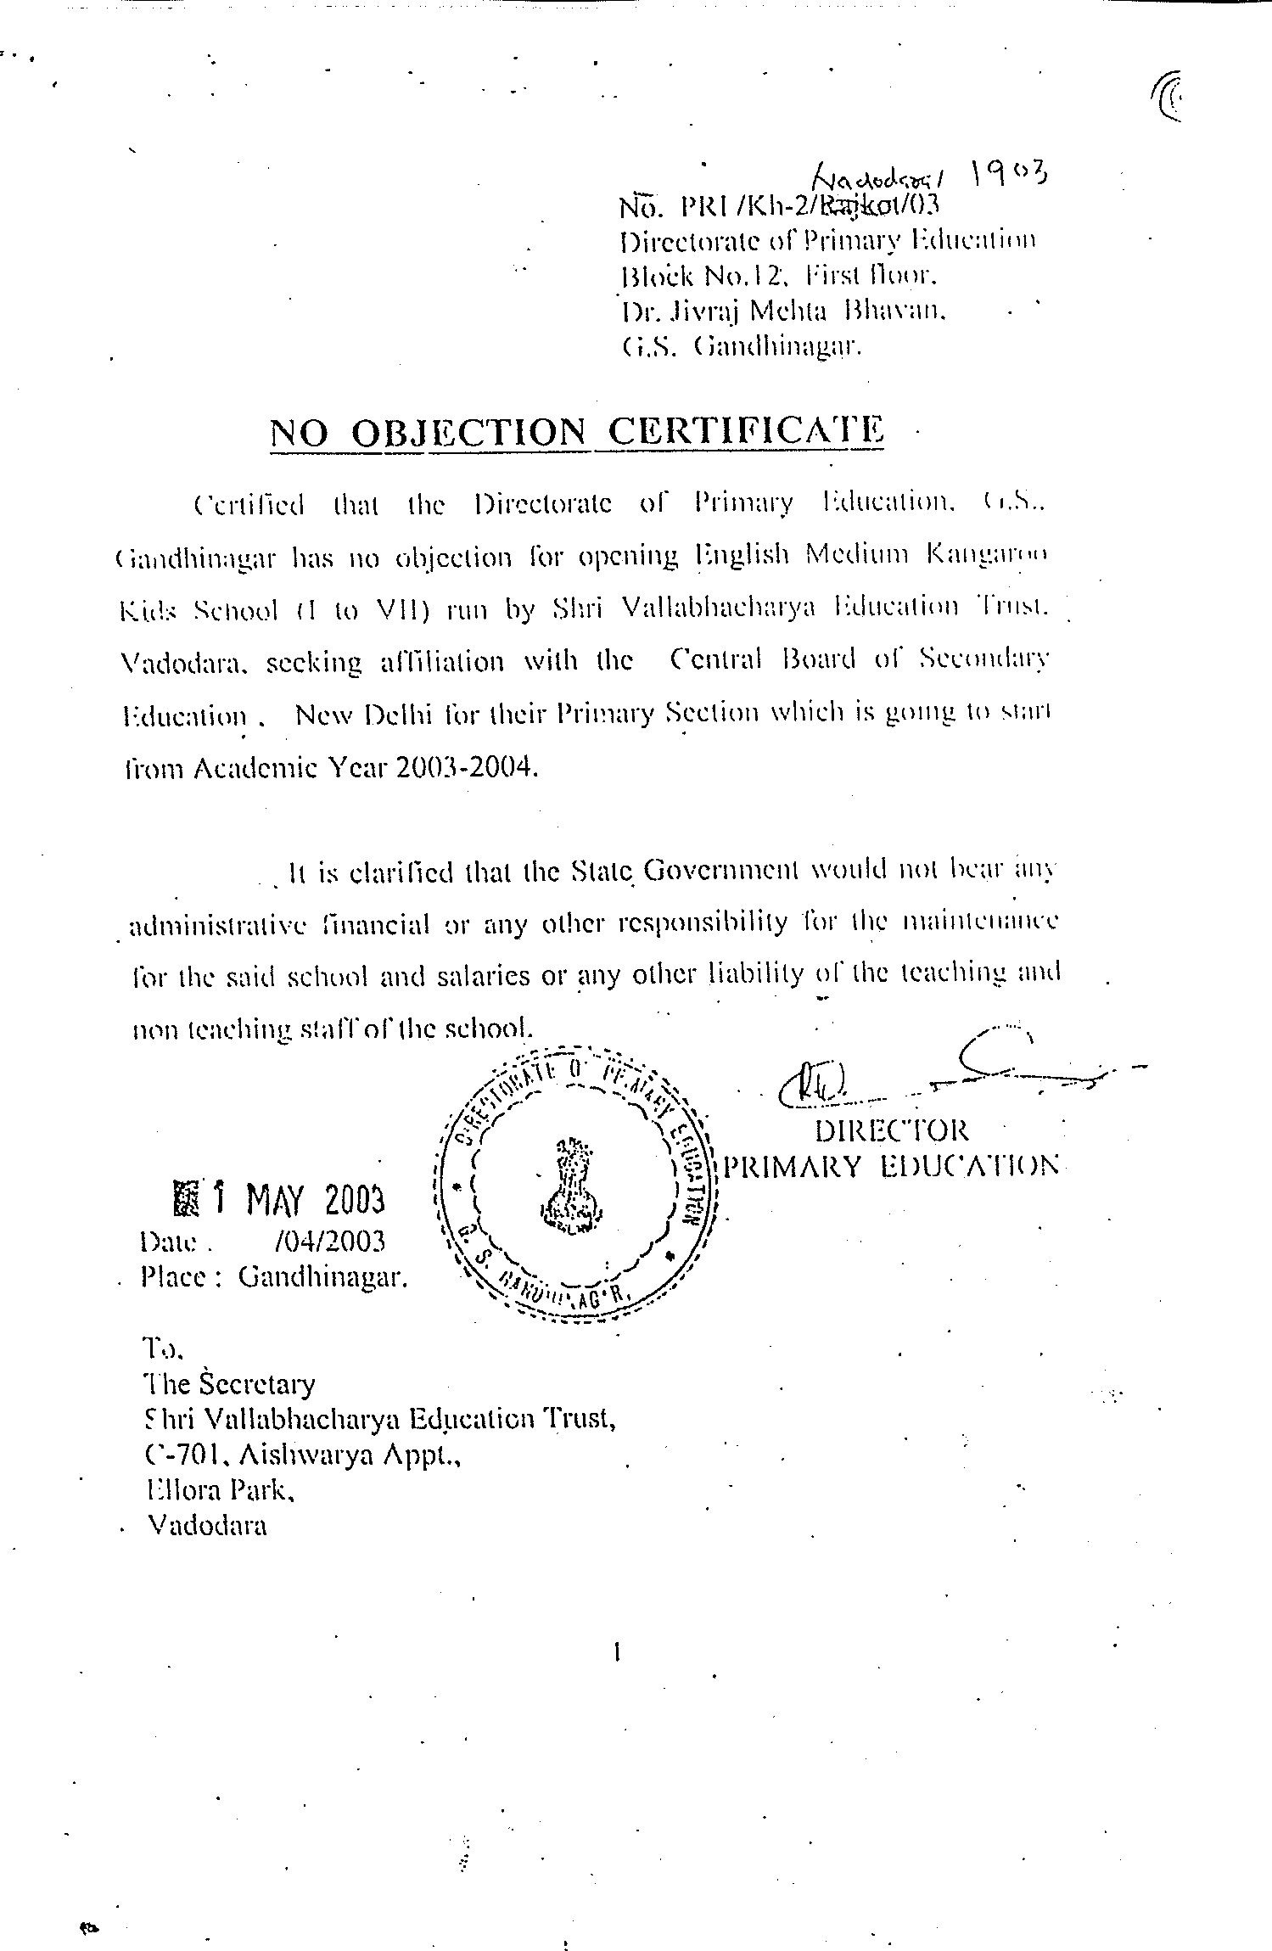

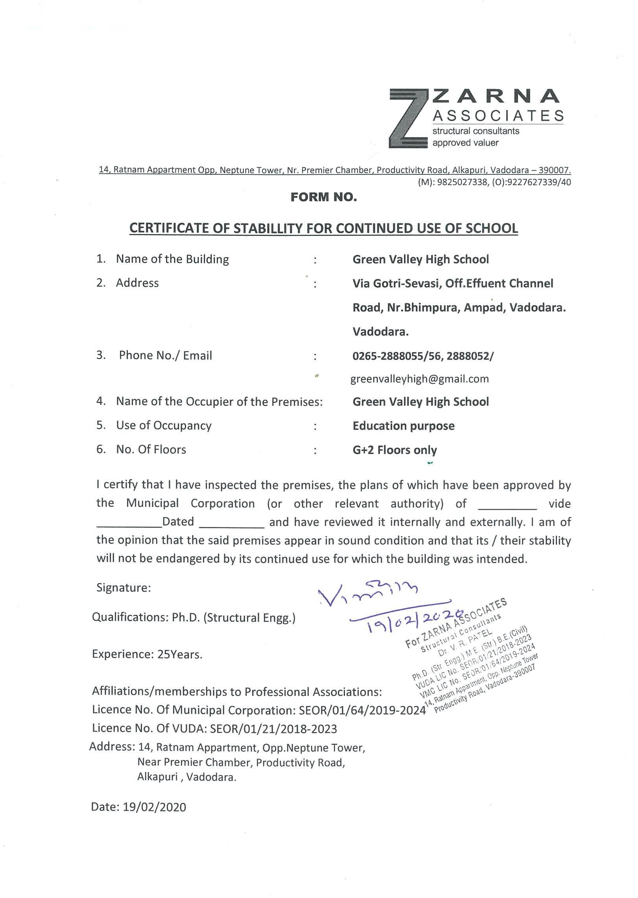

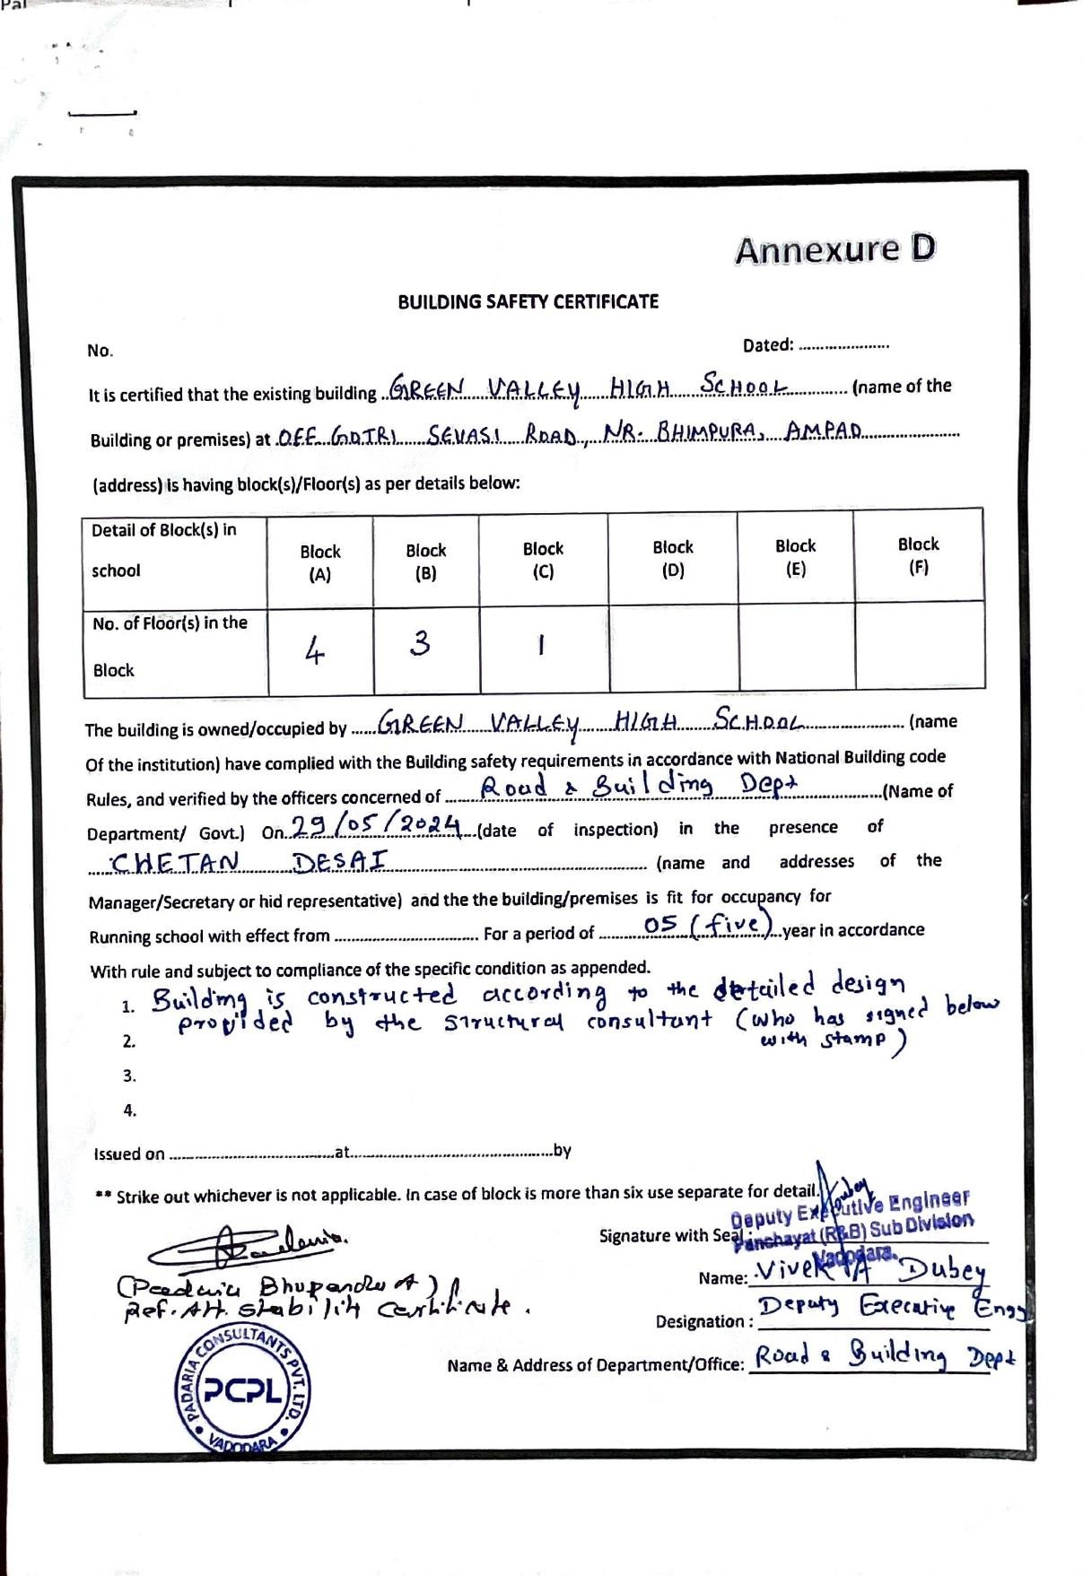

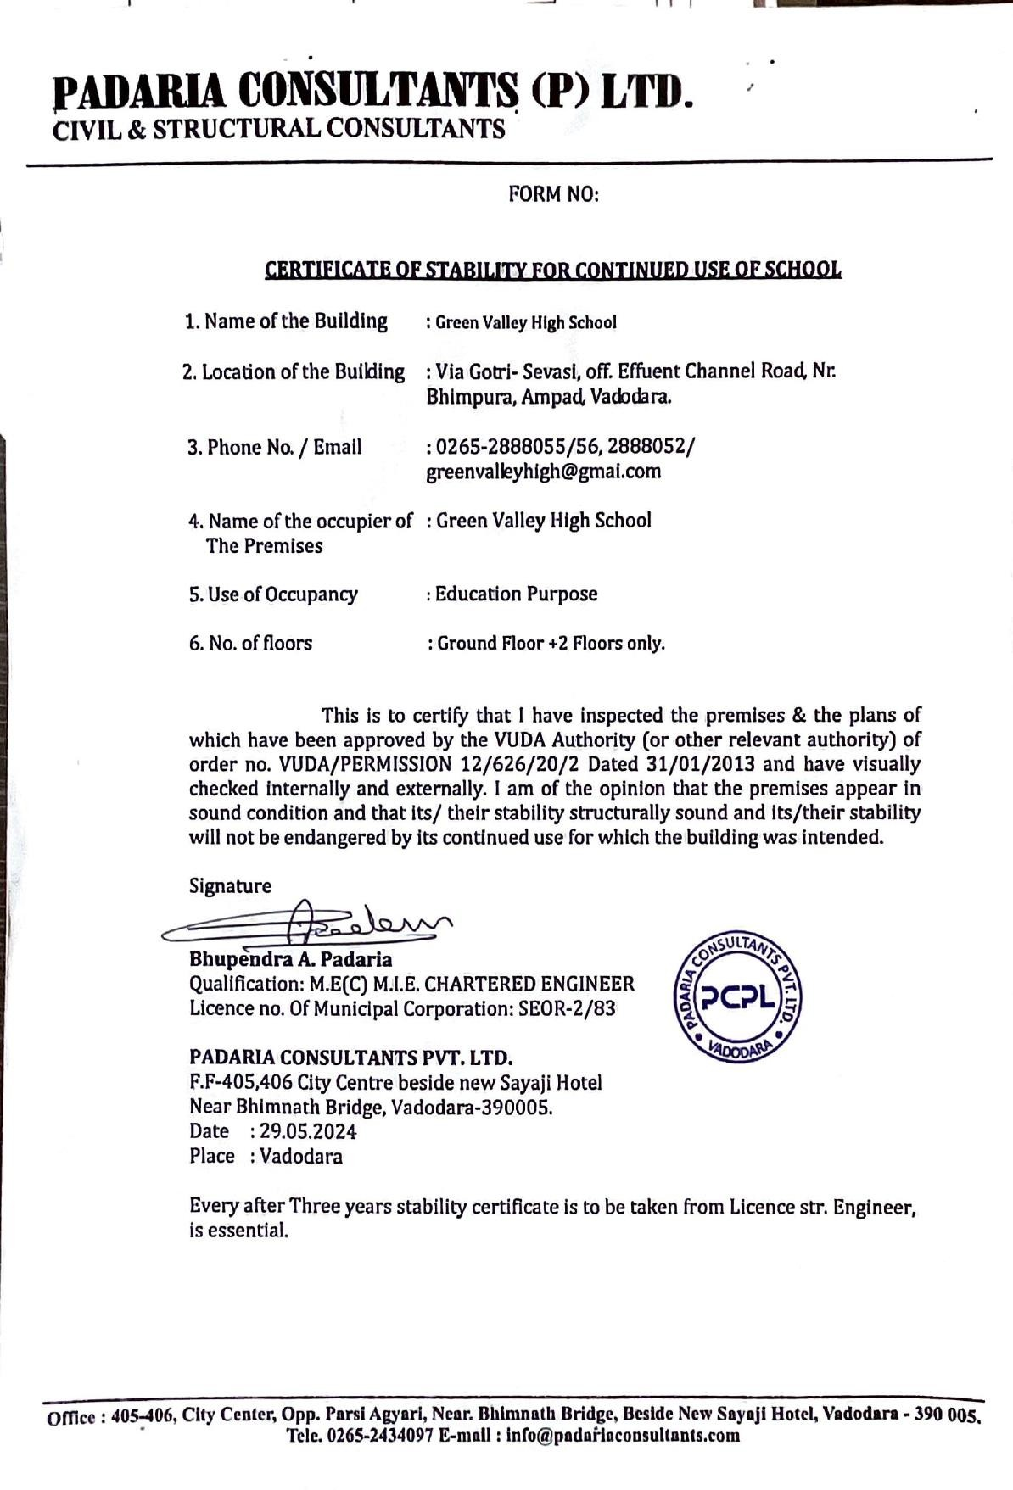

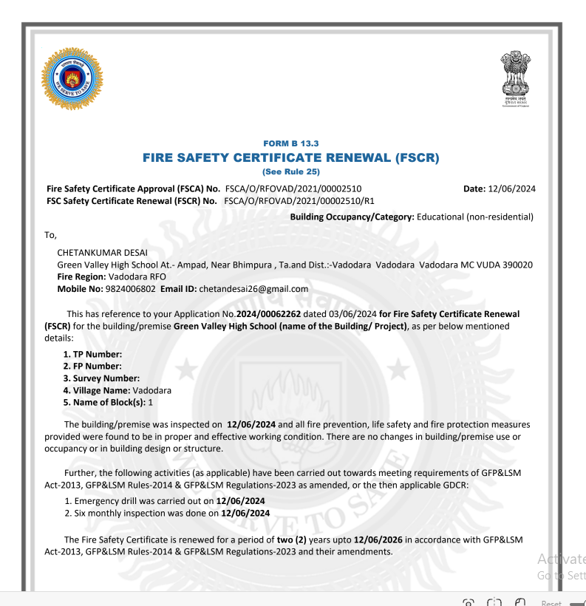

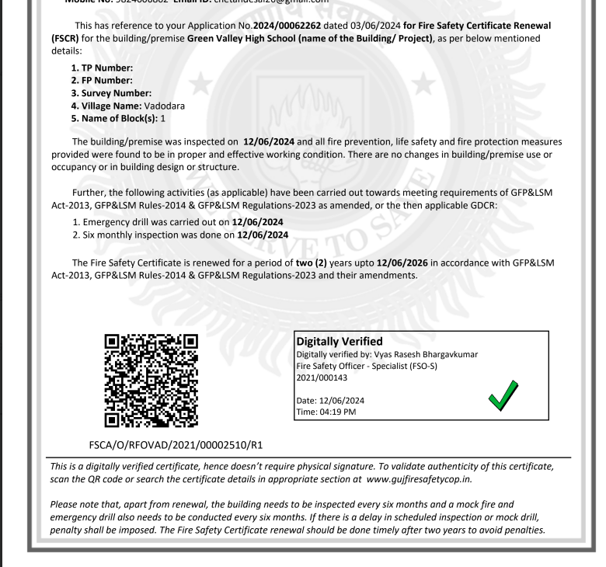
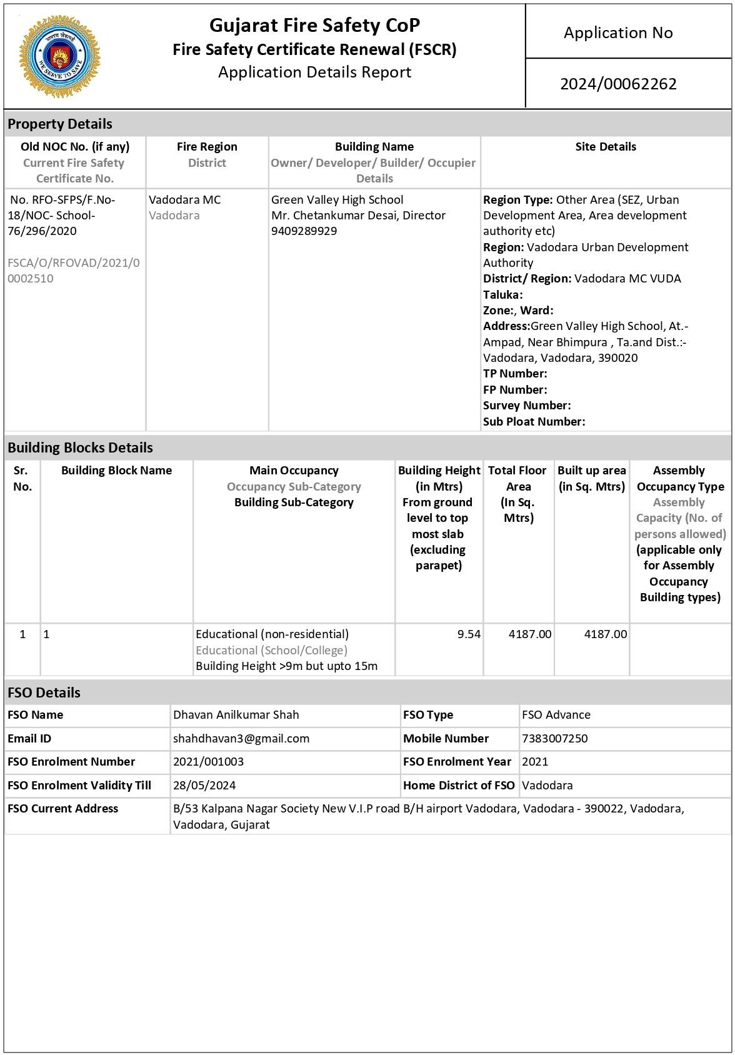

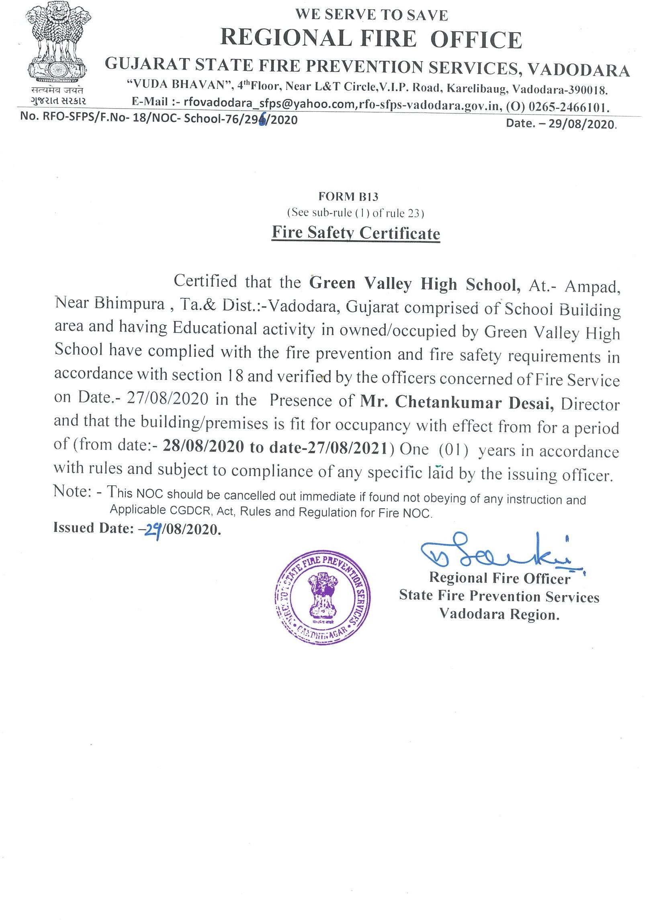

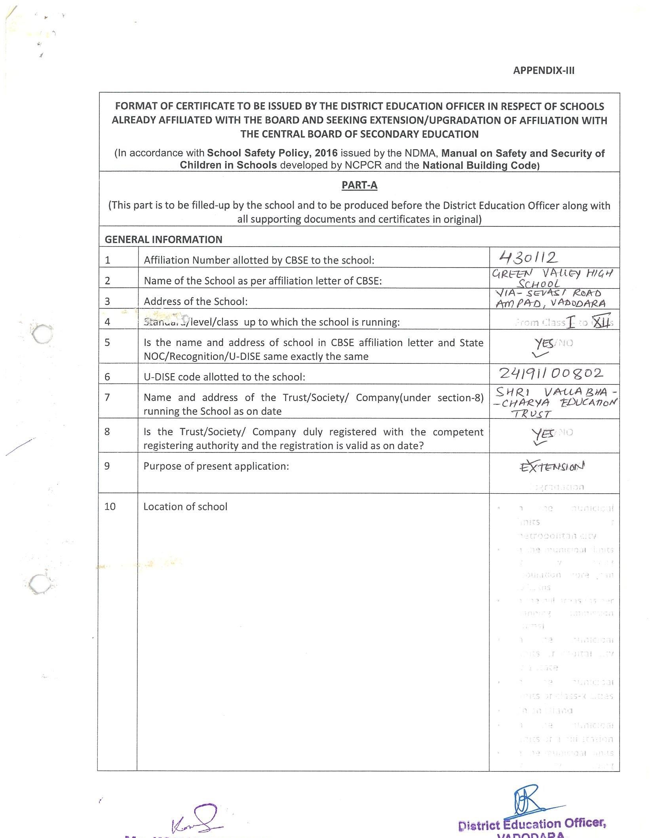

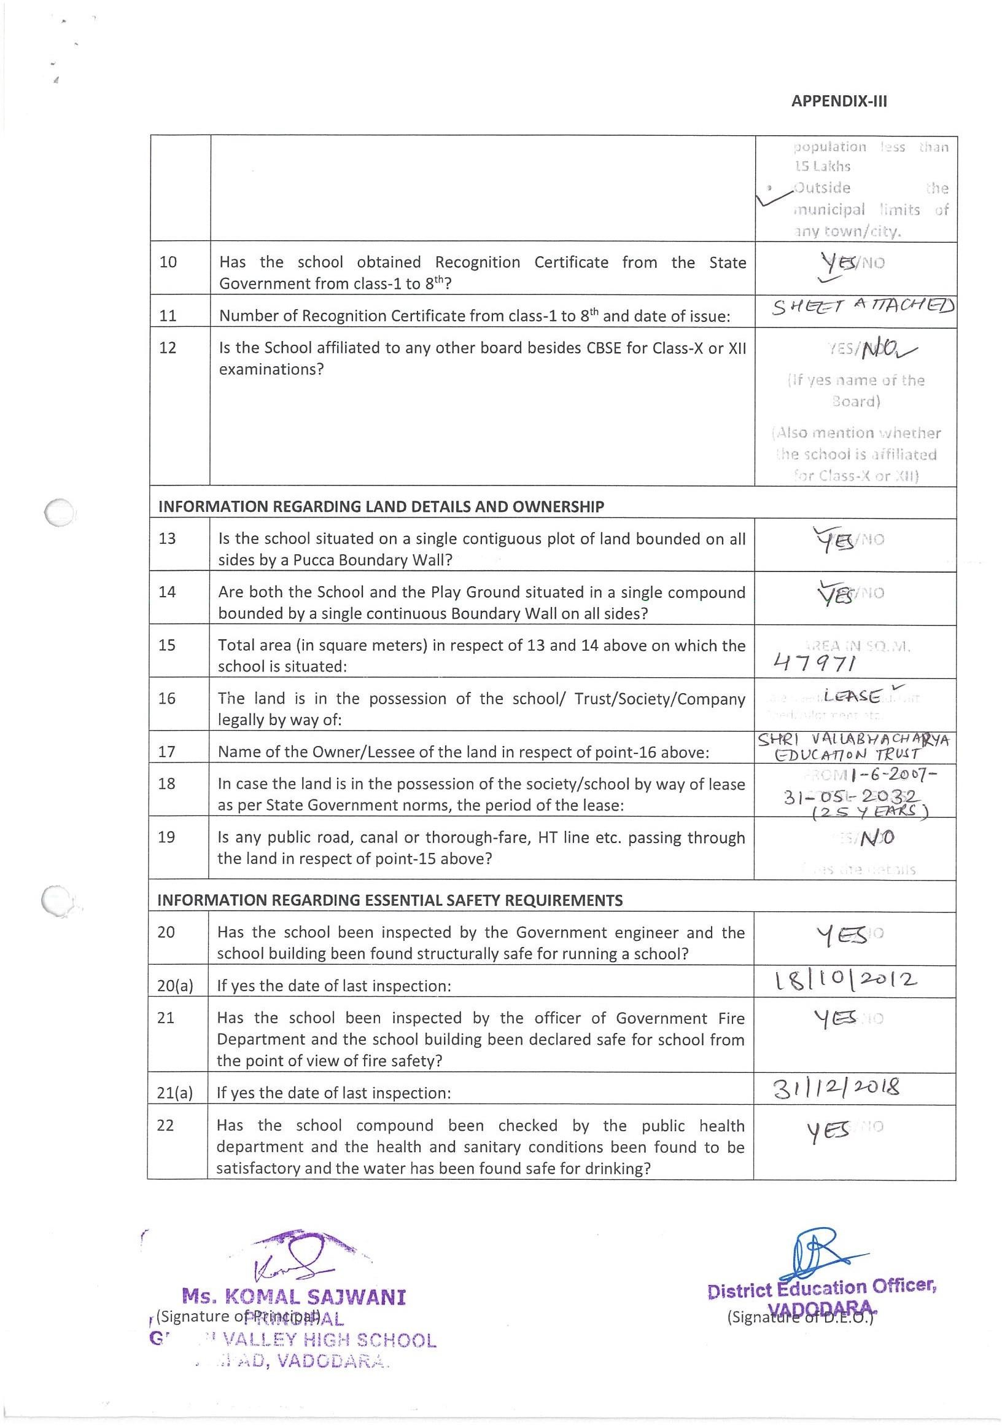

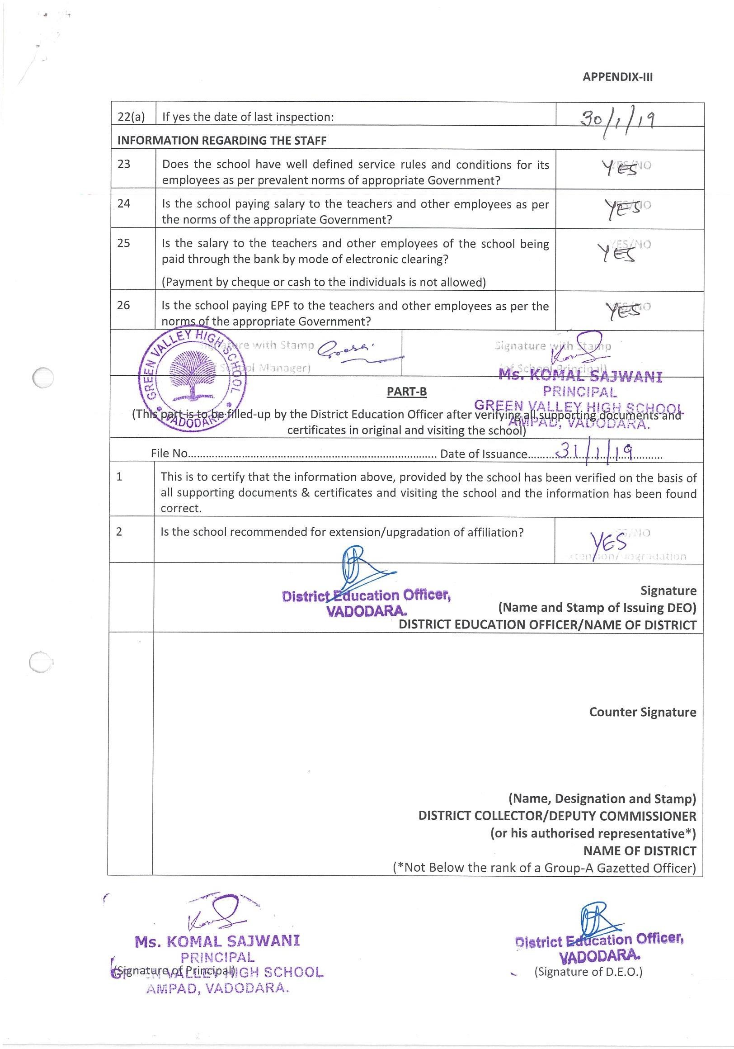

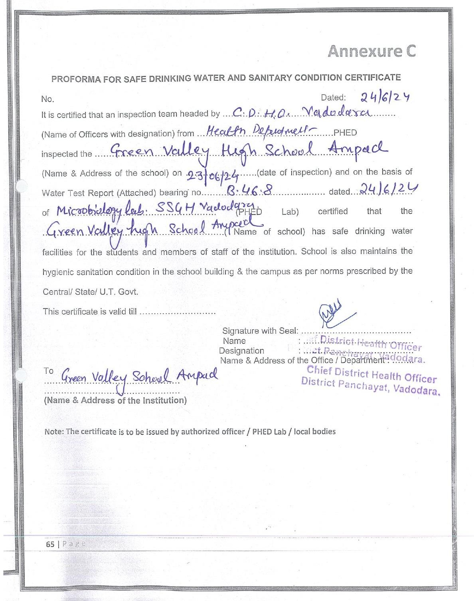

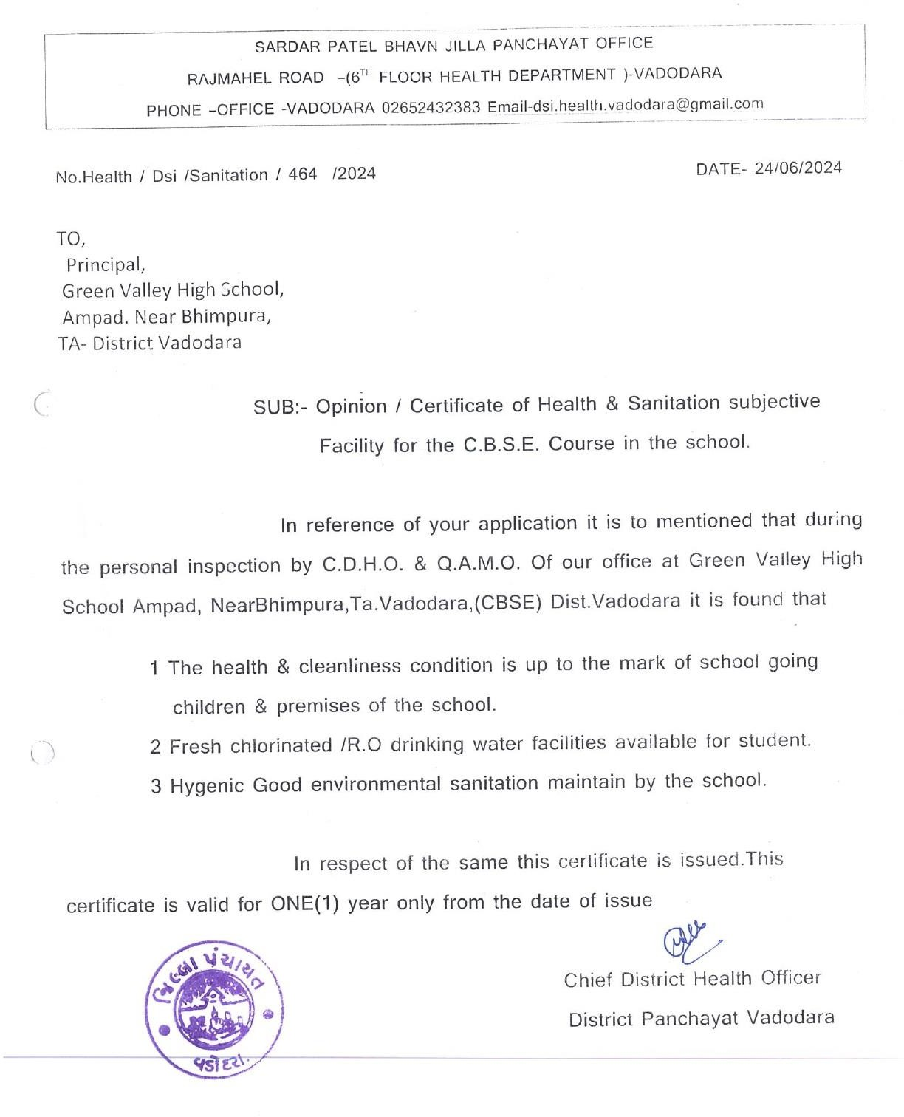

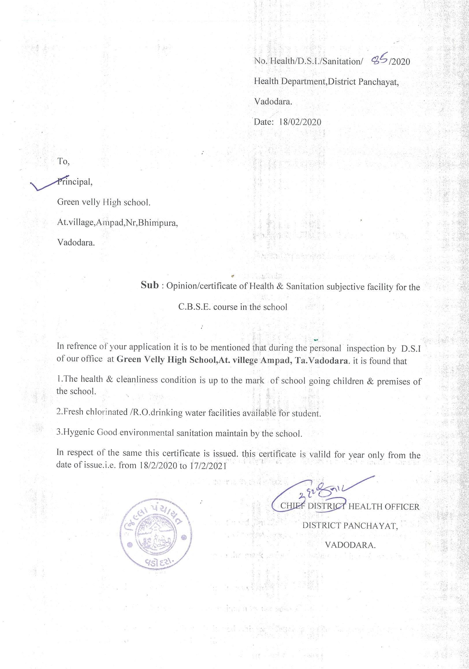

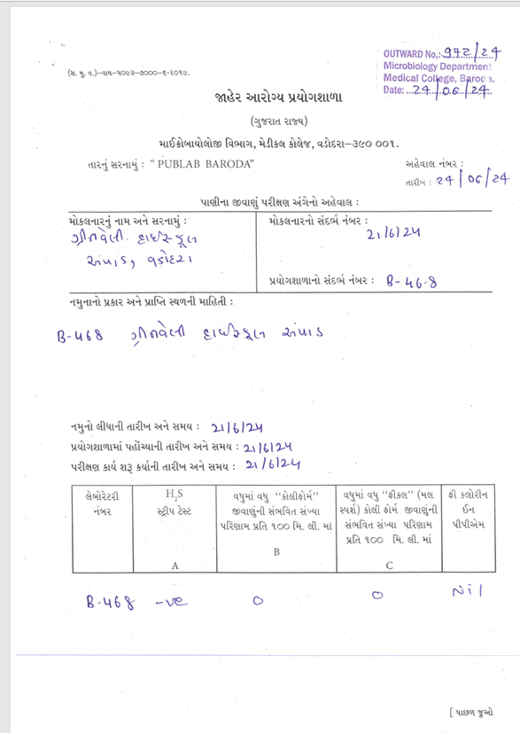

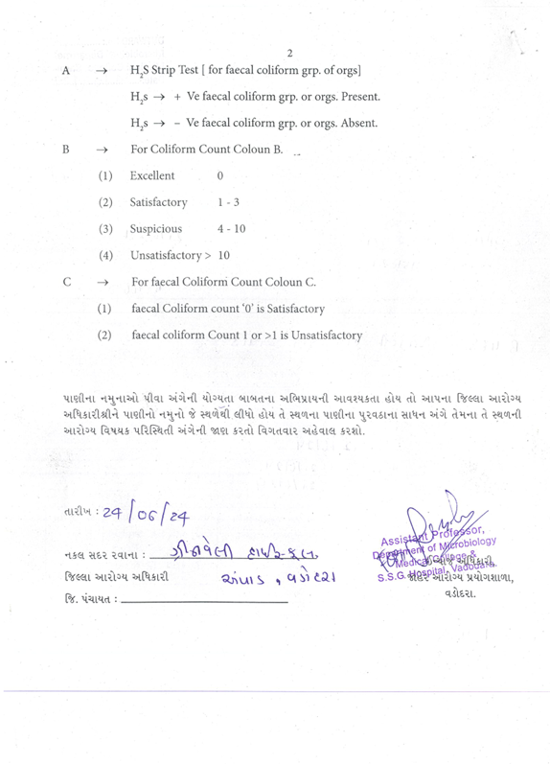
C : RESULT AND ACADEMICS :

SL NO | DOCUMENTS/INFORMATION | LINKS OF UPLOADED DOCUMENTS ON YOURSCHOOL'S WEBSITE
1 | FEE STRUCTURE OF THE SCHOOL | https://greenvalleyschool.ac.in/fee_structure.html
2 | ANNUAL ACADEMIC CALENDER | PDF Attached
3 | LIST OF SCHOOL MANAGEMENT COMMITTEE(SMC) | PDF Attached
4 | LIST OF PARENTS TEACHERS ASSOCIATION(PTA) MEMBERS | PDF Attached
5 | LAST THREE-YEAR RESULT OF THE BOARD EXAMINATION AS PER APPLICABILITY | PDF Attached

  - ANNUAL ACADEMIC CALENDER

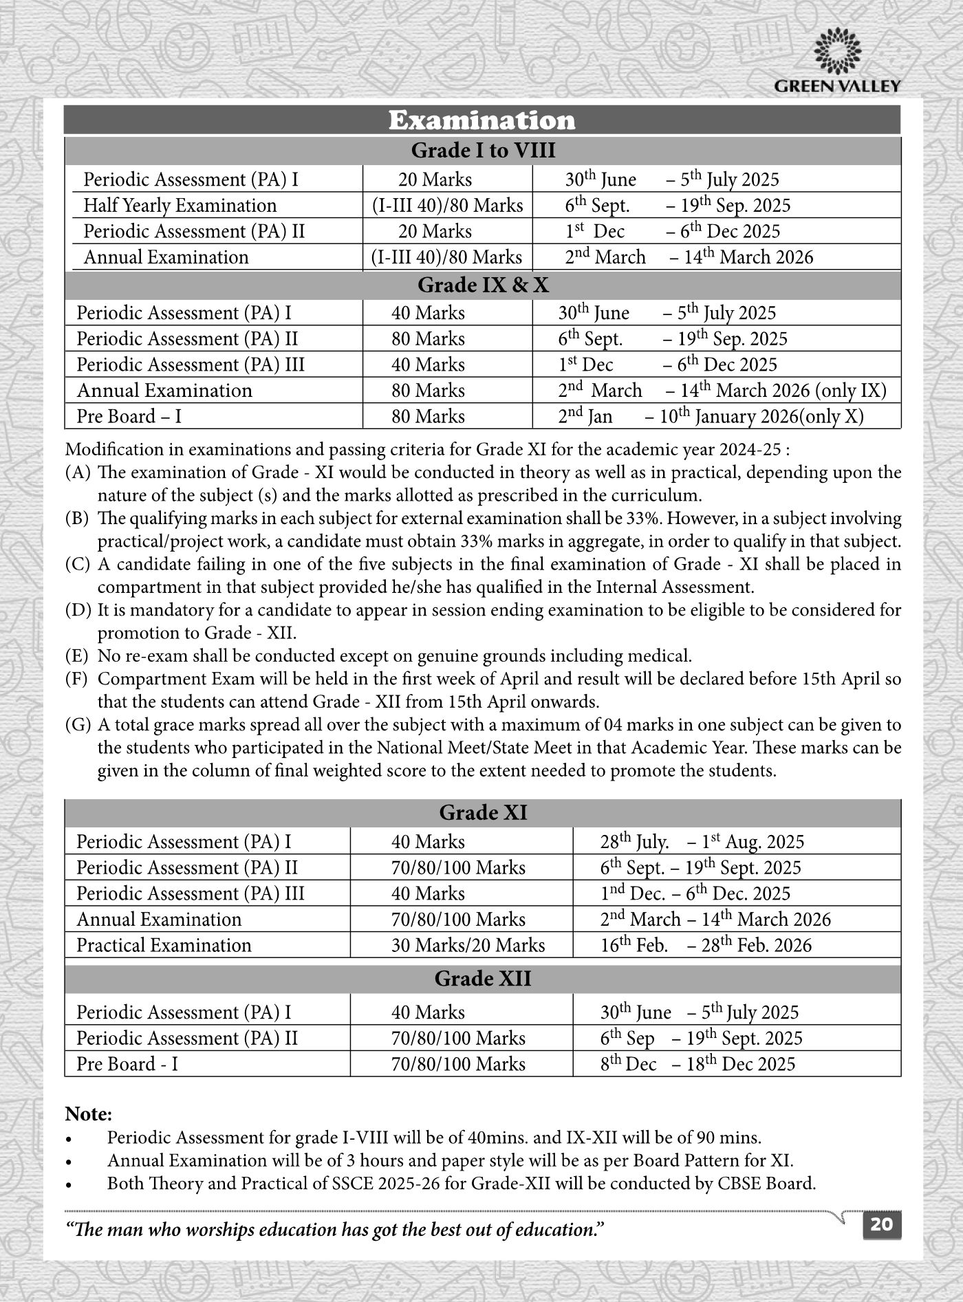

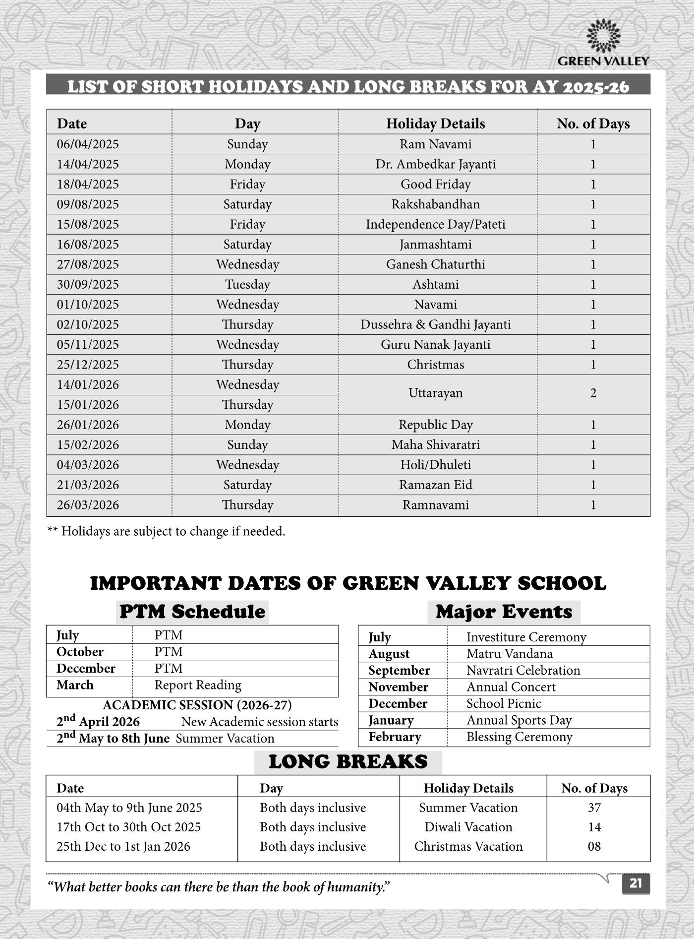

  - LIST OF SCHOOL MANAGEMENT COMMITTEE (SMC)

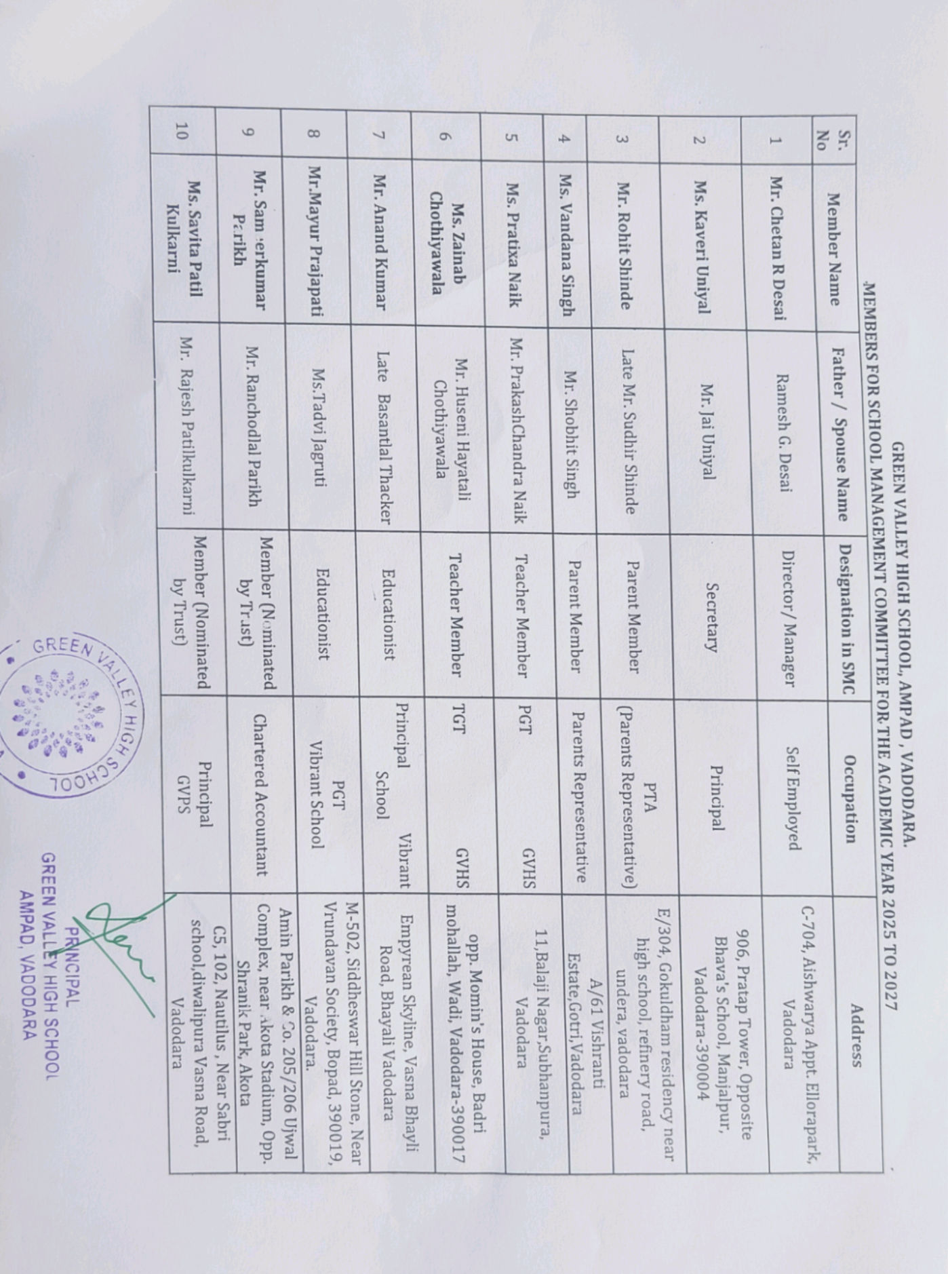
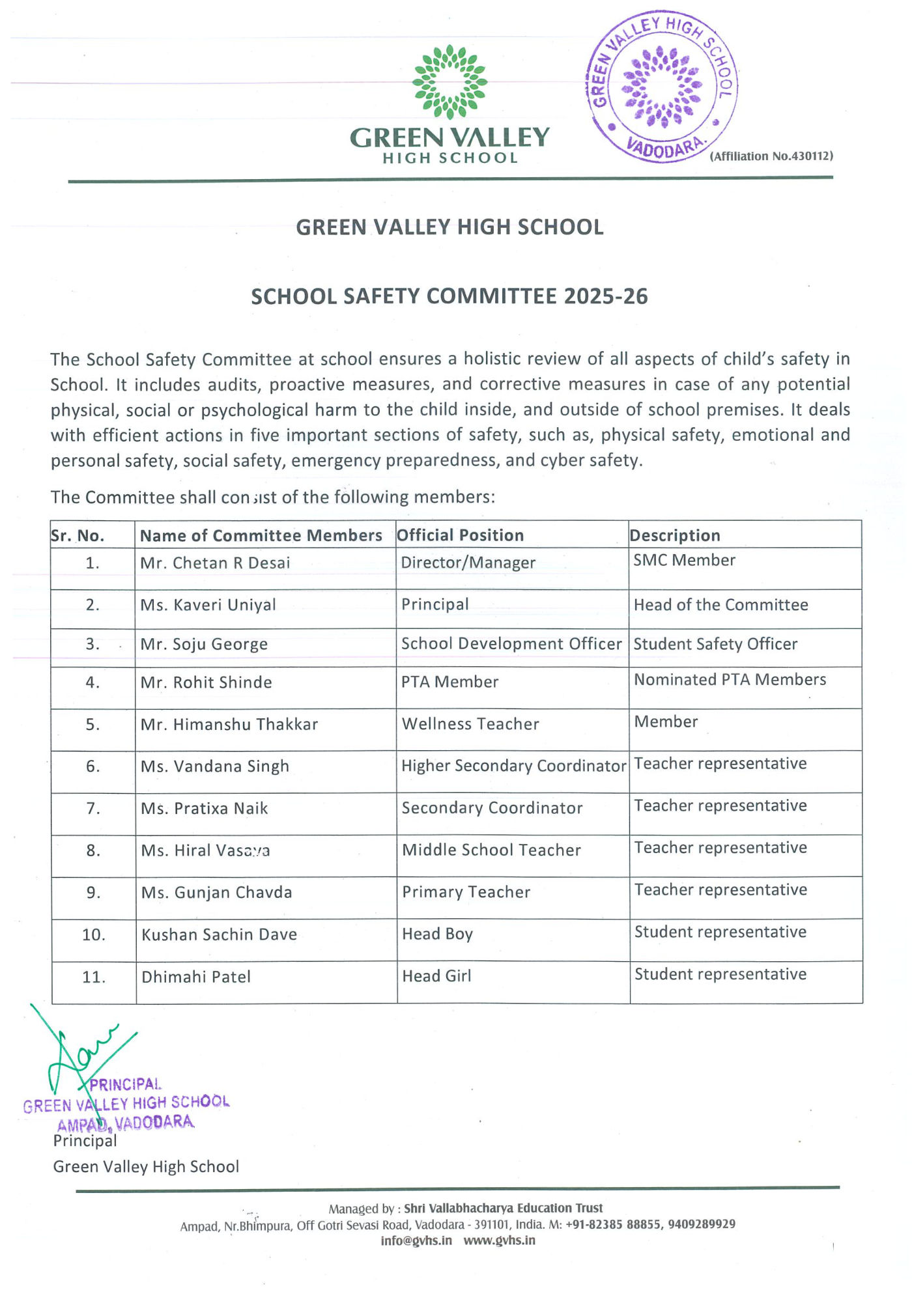

  - LIST OF PARENTS TEACHERS ASSOCIATION (PTA) MEMBERS

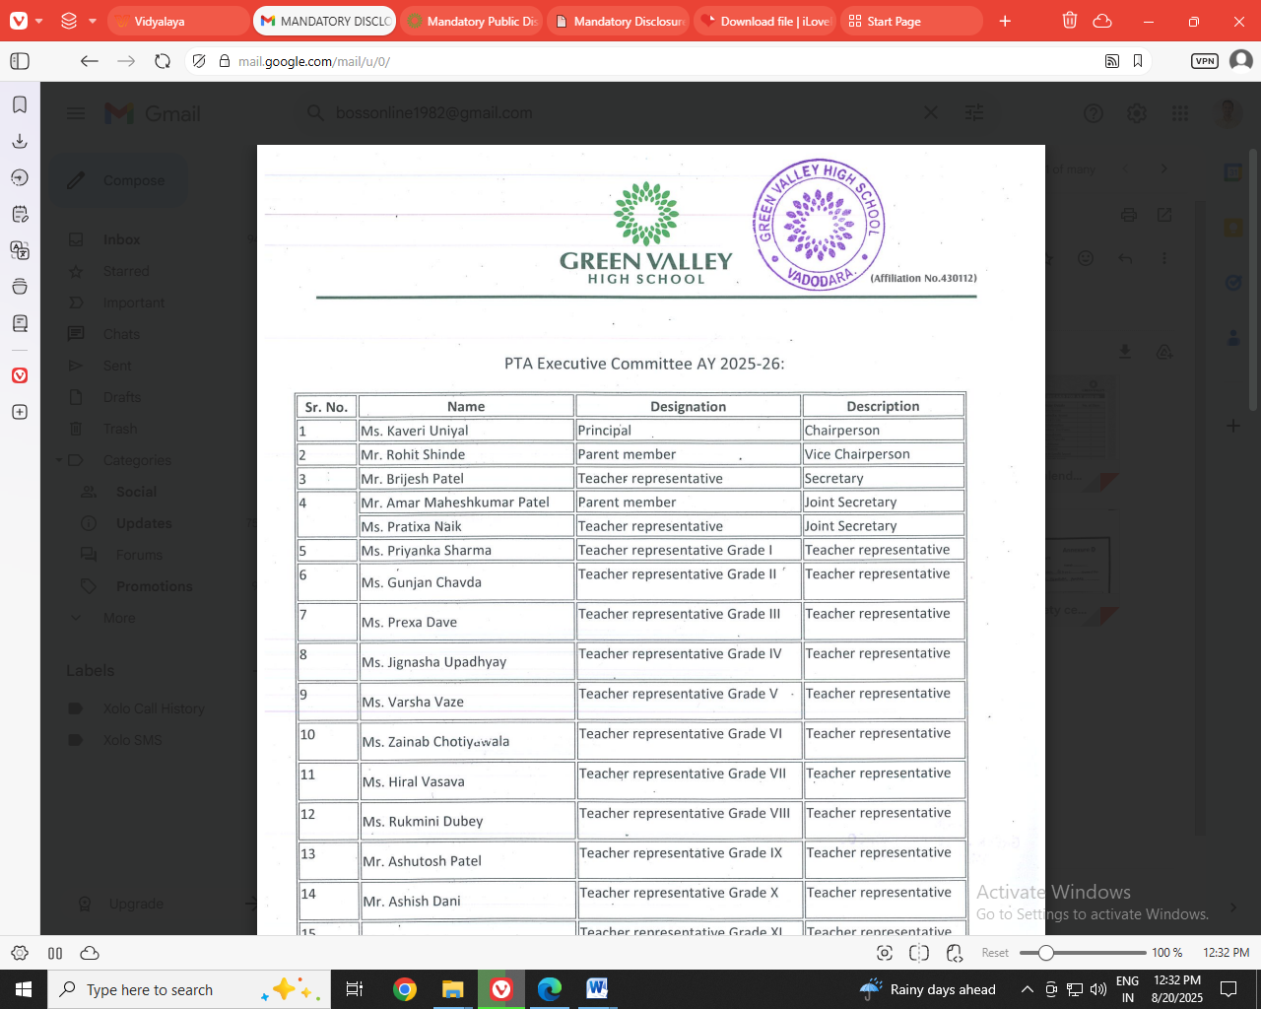

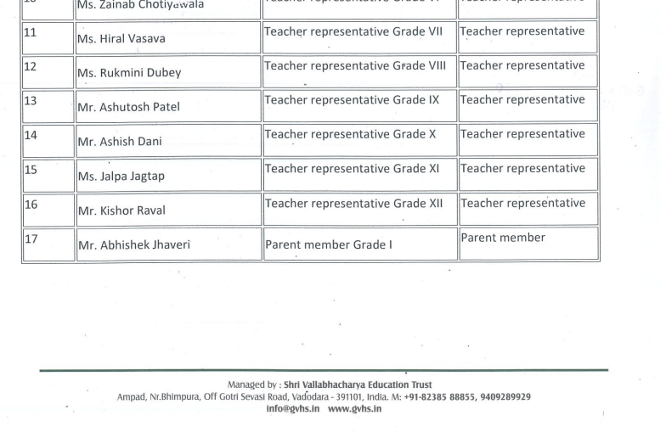
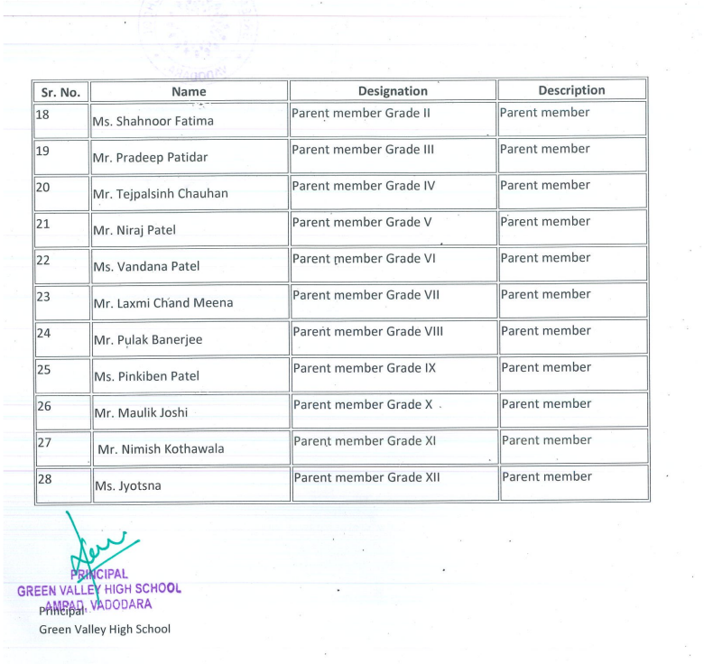
  - LAST THREE-YEAR RESULT OF THE BOARD EXAMINATION AS PER APPLICABILITY

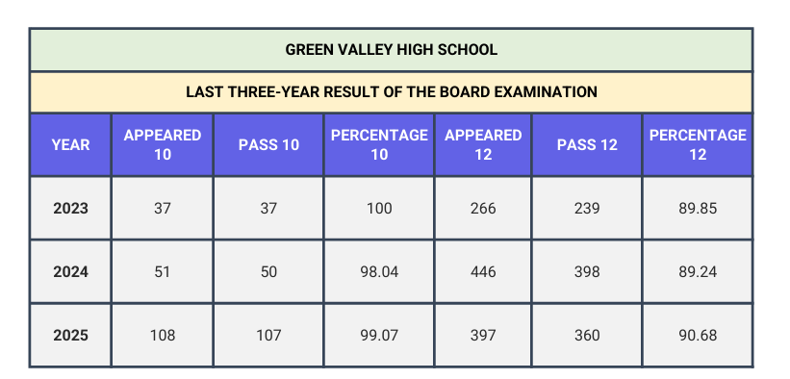

D : STAFF (TEACHING) :
TOTAL NO. OF TEACHERS | 47
PGT | 31
TGT | 10
PRT | 6

SL NO | INFORMATION | DETAILS
1 | PRINCIPAL | Mrs. KAVERI UNIYAL
2
3 | TEACHERS SECTION RATIO | 1.5:1
4 | DETAILS OF SPECIAL EDUCATOR | HIMANSHU THAKKAR
5 | DETAILS OF COUNSELLOR AND WELLNESSTEACHER | HIMANSHU THAKKAR
E : SCHOOL INFRASTRUCTURE:

SL NO | INFORMATION | DETAILS
1 | TOTAL CAMPUS AREA OF THE SCHOOL  (INSQ MTR) | 47971
2 | NO. AND SIZE OF THE CLASS ROOMS (IN  SQMTR) | 37 & 56
3 | NO. AND SIZE OF LABORATORIES  INCLUDINGCOMPUTER LABS (IN SQ MTR) | 9 & 75
4 | INTERNET FACILITY | YES
5 | NO. OF GIRLS TOILETS | 24
6 | NO. OF BOYS TOILETS | 48
7 | LINK OF YOUTUBE VIDEO OF THE INSPECTION OF SCHOOL COVERING THE INFRASTRUCTURE OF THE SCHOOL | Green Valley High School : CBSE Inspection 2020 - YouTube  Or  In youtube, in search option type  “green valley inspection” .

Teaching staff details in brief :

